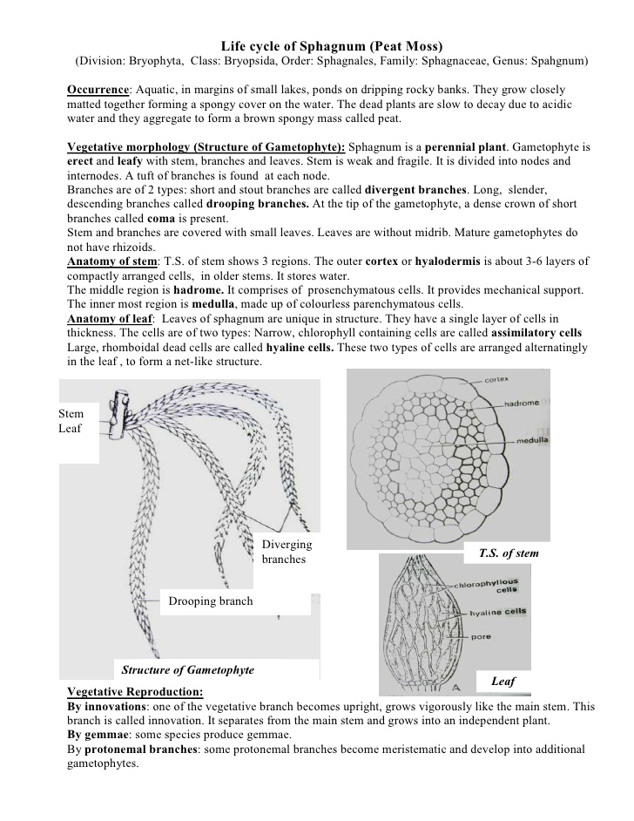

Sexual reproduction: It is advanced oogamous type. Antheridia and archegonia are produced in special
 branches called anth...

•   The 4-6 layered capsule wall surrounds the columella and spore sac. Its outer layer is called
    epidermis and it con...

