1 . Create the following type of table with the help of html code.
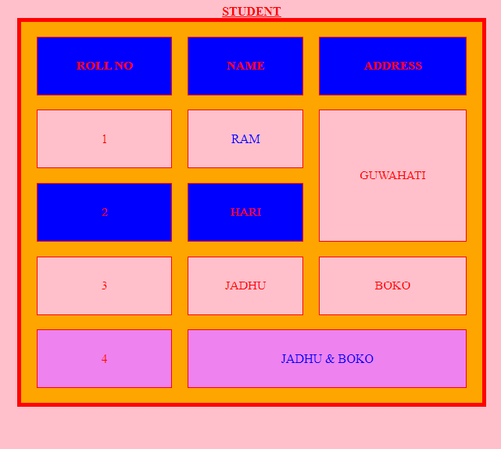
<html>
<head>
<title>
USE OF TABLE
</title>
<body bgcolor="pink" text="red">
<table border="5" width="600" height="400"
align="center" bgcolor="ORANGE" BORDERCOLOR="red"
CELLSPACING="20" CELLPADDING="30" >
<caption><B><U>STUDENT</U></B></caption>

<tr BGCOLOR="BLUE" >
<th>ROLL NO</th>
<th>NAME</th>
<th>ADDRESS</th>
</tr>
<tr BGCOLOR="PINK" align="center">
<td>1</td>
<td><font color="blue">RAM</font></td>
<td rowspan="2">GUWAHATI</td>
</tr>
<tr align="center" BGCOLOR="BLUE">
<td>2</td>
<td>HARI</td>
</tr>
<tr align="center" BGCOLOR="PINK">
<td>3</td>
<td>JADHU</td>
<td>BOKO</td>
</tr>
<tr align="center" BGCOLOR="VIOLET">
<td>4</td>
<td colspan="2"><FONT COLOR="BLUE">JADHU & BOKO</FONT></td>

</tr>
</table>
</body>
</html>

