Brecht and theatre

Brecht's approach to epic theatre drew on the work of earlier director Erwin Piscator, as well as cabaret, Elizabethan history plays and new technologies of light and sound. Andrew Dickson explores how the rejection of naturalism, in the service of political ideals, underpins Brecht's plays, and considers the influence of Brecht's techniques on theatre today.
Powerfully innovative and fiercely political, the German playwright, poet, theorist and director Bertolt Brecht believed that theatre had a duty not only to reflect society, but to change it. An artist who came of age in the chaos that followed Germany’s defeat in the First World War, Brecht honed his craft on the anarchic and experimental scene of Weimar-era Berlin, becoming a committed Marxist in the mid-1920s. In later years, Brecht set up his own theatre group, the Berliner Ensemble, and refined the principles of what he called ‘epic theatre’, which he once described as the opposite to the kind of naturalistic drama where the audience ‘hand in their hat at the cloakroom, and with it ... their normal behaviour’.^{[1]} Committed to fighting social and economic injustice, and often bitterly funny about the dehumanising effects of capitalism, the plays are sometimes heavy-handed, and can seem propagandistic. Brecht has arguably had far more influence as a theoretician and visionary: the innovations he introduced have become so commonplace that it’s hard to encounter a piece of contemporary theatre that does not build on techniques he pioneered.^{[2]}

Farce on the frontline
Politically liberal and slowly recovering from the economic tumult that followed Germany’s defeat in the First World War, Berlin was a magnet for artists from all over Europe, and became a hotbed of modernist theatre, visual art, music, design, dance and film. One of Brecht’s first collaborators was the slightly older director Erwin Piscator (1893–1966), who had come to prominence in a loose grouping of theatremakers and intellectuals in 1920s Berlin. During the First World War, Piscator had been drafted into the so-called German Front Theatre, and was deeply marked by the experience – most of all his memories of performing an imported London farce in bombed-out ruins, not far from the front line. Piscator later claimed that this had been his inspiration for the idea of ‘epic theatre’, which instead of adopting the kind of immersive psychological naturalism promoted by the Russian director and theorist Konstantin Stanislavsky, sought to shock and unsettle the audience.^{[3]}
The shows Piscator worked on at the Volksbühne Theatre in Berlin refined these Expressionist and agitprop techniques, drawing on recent German history and splicing film footage together with live action. After setting up his own Piscatorbühne Theatre, he created a work called Abenteuer des braven Soldaten Schwejk (Adventures of the Good Soldier Schweik, 1928), which used material written by Brecht alongside animated cartoons by the artist George Grosz and life-size puppetry. Piscator described these experiments in his 1929 book The Political Theatre, often seen as the first real exposition of ‘epic’ techniques.^{[4]}

The New Movement in the Theatre
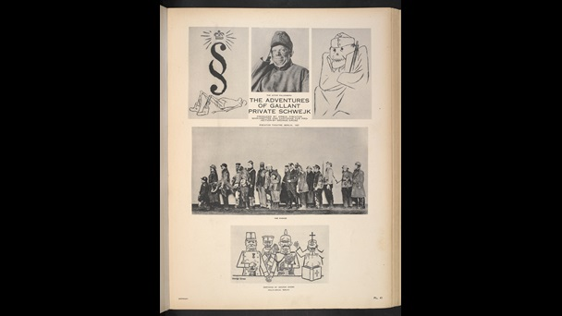
Production photographs and designs by the artist George Grosz from Piscator’s The Adventures of the Good Soldier Schweik.
View images from this item (18)
Usage terms This material is in the Public Domain. Except for artworks by Jean Hugo: © ADAGP, Paris and DACS, London. Except as otherwise permitted by your national copyright laws this material may not be copied or distributed further. George Grosz: © Estate of George Grosz, Princeton, N.J. / DACS. Except as otherwise permitted by your national copyright laws this material may not be copied or distributed further.

‘Organs of mass communication’
Even before Piscator fled Germany in 1931, Brecht had started to develop his own approach to epic theatre, building on his experiences in the cabaret scene in Weimar Berlin, and combining it with an eclectic jumble of elements borrowed from other political drama, American silent film (notably Charlie Chaplin), the music hall tradition and Elizabethan history plays.^{[5]}
Arguably, his first masterpiece, created in collaboration with the composer Kurt Weill, was 1928’s Die Dreigroschenoper (The Threepenny Opera), an updated version of an 18th-century ballad opera by John Gay. The piece focusses on the escapades of the roguishly appealing villain Macheath, nicknamed ‘Mack the Knife’, and is populated by a rogues' gallery of cut-throats, conmen and small-time crooks – a knowing version of Berlin itself. Whip-smart and satirical, propelled by Weill’s sardonically jazzy melodies, The Threepenny Opera was a daring experiment in bringing ‘low’ art into a high-art setting, and the boldest thing Brecht had yet done. Critics were puzzled; according to a reviewer for Die Zeit:
It is not ... a morality play, it is not a revue, it is not a conventional burlesque, and it is not The Beggar’s Opera; but it is an interesting combination of them, illustrating the progress of a movement towards freeing music, acting, and the cinematograph from the ruts of Italian opera, Wagnerian music-drama, drawing-room comedy, and Hollywood, and creating something new with them.
But audiences loved it.

Premier of Brecht’s musical, The Threepenny Opera, at the Theatre am Schiffbauerdamm, Berlin
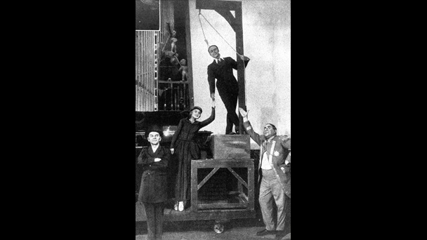
Brecht's first masterpiece, The Threepenny Opera was a daring experiment in bringing ‘low’ art into a high-art setting.
View images from this item (2)
Usage terms © Ullstein Bild / Getty Images
Brecht and Weill continued their experiments with the ‘anti-opera’, Aufstieg und Fall der Stadt Mahagonny (The Rise and Fall of the City of Mahagonny, 1930). In his notes for the piece, Brecht stated that his purpose was to make drama into a vehicle for political instruction, and that theatres should be places not just for enjoyment, but for education – ‘to develop the means of pleasure into an object of instruction, and to convert certain institutions from places of entertainment into organs of mass communication’.^{[6]} At roughly the same time, he also experimented writing what he called Lehrstücke (‘exemplary/learning plays’), a series of radical and heavily Marxist dramas that broke down the divide between audience and performers.^{[7]}

Verfremdungseffekt (‘alienation’ or ‘defamiliarisation’)
In all this, Brecht was strongly influenced by Piscator’s dramatic experiments, and recycled many of his techniques, several of which relied on traditional devices such as choruses and handheld placards. He also included technology that was still a novelty for theatremakers of the 1920s – slide or film projections, revolving stages, loudspeakers blaring music or sound effects. As in Piscator’s work, the object was to reject naturalism and draw attention to the artifice of the theatrical process, a principle Brecht described as Verfremdungseffekt (usually translated as ‘alienation’ or ‘defamiliarisation’ effect, and often shortened to ‘V-effect’ or, in English, ‘A-effect’). For Brecht, the key aim was to discourage the audience from empathising with events on stage and instead incite them to real-life action:
The dramatic theatre’s spectator says: Yes, I have felt like that too – Just like me – It's only natural – It’ll never change – The sufferings of this man appall me, because they are inescapable – That’s great art; it all seems the most obvious thing in the world – I weep when they weep, I laugh when they laugh.
The epic theatre’s spectator says: I’d never have thought it – That's not the way – That's extraordinary, hardly believable – It's got to stop – The sufferings of this man appall me, because they are unnecessary – That’s great art; nothing obvious in it – I laugh when they weep, I weep when they laugh.^{[8]}
In other words, instead of comforting spectators with the universality of experience – a function of drama described as early as Aristotle’s Poetics in c. 335 BCE – Brecht wanted to shock them out of their apathy and complacency.

Premier of Brecht’s musical, The Threepenny Opera, at the Theatre am Schiffbauerdamm, Berlin
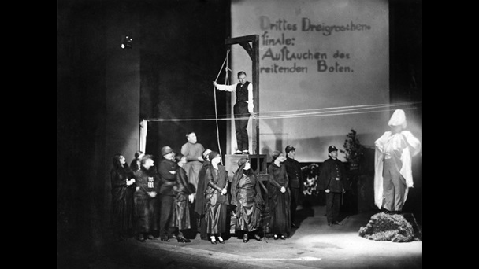
Brecht was influenced by Piscator and used technology on stage including placards, slide or film projections, sound and lighting effects. The aim was to reject naturalism and draw attention to the artifice of the theatrical process.

View images from this item (2)
Usage terms © Ullstein Bild / Getty Images

Gestus
Another important concept Brecht developed was the gestus, which blends the concepts of ‘gesture’ and ‘gist’. Although notoriously difficult to define – Brechtians still disagree on how to interpret the term – at base this is an acting technique that relies on stylised gestures rather than spontaneous emotion, and which uses easily communicable symbols (a soldier’s gun, a woman’s cart) to get the play’s message across to the audience. Brecht and his actors employed photographs of rehearsals to make sure that each gestus was delivered with crystalline, almost cartoonish clarity, the playwright recording them in ‘model books’ that listed every single move, prop and stage direction his performers used.^{[9]}

The Resistible Rise of Bertolt Brecht
Brecht wrote in excess of 50 plays, and his voluminous writings return frequently to the concept of epic theatre, adjusting his view of it as time went on (one essay is called simply ‘The Epic Theatre and its Difficulties’).^{[10]} Often there is an element of parable to Brecht’s dramas – part of their didactic purpose – together with a spiky combativeness that it is hard to mistake for anyone else. They also use fragmentary, episodic structures, leaping across space and time in gleeful disregard for the conventions of naturalistic drama. And in addition to the technical resources already employed, as a director he used light (often harsh and white) and music to further emphasise the ‘epic’ effect, rebelling against the 19th-century trend for naturalism at any cost. There is, too, often an urgent topicality to Brecht’s dramas, which frequently touches on political problems of his own times.
One of Brecht’s first epic plays is Die Heilige Johanna der Schlachthöfe (St Joan of the Slaughterhouses, 1929–31), a bitterly funny treatment of the story of the medieval martyr Joan of Arc, who led French forces to military victory before being burnt at the stake.^{[11]} Transplanted to 20th-century Chicago in the wake of the Wall Street Crash of 1929, this version pits ‘Joan Dark’ against Pierpoint Mauler, the fat-cat owner of a meat-processing plant. Despite never being staged in Brecht’s lifetime, it clearly points the way to his later and more popular Die Aufhaltsame Aufstieg des Arturo Ui (The Resistible Rise of Arturo Ui, 1941), a satirical depiction of a fictional Chicago mobster who has an insatiable thirst for power and bears striking similarities to one Adolf Hitler.
Brecht himself had been forced to flee Germany in 1933 when the Nazis came to power, and other plays written during his years of exile – first in Scandinavia, then in the US – experiment with different modes of epic theatre. One of the best is Mutter Courage und ihre Kinde (Mother Courage and Her Children, 1941), a sardonic chronicle play about the Central European Thirty Years’ War of the 1600s, focussed on a cold-blooded female character who does not allow the death of her offspring to get in the way of her business. Brecht followed it with Der Gute Mensche von Sezuan (The Good Woman/Soul of Szechuan, 1943), a ‘parable in ten scenes’ which tells the story of a kind-hearted prostitute who only escapes being taken advantage of by disguising herself as someone else.

Letters between Bertolt Brecht, Theatre Workshop and the Berliner Ensemble, about the first British production of Mother Courage
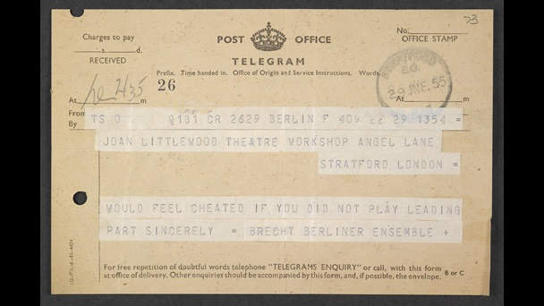
‘Would feel cheated if you did not playing leading part’: a telegram from Bertolt Brecht to Joan Littlewood, who played the character of Mother Courage in the first authorised British production of the play.
View images from this item (20)
Usage terms Bertolt Brecht: © Bertolt-Brecht-Erben / Suhrkamp Verlag. You may not use the material for commercial purposes. Please credit the copyright holder when reusing this work. Gerry Raffles: © Gerry Raffles Estate. You may not use the material for commercial purposes. Please credit the copyright holder when reusing this work.
Elisabeth Hauptmann: © Akademie der Künste Berlin, Elisabeth-Hauptmann-Archiv. Published under a Creative Commons Non-Commercial Licence.
Carl Weber: © Sabine Gewinner-Feucht/Akademie der Künste, Berlin. Published under a Creative Commons Non-Commercial Licence.
Also in 1943, Leben des Galilei (often just called Galileo in English), a study of the life of the iconoclastic scientist and astronomer, was produced in Zurich – though with typical alertness to current events Brecht reworked it numerous times, emphasising its parallels to contemporary debates about nuclear technology and the limits of science. Soon afterwards, he wrote Der Kaukasische Kreidekreis (The Caucasian Chalk Circle), a fable about a serving girl from rural Georgia who adopts an abandoned princeling. Based on a short story Brecht wrote some years earlier, the plot is also a reworking of a 14th-century Chinese play, and features a trial scene that resembles the biblical story in which King Solomon adjudicates the fate of a baby claimed by two separate mothers (the title refers to the circle of chalk inside which the play’s baby is placed during the scene). Decisively anti-naturalist in style, Circle is also somewhat moralising, foregrounding the conflict between justice and class struggle, embodied in the sympathetic figure of the servant girl. Unusually, though, Brecht allows himself a happy ending: the girl gets to keep the baby she loves so much.

Photograph of Juliet Stevenson in The Caucasian Chalk Circle, 1997
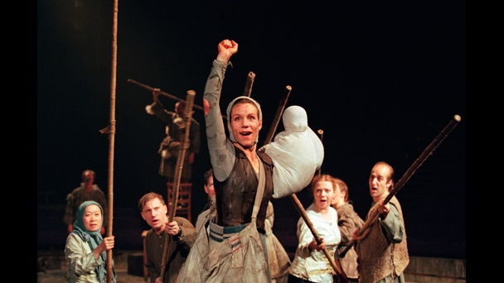
Juliet Stevenson as Grusha.
View images from this item (1)
Usage terms © Donald Cooper / Photostage
www.photostage.co.uk

Brecht in the world
Having failed to make a career for himself as a Hollywood screenwriter, in 1947 Brecht was forced to leave the United States in a hurry because of suspicions about his politics, returning to Germany in 1949. Mother Courage’s success led to the founding that same year of the Berliner Ensemble, a venture that he undertook
together with his wife Helen Weigel (who herself played Mother Courage). The group toured extensively through Europe in the 1950s, notably visiting France in 1954 and England in 1956. Brecht himself died soon after the London visit, but under Wiegel the company’s work promoted the tenets of Brechtian theatre widely, and influenced theatremakers as different as the community-spirited Brazilian practitioner Augusto Boal and the radical East German theatremaker Heiner Müller.
Although the plays themselves come in and out of fashion, the principles of epic theatre now seem surprisingly mainstream. Tennessee Williams was taught by Piscator in the early 1940s, and his near-contemporary Arthur Miller was likewise influenced by expressionist techniques pioneered by Brecht. The 1956 visit of the Berliner Ensemble to London radicalised British theatre, developing their earlier influence on groups and practitioners such as Joan Littlewood’s Theatre Workshop, bowling over the young director Peter Hall and leading to the founding of the Royal Shakespeare Company in 1961, as well as inspiring a generation of political activist theatremakers in the 1970s.
Brecht’s shade lingers, too, in some surprising places. As well as being a forerunner for the so-called ‘docudrama’ and ‘verbatim theatre’ movements of the 1990s and 2000s, which restaged real-life events such as the inquiry into the death of the black teenager Stephen Lawrence (The Colour of Justice, 1999) and used verbatim testimony from Scottish soldiers (Black Watch, 2006), it is visible in major commercial hits. Two of the most successful English-language theatre shows of recent times, War Horse and The Curious Incident of the Dog in the Night-Time, employ puppetry and multimedia effects that are direct descendants of the experiments used in Berlin in the 1920s by Brecht and Piscator – though both would no doubt have disagreed passionately with their politics. In the words of the contemporary dramatist David Edgar, ‘Brecht is part of the air we breathe’.^{[12]}

Photograph of a 1930s production of The Threepenny Opera, Moscow
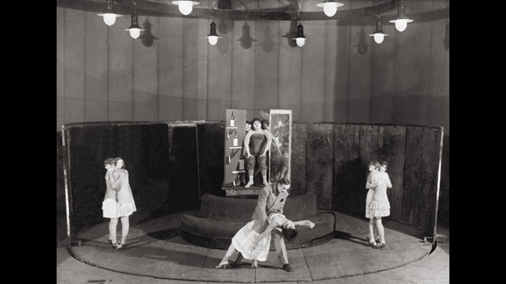View images from this item (1)
Usage terms © Imagno / Hulton Archive / Getty
Footnotes
[1] ‘Effect of the Innovations: A Threat to Opera?’, in Bertolt Brecht, Brecht on Theatre, trans. by John Willett (London: Methuen, 1964), p. 39.
[2] For accounts of epic theatre and Brecht more generally, see Sarah Bryant-Bertail, Space and Time in Epic Theatre (Rochester, NY: Camden House, 2000); John Willett, Brecht in Context (London: Methuen, 1984); Manfred Wekwerth, Daring to Play: A Brecht Companion (London: Routledge, 2011); Stephen Unwin, A Guide to the Plays of Bertolt Brecht (London: Methuen, 2005) and David Barnett: Brecht in Practice: Theatre, Theory and Performance (London: Methuen, 2015). Stephen Parker’s recent Bertolt Brecht: A Literary Life (London: Bloomsbury, 2014) is also excellent.
[3] Stanislavsky’s most famous delineation of his theory is in the work often called An Actor Prepares, translated more recently by Jean Benedetti as An Actor’s Work (London: Routledge, 2008).
[4] A brief online introduction to Piscator and his work (including images) is at: http://www.thedramateacher.com/erwin-piscator-multimedia-pioneer-for-the-theatre/. For more, see C. D. Innes, Erwin Piscator's Political Theatre: The Development of Modern German Drama (Cambridge: Cambridge University Press, 1972).
[5] The best short introduction to Brecht’s concept of epic theatre – a difficult and knotty subject – is by Peter Brooker, ‘Key Words in Brecht’s Theory and Practice of Theatre’, in The Cambridge Companion to Brecht, ed. by Peter Thomson and Glendyr Sacks (Cambridge: Cambridge University Press, 1994), pp. 185–200.
[6] Brecht on Theatre, p. 42.
[7] Brooker in Cambridge Companion, p. 79.
[8] ‘Theatre for Pleasure or Theatre for Instruction?’, in Brecht on Theatre, p. 71.
[9] A list of actors’ exercises based on Brecht’s work is listed on Laura White’s Brecht blog, and makes for fascinating reading. See: http://blogofbrecht.blogspot.co.uk/2012/11/gestus.html.
[10] Brecht on Theatre, pp. 22–23.
[11] The collected plays are published in a huge multi-part series of translations by Methuen; St Joan is vol. 3i.
[12] Michael Billington, ‘Bertolt Brecht: Irresistible Force or Forgotten Chapter in Theatrical History?’, The Guardian, 18 September 2013 [https://www.theguardian.com/stage/2013/sep/18/bertolt-brecht-arturo-ui-revival].

Banner: © ullstein bild via Getty Images

