Operations on 2-d array(multidimensional array)

Transpose of a matrix
The transpose of a matrix is the one whose rows are columns of the original matrix, i.e. if A and B are two matrices such that the rows of the matrix B are the columns of the matrix A then Matrix B is said to be the transpose of Matrix A.

Example 1
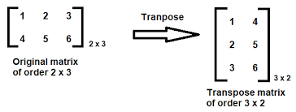
Example 2
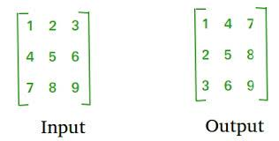

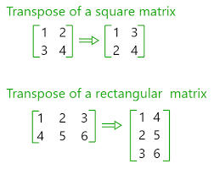
MATRIX ADDITION
Two matrices are obtained as input from the user. Addition of two matrices is possible only when both the matrices contain same number of rows and columns.
EXAMPLE 1
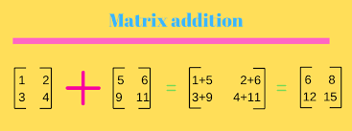

EXAMPLE 2
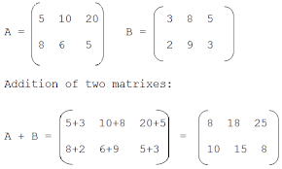
MATRIX MULTIPLICATION
When we do multiplication:
- The number of columns of the 1st matrix must equal the number of rows of the 2nd matrix.
- And the result will have the same number of rows as the 1st matrix, and the same number of columns as the 2nd matrix.

