The Greek Pantheon

Note: The Greek Gods were in essence a projection of human solipsism. They were at times representative of human attributes and displayed various human passions and emotions.
THE IMMORTALS of the Ancient Greek pantheon can be divided into roughly eight classes.
THE FIRST of these were the PROTOGENOI or First Born gods. These were the primeval beings who emerged at creation to form the very fabric of universe: Earth, Sea, Sky, Night, Day, etc. Although they were divinites they were purely elemental in form: Gaia was the literal Earth, Pontos the Sea, and Ouranos the Dome of Heaven. However they were sometimes represented assuming anthroporphic shape, albeit ones that were indivisible from their native element. Gaia the earth, for example, might manifest herself as a matronly woman half-risen from the ground ; and Thalassa the sea might lift her head above the waves in the shape of a sea-formed woman.
THE GODS
THE SECOND were the nature DAIMONES (Spirits) and NYMPHAI who nurtured life in the four elements. E.g. fresh-water Naiades, forest Dryades, beast-loving Satyroi, marine Tritones, etc.
THE THIRD were the body- and mind-affecting DAIMONES (Spirits). E.g. Sleep (Hypnos), Love (Eros), Joy (Euphrosyne), Hate (Eris), Fear (Phobos), Death (Thanatos), Old Age (Geras), etc.
THE FOURTH class consisted of the THEOI (Gods) who controlled the forces of nature and bestowed civilised arts upon mankind.
THE GODS
THEOI OURANIOI (Sky Gods). E.g. Helios (Sun), Anemoi (Winds), etc.
THEOI HALIOI (Sea Gods). E.g. The Nereides, Triton, Glaukos, etc.
THEOI KHTHONIOI (Underworld Gods). E.g. Persephone, Hekate, etc.
THEOI GEORGIKOI (Agricultural Earth Gods). E.g. Ploutos, etc.
THEOI NOMIOI (Pastoral Earth Gods). E.g. Pan, Aristaios, etc.
THEOI POLIKOI (City Gods). E.g. Hestia, Eunomia, etc.
THEOI OLYMPIOI (Olympian Gods). E.g. The Mousai, Hebe, etc.
THEOI TITANES (Titan Gods). E.g. Themis, Kronos, Prometheus, etc.
APOTHEOTHENAI (Deified Mortals). E.g. Herakles, Asklepios, etc.
THE FIFTH were the 12 OLYMPIAN GODS who governed the universe and commanded the legions of lesser gods and spirits. They were, namely, Zeus, Hera, Poseidon, Demeter, Artemis, Apollon, Ares, Athene, Aphrodite, Hephaistos, Hermes, Dionysos, and Hestia.
THE SIXTH of the immortals were the spirits of the CONSTELLATIONS which circed the heavenly night sky. Every constellation, including the twelve signs of the Zodiac, was possessed of one or more spirits EG Saggitarius was the centaur Kheiron, Gemini the Dioskouroi Twins, etc.
THE GODS
THE SEVENTH class consisted of the fabulous MONSTERS, BEASTS, GIANTS of myth. They were semi-divine creatures, closely related to the gods.E.g.GIGANTES (Giants), DRAKONES (Dragons), Kentauroi (Centaurs), Kerberos (Cerberus), Sphinx, Sirens, etc.
THE EIGHTH were the HEROI HEMITHEOI (Semi-Divine Heroes) who were worshipped after death as minor divinities. They included great heroes like Akhilleus, Theseus and Perseus; heroines such as Alkmene, Helene and Baubo; and founding kings like Erikhthonios, Kadmos and Pelops.
There were many divinities in the Greek pantheon who fell into more than one of these categories. Tykhe (Lady Fortune), for example, can easily be classified under category Two as an Okeanis Nymphe, Three as fortune personified, and Four as a popularly worshipped goddess.

(I) THE TWELVE OLYMPIAN GODS
The Greek Pantheon was ruled by a council of twelve great gods known as the Olympians, namely Zeus, Hera, Poseidon, Demeter, Athene, Hephaistos, Ares, Aphrodite, Apollon, Artemis, Hermes, Dionysos, and sometimes Hestia.
These twelve gods demanded worship from all their subjects. Those who failed to honour any one of the Twelve with due sacrifice and libation were duly punished.
Directly and through a host of divine minions the Twelve gods governed all aspects of human life.
ZEUS
ZEUS
Modern Spellings: Zeus (En, Fr, Es, It)
Roman Name: Jupiter, Jove
God of: King of Heaven, Sky, Weather, Fate, Kingship
Parents: Titan Kronos & Titanis Rhea
Spouse: Hera
Offspring: Athene, Apollon, Artemis, Ares, Aphrodite, Hermes, Dionysos, Herakles, others see pg 2 (below)
Animals: Golden eagle, Wolf
Plants: Oak, Celery
Iconography: Lightning bolt, Lotus staff, Eagle, Oak wreath
POSEIDON
POSEIDON
Modern Spell.: Poseidon (En), Poséidon (Fr), Poseidón (Es), Poseidone (It)
Roman Name: Neptunus (Neptune)
God of: King of the Seas, Rivers, Earthquakes, Horses
Parents: Titan Kronos & Titanis Rhea
Spouse: Amphitrite
Offspring: Triton, others see pg 2 (below)
Animals: Horse, Bull, Dolphin
Plants: Seaweed, Pine Tree
Iconography: Trident, Fish
HERA
HERA
Modern Spellings: Hera (En, Es), Héra (Fr), Era (It)
Roman Name: Juno
Goddess of: Queen of Heaven, the Sky, Women, Marriage, Impregnation
Parents: Titan Kronos & Titanis Rhea
Spouse: Zeus
Offspring: Ares, Hephaistos, Eileithyia, Hebe, others see pg 2 (below)
Animals: Cuckoo, Peacock, Crane, Hawk, Cow (Heifer), Lion
Plants: Chaste Tree, Pomegranate
Iconography: Lotus staff, Crown, Lion
DEMETER
DEMETER
Modern Spellings: Demeter (En), Déméter (Fr), Deméter (Es), Demetra (It)
Roman Name: Ceres
Goddess of: Agriculture, Grain & Bread, The Afterlife
Parents: Titan Kronos & Titanis Rhea
Spouse: None
Offspring: Persephone, Ploutos, others see pg 8 (below)
Animals: Serpent, Swine, Gecko
Plants: Wheat, Barley, Poppy, Mint
Iconography: Grain Sheaf, Lotus Staff, Torch, Cornucopia
APOLLON
APOLLON
Modern Spellings: Apollo (En, It), Apollon (Fr), Apolo (Es)
Roman Name: Apollo
God of: Music, Prophecy, Education, Healing & Disease
Parents: God Zeus and Titanis Leto
Spouse: None
Offspring: Asklepios, others see pg 2 (below)
Animals: Swan, Raven, Mouse, Wolf
Plants: Laurel, Larkspur
Iconography: Lyre, Laurel wreath or branch, Bow & arrows, Delphic tripod
ARTEMIS
ARTEMIS
Modern Spellings: Artemis (En), Artémis (Fr), Artemisa (Es), Artemide (It)
Roman Name: Diana
Goddess of: Hunting, Wild Animals, Children, Choirs, Disease
Parents: God Zeus & Titanis Leto
Spouse: None (Virgin Goddess)
Children: None (Virgin Goddess)
Animals: Deer, Bear, Wild boar, Guinea fowl, Quail
Plants: Cypress, Walnut, Amaranth-flower
Iconography: Bow & arrows, Hunting spears, Lyre, Deer
ATHENE
ATHENE
Modern Spellings: Athena (En), Athéna (Fr), Atenea (Es), Atena (It)
Roman Name: Minerva
Goddess of: Warcraft, Heroism, Counsel, Pottery, Weaving, Olives & Oil
Parents: God Zeus & Titanis Metis
Spouse: None (Virgin Goddess)
Offspring: None (Virgin Goddess)
Animals: Little Owl, Crow
Plants: Olive Tree
Iconography: Greek helmet, Aigis (Goat-skin breastplate), Spear
Images: Vase paintings see pg 1; statues pgs 2-5 (below)
ARES
ARES
Modern Spellings: Ares (En, Es, It), Arès (Fr)
Roman Name: Mars
God of: War, Battle, Manliness
Parents: God Zeus & Goddess Hera
Spouse: Perhaps Aphrodite
Offspring: Deimos, Phobos, others see pg 8 (below)
Animals: Serpent, Vulture, Woodpecker, Eagle-owl
Plants: Perhaps Manna Ash
Iconography: Helmet, Spear
APHRODITE
APHRODITE
Modern Spellings: Aphrodite (En, Fr), Afrodita (Es), Afrodite (It)
Roman Name: Venus
Goddess of: Love, Beauty, Pleasure, Procreation
Parents: God Zeus & Titanis Dione; or Born of the Sea-Foam
Spouse: Hephaistos, perhaps later Ares
Offspring: Eros, others see pg 10 (below)
Animals: Turtle dove, Sparrow, Goose, Hare
Plants: Apple Tree, Rose, Myrtle, Myrrh Tree, Anemone, Lettuce
Iconography: Eros (winged godling), Apple, Dove
HERMES
HERMES
Modern Spellings: Hermes (En, Es), Hermès (Fr), Ermes (It)
Roman Name: Mercurius (Mercury)
God of: Animal Husbandry, Travel, Trade, Athletics, Language, Thievery, Good Luck, Guide of the Dead, Herald of the Gods
Parents: God Zeus & Nymphe Maia
Spouse: None
Children: Pan, others see pg 9 (below)
Animals: Tortoise, Sheep, Cattle, Hawk
Plants: Crocus, Strawberry Tree
Iconography: Kerykeion (Herald's Rod), Traveller's Cap, Winged Bow
HEPHAISTOS
HEPHAISTOS
Modern Spell.: Hephaestus (En), Héphaïstos (Fr), Hefesto (Es), Efesto (It)
Roman Name: Vulcanus (Vulcan)
God of: Metalworking, Fire, Building, Scupture, Volcanism
Parents: Goddess Hera (no father)
Spouse: Aphrodite or Kharis
Offspring: See pg 6 (below)
Animals: Donkey, Crane
Plants: Fennel
Iconography: Hammer, Tongs, Anvil, Donkey, Crane-head
DIONYSOS
DIONYSOS
Modern Spellings: Dionysus (En, Fr), Dioniso (Es), Dionysio (It)
Roman Name: Liber, Bacchus
God of: Wine, Drunkenness, Madness, Parties, Vegetation, The Afterlife
Parents: God Zeus & Princess Semele
Spouse: Ariadne
Offspring: See pg 10 (below)
Animals: Leopard, Lynx, Tiger, Serpent, Bull, Goat, Donkey
Plants: Grape-vine, Ivy, Bindweed, Silver Fir
Iconography: Thyrsos (pine-cone tipped staff), Grapes, Ivy wreath, Leopard
Images: Vase paintings & mosaics pg 2; statues pgs 13-14 (below)
HESTIA
HESTIA
Modern Spellings: Hestia (En, Fr, Es), Estia (It)
Roman Name: Vesta
Goddess of: Home, Hearth, Family, Meals, Sacrificial offerings
Parents: Titan Kronos & Titanis Rhea
Spouse: None (Virgin Goddess)
Offspring: None (Virgin Goddess)
Animals: Swine
Plants: Chaste Tree
Iconography: Chaste tree branch, Head veil, Kettle

(II) KING & QUEEN OF THE DEAD
The thirteenth of the great gods was Haides, King of the Dead. Unlike the other 12, he was never titled Olympian, nor did he partake in the feasts of Heaven. Instead this lord remained ever enthroned within the gloom of the underworld.
HAIDES
HAIDES
Modern Spellings: Hades (En, Es), Hadès (Fr), Ade (It)
Roman Name: Pluto, Dis
God of: King of the Underworld, the Dead, Death
Parents: Titan Kronos & Titanis Rhea
Spouse: Persephone
Offspring: See pg 1 (below)
Animals: Screech owl
Plants: Asphodel, Mint, White Poplar
Iconography: Cornucopia, Bird-tipped staff
PERSEPHONE
PERSEPHONE
Modern Spellings: Persephone (En), Perséphone (Fr), Perséfone (Es),
Persefone (It)
Roman Name: Proserpina
Goddess of: Queen of the Underworld, the Afterlife, Spring Growth, Grain
Parents: God Zeus & Goddess Demeter
Spouse: Haides
Offspring: See pg 1 (below)
Animals: Screech owl
Plants: Wheat, Narcissus, Black Poplar, Mint, Asphodel
Iconography: Eleusinian torch or torches, Wheat

(III) OTHER IMPORTANT GODS
The other Gods and Spirits of the Pantheon fell within the sphere of one or more of the twelve great Olympians. They essentially functioned as minions and, servants of the greater gods.
The most important of these gods appear below.
HEKATE
HEKATE
Modern Spellings: Hecate (En), Hécate (Fr, Es), Ecate (It)
Roman Name: Hecate, Trivia
Goddess of: Witchcraft, Ghosts
Parents: Titan Perses & Titanis Asteria
Spouse: None (perhaps a Virgin Goddess)
Offspring: See pg 1 (below)
Plants: Herbs, Asphodel
Animals: Dog, Weasel, Polecat
Iconography: Twin torches, Triple body
THE 3 ERINYES (Furies)
THE ERINYES
Modern Spellings: Erinyes, Erinnyes (En, Fr), Erinias (Es), Erinni (It)
Roman Name: Furiae
Goddesses of: Punishment, Retribution
Parents: Protogenos Ouranos & Protogenos Gaia
Names: Alekto, Megaira, Tisiphone
Animals: Poisonous serpent, Screech owl
Plants: Elm, Yew
Iconography: Serpentine hair, Poison serpents, Wings, Whip
HELIOS
HELIOS
Modern Spellings: Helius (En), Hélios (Fr), Helios (Es), Elo (It)
Roman Name: Sol
God of: the Sun
Parents: Titan Helios & Titanis Thea
Spouse: Rhode
Offspring: Phaethon, others see pg 3 (below)
Animals: Rooster, White Horse
Plants: Heliotrope, Frankincense
Iconography: Aureole (sun crown)
GAIA
GAIA
Modern Spellings: Gaea (En), Gaia (Fr, Es), Gea (It)
Roman Name: Terra, Tellus
Goddess of: the Earth
Parents: None (Emerged at Creation)
Spouse: Ouranos
Offspring: Ouranos (Sky), Pontos (Sea), the Titanes, the Erinyes, the Kyklopes, the Hekatonkheires, the Gigantes, others see pg 1 (below)
Animals: -
Plants: -
Iconography: Half risen from earth1
RHEA
RHEA
Modern Spellings: Rhea (En, Fr), Rea (Es, It)
Roman Name: Ops
Goddess of: Mother of the Gods, Motherhood, Mountains
Parents: Protogenos Ouranos & Protogenos Gaia
Spouse: Kronos
Offspring: Zeus, Poseidon, Haides, Hera, Demeter, Hestia
Animals: Lion
Plants: Silver Fir
Iconography: Turret crown, Lions
THEMIS
THEMIS
Modern Spellings: Themis (En), Thémis (Fr), Temis (Es), Temi (It)
Roman Name: Themis
Goddess of: Custom, Order, Prophecy
Parents: Protogenos Ouranos & Protogenos Gaia
Spouse: Zeus
Offspring: Horai, Moirai, others see pg 1 (below)
Animals: -
Plants: -
Iconography: Delphic tripod
LETO
LETO
Modern Spellings: Leto (En, Es, It), Lètô (Fr)
Roman Name: Latona
Goddess of: Motherhood, Womanly Demure
Parents: Titan Koios & Titanis Phoibe
Spouse: None (consort of Zeus)
Offspring: Apollon, Artemis
Animals: Rooster, Weasel (Ichneumon)
Plants: Date Palm
Iconography: Head veil
PAN
PAN
Modern Spellings: Pan (En, Fr, Es, It)
Roman Name: Faunus
God of: Herds & Flocks, Mountain Wilderness
Parents: God Hermes & Nymphe Penelopeia
Spouse: Aix
Offspring: See pg 1 (below)
Animals: Goat, Sheep
Plants: Pine Tree, Reeds
Iconography: Pan-pipes, Goat legs, Horns
EILEITHYIA
EILEITHYIA
Modern Spellings: Ilithyia (En), Ilithye (Fr), Ilitía (Es), Ilizia (It)
Roman Name: Lucina
Goddess of: Childbirth, Pregnancy & Labour
Parents: God Zeus & Goddess Hera
Spouse: None
Offspring: See pg 1 (below)
Animals: Weasel (Ichneumon)
Plants: -
Iconography: Raised hands
1
EROS
EROS
Modern Spellings: Eros (En, Fr, Es, It)
Roman Name: Cupidus (Cupid), Amor
God of: Love, Sexual Desire
Parents: Goddess Aphrodite & (father variously named)
Spouse: Psykhe
Offspring: See pg 1 (below)
Animals: Hare
Plants: Apple, Rose, Myrtle
Iconography: Wings, Bow & arrows, Torch, Myrtle wreath
AMPHITRITE
AMPHITRITE
Modern Spellings: Amphitrite (En, Fr), Anfitrite (Es, It)
Roman Name: Salacia
Goddess of: Queen of the Sea, Sea Life (fish, shellfish, sea-mammals)
Parents: Sea-God Nereus & Nymphe Doris
Spouse: Poseidon
Offspring: Triton, others see pg 1 (below)
Animals: Dolphin, Fish, Seal
Plants: Seaweed
Iconography: Dolphin, Fish, Pinched fingers
ASKLEPIOS
ASKLEPIOS
Modern Spellings: Asclepius (En), Asclépios (Fr), Asclepio (Es, It)
Roman Name: Aesculapius
God of: Medicine, Healing
Parents: God Apollon & Princess Koronis
Spouse: Epione
Offspring: See pg 1 (below)
Animals: Serpent
Plants: Herbs (healing)
Iconography: Serpent-entwined staff
THE 9 MOUSAI (Muses)
THE MOUSAI
Modern Spellings: Muses (En, Fr), Musas (Es), Muse (It)
Roman Name: Musae
Goddesses of: Music, Song, Dancing, the Arts
Parents: God Zeus & Titanis Mnemosyne
Names: Kleio, Euterpe, Thaleia, Melpomene, Terpsikhore, Erato, Polyhymnia, Ourania, Kalliope
Animals: Dove
Plants: -
Iconography: Lyre (cithara & barbiton), Laurel wreath, Scroll-chest, Scroll
THE 3 KHARITES (Graces)
THE KHARITES
Modern Spellings: Charites (En, Fr), Cárites (Es), Carite (It)
Roman Name: Gratiae
Goddesses of: Joy, Mirth, Beauty, Adornment, Festivities, Dancing
Parents: God Zeus & Titanis Eurynome
Names: Aglaia, Euphrosyne, Thaleia
Animals: -
Plants: -
Iconography: Dancing circle
Images: Mosaics & frescoes
THE 3 HORAI (Seasons)
THE HORAI
Modern Spellings: Horae (En), Heures (Fr), Horas (Es), Ore (It)
Roman Name: Horae
Goddesses of: the Seasons, Law, Good Order, Peace
Parents: God Zeus & Titanis Themis
Names: Eirene, Dike, Eunomia
Animals: -
Plants: Fruit trees
Iconography: Branches of fruit & blossoms, Basket of fruit, Corn
THE 3 MOIRAI (Fates)
Modern Spellings: Moirae (En), Moires (Fr), Moras (Es), Moire (It)
Roman Name: Parcae
Goddesses of: Fate, Destiny
Parents: God Zeus & Titanis Themis
Names: Klotho, Lakhesis, Atropos
Offspring: None (Virgin goddesses)
Animals: -
Plants: -
Iconography: Spinning spool, Thread, Shears
HERAKLES THEOS
HERAKLES
Modern Spellings: Heracles (En, Es), Héraclès (Fr), Eracle (It)
Roman Name: Hercules
God of: Defender against Evil
Parents: God Zeus & Princess Alkmene
Spouse: Hebe
Offspring: Numerous mortal offspring
Animals: -
Plants: White Poplar
Iconography: Lion skin cape, Gnarled club

The Twelve Olympian in Details( In Alphabetical order)

1.Aphrodite

Aphrodite was the ancient Greek goddess of love, beauty, desire, and all aspects of sexuality. She could entice both gods and men into illicit affairs with her beauty and whispered sweet nothings. Born near Cyprus from the severed genitalia of the sky god Uranus, Aphrodite had a wider significance than the traditional view as a mere goddess of love.
Worshipped by men, women, and city-state officials, Aphrodite also played a role in the commerce, warfare, and politics of ancient Greek cities. In addition, Aphrodite was honoured as a protector of those who travelled by sea and, less surprisingly, courtesans and prostitutes. The goddess' Roman equivalent was Venus.

Birth from Uranus
In mythology, the goddess was born when Cronos castrated his father Uranus (Ouranos) with a sickle and cast the genitalia into the sea from where Aphrodite appeared amidst the resulting foam (aphros). In other versions, she is the daughter of Zeus and Dione, the Titaness. Hesiod recounts the first version and Homer the second, and the Greeks were troubled by such an obvious contradiction from their two great myth-makers. Indeed, Plato even came up with a theory to reconcile the two ancient authors, suggesting that there were actually two different goddesses of the same name, one to represent (in his view) the higher love between men and another to represent the love between men and women. Plato called these the 'Heavenly Aphrodite' and 'Pandemic Aphrodite' respectively.
APHRODITE WAS ESPECIALLY WORSHIPPED ON CYPRUS - A LOCATION WHICH HINTS AT HER EASTERN ORIGINS AS A FERTILITY GODDESS.
Believed to have been born close to Cyprus, Aphrodite was especially worshipped in Paphos on the island - a geographic location which hints at her eastern origins as a fertility goddess and possible evolution from the Phoenician goddess Astarte or the Near Eastern goddess Inanna (Ishtar). The two areas of Greece and the Near East witnessed intense cultural exchange prior to the 8th-century BCE Archaic Period, and it is perhaps significant that the 5th-century BCE Greek historian Herodotus states that the most ancient cult site to Aphrodite was at Ascalon in Syria. It is also possible that the goddess derived from an entirely local Cypriot deity. The strong association with the island is evidenced in her common name, Cypris, meaning 'of Cyprus'.
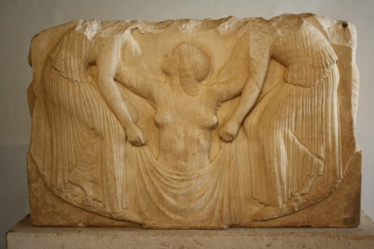
The Birth of Aphrodite
Mark Cartwright (CC BY-NC-SA)

More certain than her origins is that the goddess' birth and consequent association with the sea was manifested in the location of many coastal sanctuaries dedicated to her and several common epithets such as Aphrodite Pontia ('of the deep sea') and Aphrodite Euploia ('of the fair voyage'). Aphrodite was associated with the brightest planet, Venus, and this, always a valuable navigational aid, may be another connection with ancient mariners.
HEPHAISTOS, A FIENDISHLY CLEVER DESIGNER & ENGINEER, MANUFACTURED A SPECIAL GOLDEN BED TO ENTRAP HIS WIFE.

Hephaistos & Ares
Compelled by Hera to marry the not-so-great catch of Hephaistos, the lame god of fire and crafts, Aphrodite was less than faithful, having notorious affairs with the gods Ares, Hermes, and Dionysos. The fling with Ares was perhaps the most shocking of the many episodes of infidelity that occurred amongst the Olympian Gods. Hephaistos, a fiendishly clever designer and engineer, manufactured a special golden bed to entrap his wife. When Aphrodite and Ares were at their most passionate, the bed sprang forth golden chains which locked the naked gods in their illicit embrace. Their embarrassment was made worse when Helios the sun god shone down his bright light upon the couple so that all the Olympians could get a good look at the disgrace. When finally freed, Ares fled to Thrace and Aphrodite back to Cyprus.
Aphrodite was considered the mother of Eros, Harmonia (with Ares), the Trojan hero Aeneas (with Anchises), Eryx the king of Sicily (with Butes the Argonaut) and, with either Dionysos or Adonis, Priapus (a gardener with huge genitals). The goddess had a large retinue of lesser deities such as Hebe (goddess of youth), the Hours, Dike, Eirene, Themis, the Graces, Aglaia, Euphrosyne, Thaleia, Eunomia, Daidia, Eudaimonia, Himeros (Desire) and Peitho (Persuasion).
Aphrodite often represented unity and concord, as well as mixis or 'mingling', and this may explain the goddess' wide range of associations such as warfare and politics, arenas where disparate groups had to work together as one. She was specifically the protectress of city magistrates, too.

The Trojan War
In mythology, Aphrodite is cited as partly responsible for the Trojan War. At the wedding of Peleus and Thetis, Eris (goddess of strife) offered a golden apple for the most beautiful goddess. Hera, Athena, and Aphrodite vied for the honour, and Zeus appointed the Trojan prince Paris as judge. To influence his decision, Athena promised him strength and invincibility, Hera offered the regions of Asia and Europe, and Aphrodite offered the most beautiful woman in the world. Paris chose Aphrodite and so the victorious goddess gave him fair Helen of Sparta. However, as she was already the wife of Menelaos, Paris's abduction of Helen provoked the Spartan king to enlist the assistance of his brother Agamemnon and send an expedition to Troy to take back Helen.
Hesiod describes the goddess as 'quick-glancing', 'foam-born', 'smile-loving', and most often as 'golden Aphrodite'. Similarly, in Homer's description of the Trojan War in the Iliad, she is described as 'golden' and 'smiling' and supports the Trojans in the war. In notable episodes, Aphrodite protects her son Aeneas from Diomedes and saves the hapless Paris from the wrath of Menelaos.

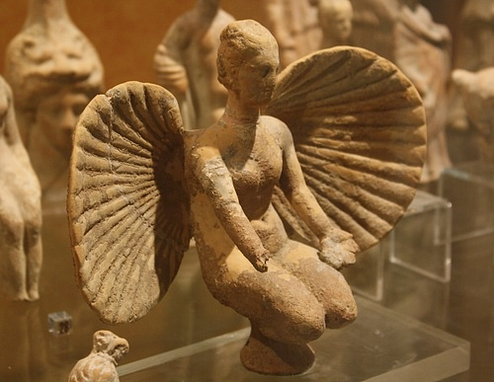
Terracotta Aphrodite, Brundisium
Mark Cartwright (CC BY-NC-SA)

2.Adonis
One of the goddess' most famous flings was with the beautiful Adonis. Aphrodite kept the youth safely in a chest guarded by Persephone, but the latter fell in love with him too and would not give him back to the goddess of love. Zeus was obliged to intervene, and he ruled that Adonis should spend four months of the year with each lady (and fourth months rest on his own). Tragically killed in a hunting accident, the impossibly handsome youth was transformed into a flower without scent. Aphrodite was distraught at her loss, and her grief was commemorated in a cult, the annual highlight of which was a women-only festival, the Adonia.

Representation in Art
The birth of Aphrodite from the sea (perhaps most famously depicted on the throne base of the great statue of Zeus at Olympia) and the judgment of Paris were popular subjects in ancient Greek art. The goddess is often identified with one or more of the following: a mirror, an apple, a myrtle wreath, a sacred bird or dove, a sceptre, and a flower. On occasion, she is also depicted riding a swan or goose. She is usually clothed in Archaic and Classical art and wears an elaborately embroidered band or girdle across her chest which held her magic powers of love, desire, and seductive allurement. It is only later (from the 4th century BCE) that she is depicted naked or semi-naked, such as in the Venus de Milo marble statue. The story of Aphrodite continued to interest artists, especially during the Renaissance, and she was perhaps most famously captured in Sandro Botticelli's 1486 painting the Birth of Venus, now in the Uffizi gallery of Florence.
3.Apollo
Apollo was a major Greek god associated with the bow, music, and divination. The epitome of youth and beauty, source of life and healing, patron of the arts, and as bright and powerful as the sun itself, Apollo was, arguably, the most loved of all the gods. He was worshipped at Delphi and Delos, amongst the most famous of all Greek religious sanctuaries.
Son of Zeus and Leto, and the twin brother of Artemis, Apollo was born on the island of Delos (in Hesiod's Theogony he is clutching a golden sword). His mother, fearful of revenge from Zeus' wife Hera, had chosen barren Delos as the safest retreat she could find. At his first taste of ambrosia, he was said to have immediately transformed from babe to man. Apollo was then given his bow, made by the master craftsman of Mount Olympus, Hephaestus.
As with the other major divinities, Apollo had many children; perhaps the most famous are Orpheus (who inherited his father's musical skills and became a virtuoso with the lyre or kithara), Asclepius (to whom he gave his knowledge of healing and medicine) and, according to the 5th-century BCE tragedian Euripides, the hero Ion.
APOLLO ACQUIRED HIS LYRE FROM HIS MISCHIEVOUS HALF-BROTHER HERMES, THE MESSENGER GOD.

In Mythology
Apollo is a significant protagonist in Homer's account of the Trojan War in the Iliad. On the side of the Trojans, he gives particular assistance to the Trojan heroes Hector, Aeneas, and Glaukos, saving their lives on more than one occasion with his divine intervention. He brought plague to the Achaeans, led the entire Trojan army (holding Zeus' fearsome aegis) in an attack which destroyed the defensive walls of the Greek camps, and was also responsible for guiding Paris' arrow to the heel of Achilles, killing the seemingly invincible Greek hero. Apollo is most frequently described by Homer and Hesiod as the 'far-shooter', the 'far-worker', the 'rouser of armies', and 'Phoebus Apollo'.
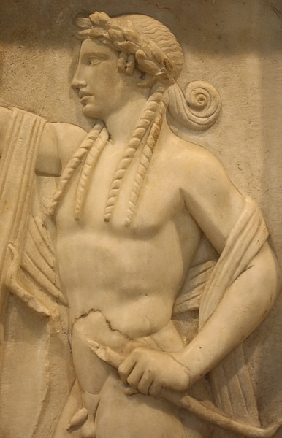
Apollo Marble Relief
Mark Cartwright (CC BY-NC-SA)

Apollo generally played the dutiful son to Zeus, father of the gods, and never attempted to usurp his position (unlike Zeus who had overthrown his own father Cronus). The pair did have a serious falling out when Zeus killed Asclepius after he had used his marvellous medicinal skills to bring a mortal back to life. In revenge, Apollo then killed the Cyclopes, the one-eyed giants who made Zeus' thunderbolts. As punishment, Apollo was obliged to spend a year in the humble service of Admetus of Therae, tending the king's sheep.
Apollo acquired his lyre from his mischievous half-brother Hermes, the messenger god. While still a baby, Hermes had stolen Apollo's sacred herd of cattle, cleverly reversing their hooves to make it difficult to follow their tracks. Hermes was permitted to keep his ill-gotten gains but only after he gave Apollo his lyre which he had invented using a tortoiseshell.
APOLLO'S MOST DIRECT PRESENCE AMONGST THE GREEKS WAS MANIFESTED IN HIS ORACLE AT DELPHI, THE MOST IMPORTANT IN THE GREEK WORLD.
Apollo's darker side as the bringer of plague and divine retribution is seen most famously when he is, with his sister Artemis, the remorseless slayer of Niobe's six (or in some accounts seven) sons as punishment for her boasting that her childbearing capacity was greater than Leto's. Another hapless victim of Apollo's wrath was the satyr Marsyas who unwisely claimed he was musically more gifted than the god. The pair had a competition and the Muses ruled that Apollo was indeed the better musician. Apollo then had the mortal flayed alive for his presumption and nailed his skin to a pine tree. The tale is an interesting metaphor for the competition between (at least to Greek ears) the civilised and ordered music of Apollo's lyre and the wilder, more chaotic music of Marsyas' flute. Apollo won another musical competition, this time against the pastoral god Pan and, judged the victor by King Midas, Apollo thus became the undisputed master of music in the Greek world. The god's defeat of Marsyas and Pan may reflect the Greek conquest of Phrygia and Arcadia respectively.
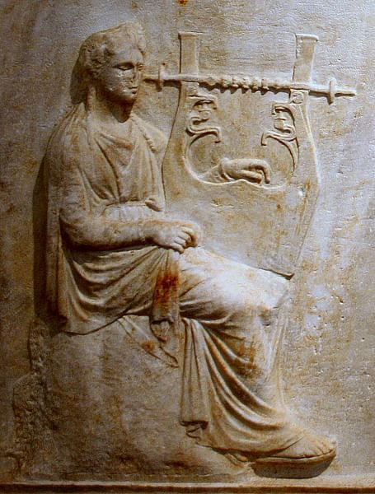
Apollo, detail from NAM, Athens, 215.
James Lloyd (CC BY-NC-SA)

Associations
Objects traditionally associated with the god include:
- a silver bow - symbolic of his prowess as an archer.
- a kithara (or lyre) - made from the shell of a tortoise, this was symbolic of Apollo's ability in music and his leadership of the chorus of the nine Muses.
- a laurel branch - symbolic of the fate of Daphne who, after Apollo's amorous pursuit of her, led her father, the river god Phineus, to transform her into a laurel tree.
- the omphalos - symbol of Apollo's sanctuary at Delphi as the navel of the world.
- a palm tree - which Leto gripped when she gave birth to her son.
Apollo was a much-loved god, and this was most likely due to his association with many positive aspects of the human condition such as music, poetry, purification, healing, and medicine. The god was also associated with moderation in all things. His arrows, although they could bring destruction could also ward off harm to those he favoured. A strategy to keep away evil from Greek homes was to set up a pillar of Apollo Agyieus and, on a grander scale, Apollo Propylaios protected city gates.
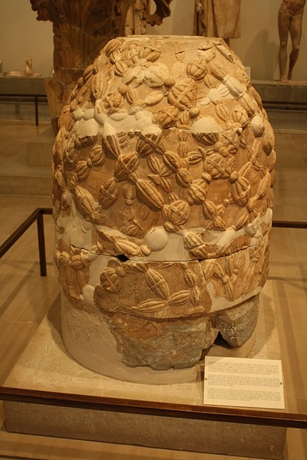
Omphalos of Delphi
Mark Cartwright (CC BY-NC-SA)

Apollo oversaw the initiation rites performed by young males (ephebes) as they entered the full civic community and became warriors. Rituals in this process involved cutting hair and offering it to the god, as well as athletic and martial challenges. The god is frequently associated with the sun (as Phoebus Apollo) and the sun god Helios, but modern scholars mostly agree that the link between Apollo and Helios does not go further back than the 5th century BCE. Apollo continued to inspire the Romans when he was principally considered a god of healing. Octavian, the future emperor Augustus (r. 27 BCE - 14 CE), famously claimed the god as his patron and even dedicated a temple to Apollo at Actium. The god of moderation was a useful association and in direct contrast to the god of excess, Dionysos, championed by Octavian's no. 1 enemy, Mark Antony.

Sacred Sites
Sanctuaries were built in honour of Apollo throughout the Greek world, notably at the islands of Delos and Rhodes and at Ptoion and Claros. Sites which still possess some vestiges of once-great temples dedicated to Apollo include those at Naxos (6th century BCE), where the massive doorway still stands proud, at Corinth (550-530 BCE), where seven Doric columns give an impression of a once impressive structure, at Didyma, Turkey (4th century BCE), whose temple was the fourth largest in the Greek world, and at Side, also in Turkey (2nd century CE) where a corner of its elegant columned facade has been restored.
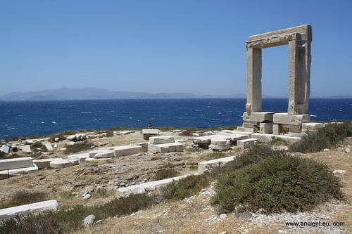
Temple of Apollo, Naxos
Mark Cartwright (CC BY-NC-SA)

Apollo's most direct presence amongst the Greeks, though, was manifested in his oracle at Delphi, which was consulted for its prophetic powers and which was the most important in the Greek world. According to legend, Apollo, wishing to reveal to humanity the intentions of his father Zeus, created the oracle on the site where he had killed the serpent (or dragon) Python. The Panhellenic Pythian games were begun at the site in order to commemorate the death of this divine creature. Tripods and laurel wreaths were given as prizes to the victors at these games. The 30 treasuries built at Delphi by various cities indicate the popularity of the god and the sanctuary in the wider Greek world such as in Asia Minor.
The oracle of Delphi was already well-visited in the 8th century BCE - despite being difficult to get to and open only in summer - and the sometimes cryptic proclamations of its priestesses were not taken lightly, often deciding how laws would be applied or whether a foreign war should be pursued. Sometimes the oracle's responses to questions were so obscure that priests at the site offered (for a fee) to give them greater clarity. As the historian B. Graziosi summarises,
Pilgrims often continued to ponder Apollo's responses, and consult further experts, back home. After that long process of consultation and interpretation, Apollo's revelations usually crystallised into lines of hexameter poetry, and were always found to be true - even if the correct interpretation sometimes emerged only after the relevant events had come to pass. (21)

Representation in Art
Apollo appears frequently in all media of ancient Greek art, most often as a beautiful, beardless youth. He is easily identified with either a kithara or a lyre, a bronze tripod (signifying his oracle at Delphi), a deer (which he often fights over with Hercules), and a bow and quiver. He is also, on occasion, portrayed riding a chariot pulled by lions or swans.
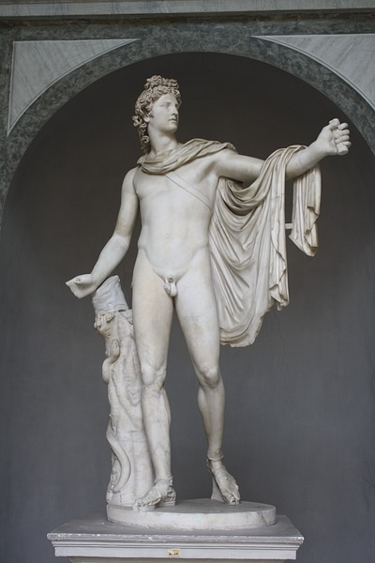
Belvedere Apollo
Mark Cartwright (CC BY-NC-SA)

Perhaps the most celebrated representation of Apollo in ancient Greek art is the statue which dominated the centre of the west pediment of the Temple of Zeus at Olympia (c. 460 BCE). Here, in a majestic pose, he brings order and reason to the battle between the Lapiths and the Centaurs at the wedding of Peirithoos. Another fine example of Apollo in his guise as a handsome youth, this time with long locks, is a 2nd-century CE marble relief from a funerary monument in Piraeus. The head of Apollo frequently appeared on Greek coins, notably on the silver tetradrachms of 5th-century BCE Catane (Catania) in Sicily and the gold staters of Philip II of Macedon (r. 359-356 BCE).
Roman sculptors were also fond of Apollo and a celebrated marble statue of the god, now in the Vatican Museums in Rome, is the Apollo Belvedere, a 2nd-century CE copy of a bronze statue of the 4th-century BCE by Leochares. Even the Etruscans were at it, perhaps one of their most famous sculptures in terracotta being the Apollo of Veii (late 6th century BCE), a striding figure of the god, known to them as Aplu, which once stood on the roof of a temple.

4.Ares
Ares was the Greek god of war and perhaps the most unpopular of all the Olympian gods because of his quick temper, aggressiveness, and unquenchable thirst for conflict. He famously seduced Aphrodite, unsuccessfully fought with Hercules, and enraged Poseidon by killing his son Halirrhothios. One of the more human Olympian gods, he was a popular subject in Greek art and even more so in Roman times when he took on a much more serious aspect as Mars, the Roman god of war.

Family Relations
Son of Zeus and Hera, Ares' sisters were Hebe and Eileithyia. Despite being a god, the Greeks considered him from Thrace, perhaps in an attempt to associate him with what they thought of as foreign and war-loving peoples, wholly different from themselves. Ares had various children with different partners, several of whom were unfortunate enough to come up against Hercules when he performed his celebrated twelve labours. Ares' daughter Hippolyta, the Amazon queen, lost her girdle to Hercules; his son Eurytion lost his cattle; and Diomedes had his horses stolen by the Greek hero. The courageous but warlike Amazons were also thought to be descendants of Ares.
In the Greek myths, Ares was noted for his beauty and courage, qualities which no doubt helped him win the affections of the Greek goddess Aphrodite (even though she was married to Hephaistos) with whom he had a daughter, Harmonia, and the god of love and desire Eros. Hephaistos managed to entrap the lovers in an ingenious bed, and the tale is told in some detail in Book 8 of Homer's Odyssey. Once caught, the punishment for Ares' indiscretion was temporary banishment from Mount Olympus.
'CITY-SACKING ARES' REPRESENTED THE MOST BRUTAL & BLOODY SIDE OF WARFARE.
Described by Hesiod in his Theogony as 'shield-piercing Ares' and 'city-sacking Ares,' the god represented the more brutal and bloody side of battle, which was in contrast to Athena who represented the more strategic elements of warfare. In stories from Greek mythology, Ares was usually to be found in the company of his other children with Aphrodite, Phobos (Fear) and Deimos (Terror), with his sister Eris (Strife), and with his charioteer Ennyo.

Battle with Hercules
The most popular myth involving Ares was his fight with Hercules. Ares' son Kyknos was infamous for waylaying pilgrims on their way to the oracle at Delphi, and so earned the displeasure of Apollo, who sent Hercules to deal with him. Hercules killed Kyknos, and a furious Ares engaged the hero in a fight. However, Hercules was protected from harm by Athena and even managed to wound Ares. Another myth and ignominious episode for Ares was his capture by the twin Giants Ephialtes and Otus when they stormed Mount Olympus. They imprisoned the god in a bronze jar (or cauldron) for one year and he was only freed through the intervention of Hermes.
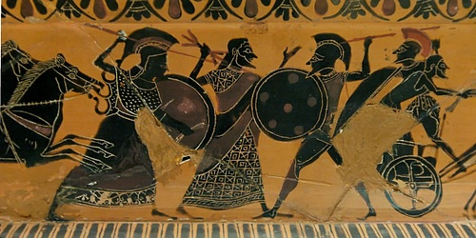
Scene from the Shield of Hercules
Jastrow (Public Domain)

The Trojan War
In Homer's version of the Trojan War in the Iliad, Ares supports the Trojans, sometimes even leading them in battle along with Hector. The Iliad shows Ares in a less than positive light and a rather unpopular member of the Greek pantheon. He is described as 'hateful Ares,' 'the man-killer,' 'the war-glutton,' and the 'curse of men.' Homer's picture of Ares, like the above mythological tales, often demonstrates his weakness in comparison to the other gods. Ares is roundly beaten by Athena who, supporting the Achaeans, knocks him out with a large rock. He also comes off worse against the Achaean hero Diomedes who even manages to injure the god with his spear, albeit with the help of Athena. Homer describes the scream of the wounded Ares as like the shouts of 10,000 men. Fleeing back to Olympus, Zeus ignores the complaints of Ares but instructs Paieon to heal his wound.

Athens & Cult
Ares again upset the harmony of Olympus when he was accused of killing Poseidon's son Halirrhothios near a stream below the Athenian acropolis. A special court was convened - the Areopagos - on a hill near the stream, to hear the case. Ares was acquitted as it was disclosed Halirrhothios had raped Ares' daughter Alcippe. Thereafter in Athens, the Areopagus became the place of trial for cases involving murder and impiety.
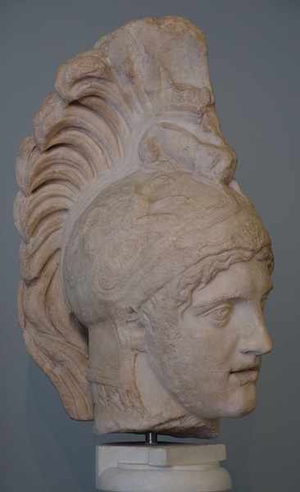
Ares Alkamenes
Carole Raddato (CC BY-SA)

Perhaps unsurprisingly, considering the city's strong militaristic culture, Ares was greatly esteemed in Sparta. Ares was not commonly worshipped but there were cult sites with temples dedicated to the god on Crete (he is mentioned in Linear B tablets from Knossos) and at Argos, Athens, Erythrae, Geronthrae, Megalopolis, Tegea, Therapne, and Troezen. He also had a cult in Thrace and was popular among the Colchians on the Black Sea.

Representation in Art
In ancient Greek Archaic and Classical art, Ares is most often depicted wearing full armour and helmet and carrying a shield and spear. In this respect, he may appear indistinguishable from any other armed warrior. Sometimes the Greek deity is shown riding his chariot pulled by fire-breathing horses. The myth of Ares' battle with Hercules was a popular subject for Attic vases in the 6th century BCE.
In later times, the Roman god Mars was given many of the attributes of Ares, although, as was typical of the Roman view of the gods, with less human qualities. In Roman mythology, Mars was also the father of Romulus and Remus (through the rape of the Vestal Virgin Rhea Silvia), the legendary founders of Rome, and, therefore, the city achieved a sacred status. Like Athena for Athens, Mars was also the patron god of the Roman capital and the month martius (March) was named after him.

5.Artemes
Artemis was the Greek goddess of hunting, wild nature, and chastity. Daughter of Zeus and sister of Apollo, Artemis was a patron of girls and young women and a protectress during childbirth. She was widely worshipped but her most famous cult site was the Temple of Artemis at Ephesus, one of the Seven Wonders of the Ancient World.
In Greek mythology, Artemis is the daughter of Zeus and Leto. Born either on Delos or Ortygia (near Ephesus in Western Turkey), she is the twin sister of the god Apollo. When she was three years old her father sat her on his lap and asked her what gifts she would like. Knowing her father's power, the young Artemis was not shy of asking and this was her reply (one gets the impression she had been thinking about this for a while):
Pray give me eternal virginity; as many names as my brother Apollo; a bow and arrow like his; the office of bringing light; a saffron hunting tunic with a red hem reaching to my knees; sixty young ocean nymphs, all of the same age, as my maids of honour; twenty river nymphs from Amnisus in Crete, to take care of my buskins [boots] and feed my hounds when I am not out shooting; all the mountains in the world; and, lastly, any city you care to choose for me, but one will be enough, because I intend to live on mountains most of the time.
(From Callimachus' Hymn to Artemis, quoted in Graves, 83)
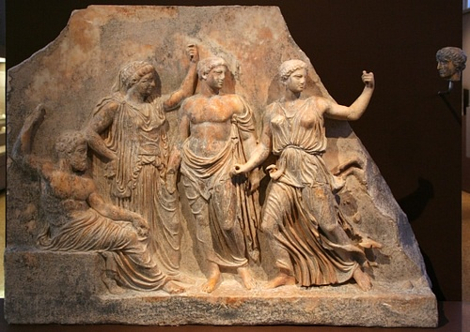
Zeus, Leto, Apollo & Artemis
Ophelia2 (Public Domain)

Given such gifts as a silver bow made by the Cyclopes and a pack of dogs as a hunting companion from Pan, Artemis was, then, regarded as a patron goddess of hunting and wild nature and a mistress of the animals. For this reason, she is associated with wild animals like the deer and boar (especially young ones), forests, and the moon. As a goddess of chastity, childbirth, and fertility, Artemis Kourotrophos was the patron of young women, particularly brides-to-be, who dedicated their toys to her as symbolic of the transition to full adulthood and the assumption of a wife's responsibilities. Finally, the goddess, as a dweller of wild nature, was linked to boundaries and transition, both in physical terms and the abstract. For this reason, perhaps, the temples dedicated to Artemis were often built either on the margins of human settlements or at places where the land changes such as marshes or at water junctions.
THE GODDESS IS SAID TO HAVE KILLED THE HUNTER ORION AFTER HIS ATTEMPTED RAPE OF EITHER ARTEMIS HERSELF OR ONE OF HER FOLLOWERS.

In Mythology
Artemis plays only a minor role in the Trojan War of Homer's Iliad and is described most often as 'the archer goddess' but also on occasion as the 'goddess of the loud hunt' and 'of the wild, mistress of wild creatures'. Supporting the Trojans, she notably heals Aeneas after he is wounded by Diomedes. Hesiod in his Theogony most often describes her as 'arrow-shooting Artemis.'
A notable episode at the start of the Trojan War which involves the goddess is the saving of Iphigenia, daughter of Agamemnon. The king had displeased the goddess by killing one of her deer in a sacred grove. As punishment, Artemis becalmed the Achaean fleet and only the sacrifice of Iphigenia would appease the goddess into granting a fair wind to Troy. Agamemnon duly offered his daughter in sacrifice, but in pity and at the last moment, the goddess substituted a deer for the girl and made Iphigenia a priestess at her sanctuary at Tauris.
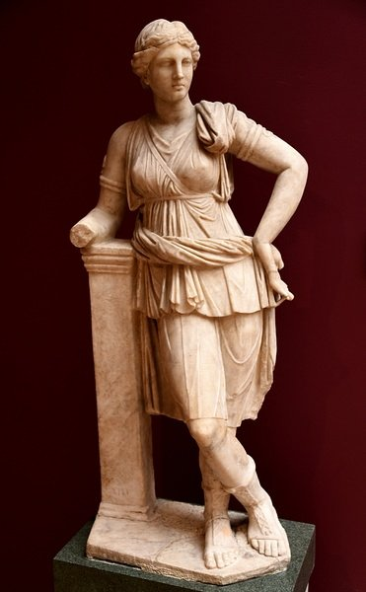
Statue of Artemis from Mytilene
Osama Shukir Muhammed Amin (CC BY-NC-SA)

Other accounts of Artemis, however, display her in a far less charitable light. She is said to have killed the hunter Orion after his attempted rape of either Artemis herself or one of her followers. Artemis turned Callisto, one of the goddess' entourage, into a bear after she had lain with Zeus, who then turned her and her son Arcas into the constellations the great and little bear (though not before Arcas had founded the race of Arcadians). The goddess uses her bow to mercilessly kill the six (or in some accounts seven) daughters of Niobe following her boast that her childbearing capacity was greater than Leto's. The hunter Actaion, after he dared boast he was the greater hunter or, in another version, had spied on Artemis while she had bathed in a forest pool, was turned into a stag by the goddess. Actaion was then torn to pieces by his own pack of 50 hunting dogs. Finally, Artemis sent a huge boar to ravage Kalydon after the city had neglected to sacrifice to the goddess. An all-star hunting party of heroes which included Theseus, Jason, the Dioskouroi, Atalanta, and Meleager was organised to hunt and sacrifice the boar in Artemis' honour. After a lengthy expedition, Atalanta and Meleager do finally succeed in killing the boar.
A CELEBRATED MARBLE REPRESENTATION OF THE GODDESS IS ON THE EAST FRIEZE OF THE PARTHENON WHERE SHE IS SEATED BETWEEN APOLLO & APHRODITE.

Temple of Artemis at Ephesus
As a deity of fertility, Artemis Ephesia was particularly revered at Ephesus, near to what many believed was her birthplace, Ortygia. Here, her cult included eastern elements (borrowed from goddesses such as Isis, Cybele, and the “Mistress of the Animals”) and her principal symbols were the bee, date-palm, and stag. The famous temple of Artemis at the city (begun c. 550 BCE) was almost twice the size of Athens' Parthenon when it was finally finished after a century of labour; it was regarded as one of the Seven Wonders of the Ancient World. The temple boasted 127 columns, and the architrave blocks above them were so heavy, weighing some 24 tons each, that the Ephesians credited Artemis herself with having helped in the construction. Inside the temple was a giant cult statue of the goddess made of cedar-wood. Today all that remains of the temple are its foundations and a rather sad single column which has been erected from composite remains.
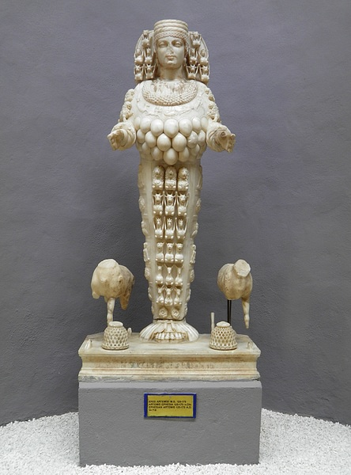
Artemis of Ephesus
Carole Raddato (CC BY-SA)

Other Places of Worship
Other notable places of worship of Artemis were the sanctuaries at Brauron, Tauris, Magnesia, Perge, and on the island of Delos, where the goddess was born in some myth versions and where she assisted the birth of her brother Apollo. At Brauron, on the east coast of Attica, a temple site and sacred spring was in use from the 8th to 3rd century BCE and hosted rites of passage for young girls and brides-to-be. It is not clear what the rites actually involved but painted pottery vessels used for libations at the site do show young girls running and dancing. In Sardis, Lydia (western Turkey) there was the fourth largest Ionic Greek temple ever built set up in Artemis' honour around 300 BCE and then renovated by the Romans in the 2nd century CE who knew Artemis as Diana. At Sparta and Athens (after the Battle of Marathon of 490 BCE), Artemis was worshipped as Artemis Agrotera and regarded as a goddess of battle, a goat being sacrificed to her before an engagement by the Spartans and an annual 500 offered to the goddess by the Athenians.

Depictions in Art
Artemis is most frequently portrayed in ancient Greek art as a beautiful maiden huntress with quiver and bow or, alternatively, a spear. She is often accompanied by a deer, stag, or a hunting dog, and on occasion, she wears a feline skin. Early representations also emphasise her role as goddess of animals and show her winged with a bird or animal in each hand. For example, on the handles of the celebrated Francois vase (570-565 BCE), she holds a panther and stag in one depiction and lions in another. In later Attic red- and black-figure vases she is also often depicted holding a torch.
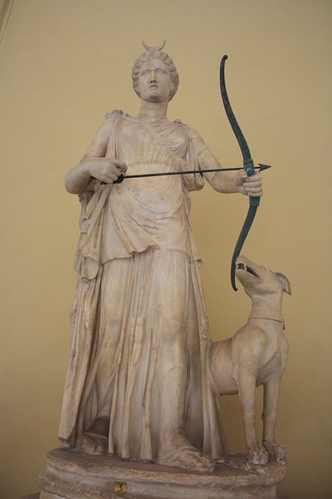
Artemis
Mark Cartwright (CC BY-NC-SA)

A celebrated marble representation of the goddess is on the east frieze of the Parthenon where she is seated between Apollo and Aphrodite with Eros (c. 440 BCE). The goddess is pulling up her robe to better cover herself, perhaps in reference to her reputation for chastity. A later and perhaps today more famous representation is as a huntress impressively grasping the antlers of a stag, a pose captured in marble by a Roman sculptor copying a lost Greek original attributed to Leochares (c. 325 BCE). Known as the Diane de Versailles, it is now on display in the Louvre Museum, Paris.
Artemis continued to interest the Romans, and there is a fine 2nd-century CE marble statue of the goddess with bow at the ready and hunting dog at her feet in the Vatican Museums, Rome. The goddess has a crescent moon on her head, reminding of her long association with that celestial body. Finally, Artemis' association with fertility, which was particularly prevalent at Ephesus, is best seen in a marble figurine from that city which has the goddess covered in what appear to be small eggs and animals. Dating to 125-175 CE, it is now on display in the Archaeological Museum of Selcuk, Turkey.

6.Athena
Goddess of wisdom, war and the crafts, and favourite daughter of Zeus, Athena was, perhaps, the wisest, most courageous, and certainly the most resourceful of the Olympian gods.
Zeus was told that his son would take his throne from him, just as he had taken power from his father Cronus. Accordingly, when Metis was pregnant, he swallowed her and Athena was born from Zeus' head, wearing armour and fully grown. A popular theme in ancient Greek art, Hephaistos is often depicted in the role of midwife, splitting Zeus' head with an axe. Athena is often cited as Zeus' favourite child.
Epithets of Athena include Pallas (girl) and Parthenos (virgin), living up to which, she is conspicuous amongst the gods of Greek mythology for not indulging in illicit relationships with other divinities, demigods, or mortals. Other epithets were Promachos (of war) - perhaps referring to more patriotic, defensive, and strategic warfare, rather than attacking warfare, in contrast to her more aggressive, conflict-loving brother Ares, Ergane (of the crafts), and Nike (victory). Nevertheless, the goddess was noted for her military prowess.
ATHENA WAS NOT TO BE TRIFLED WITH AS HER TRANSFORMATION OF MEDUSA INTO A GORGON DEMONSTRATES.
The goddess was not to be trifled with as her transformation of Medusa into a Gorgon demonstrates, and her sense of justice was such that acts of impiety were swiftly avenged, as with the Achaean heroes following their capture of Troy and desecration of the goddess' sanctuary.
Athena is also the patron goddess of household crafts, giving mortals the gifts of cooking and sewing. She is said to have invented the aulos but on seeing her reflection and her puffed cheeks when playing these pipes, she threw them away, to be picked up by the satyr Marsyas.
She is closely associated with Athens, the city named in her honour after the people of Attica chose her as their patron following her gift of the olive tree, symbol of peace and plenty. The 5th century BCE temple of the Parthenon, which continues to this day to dominate the acropolis of the city, was built in her honour. Her adopted son Erichthonios, one of the first kings of Athens, is traditionally credited with inaugurating the Panathenaic festival, held every four years to honour the goddess. The festival included a magnificent procession through the city, the presentation to Athena of a specially woven peplos (depicting the Gigantomachy), and athletic games. Prizes for the games were amphorae painted with a figure of Athena and contained prime olive oil. In her role as protector, she was also revered in many other major cities, notably as patron of Sparta, as the founder of Thebes in Boeotia, and at Corinth where she appeared on the city's coins.
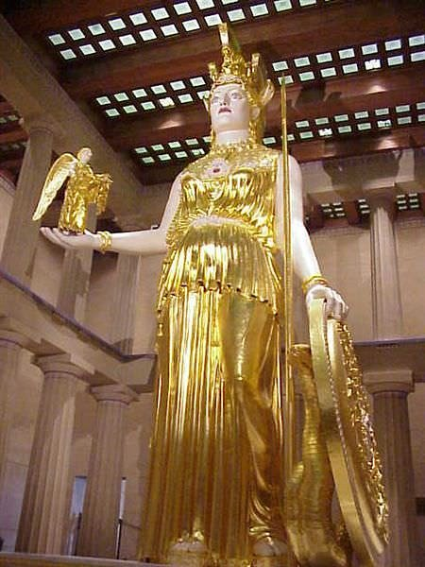
Athena Parthenos Reconstruction
Mary Harrsch (Photographed at the Nashville Parthenon, Tennessee) (CC BY-NC-SA)

In the Greek myths, she is the protector of Hercules and Athena often aids him in his twelve labours, for example, by helping him hold the world as Atlas searches for the sacred apples of the Hesperides. Perseus was another favourite and was given a shield to protect himself in his quest to kill Medusa. Achilles is helped to kill Hector, and Odysseus too was often given the benefit of Athena's wisdom, for example the idea to dress as a beggar on his return to Ithaca, and he is also protected from the arrows of his rivals when he clears the palace of the interlopers. Jason was yet another hero who benefitted from Athena's resourcefulness when she encouraged Argo to build the first Greek longship which would carry his name and the fame of the Argonauts.
Athena was a major protagonist in Homer's account of the Trojan War in the Iliad where she supports the Achaeans and their heroes, especially Achilles, to whom she gives encouragement and wise counsel, Menelaos, who is saved from the arrow of Pandaros, and Diomedes, whose spear, in one notable episode, is diverted to injure Ares himself. Aphrodite was another divinity who came off second best when she clashed with Athena. She also gave protection to Odysseus and is credited with giving him the idea of the Wooden Horse. Both Homer and Hesiod refer to Athena as 'bright-eyed' and 'Tritogeneia'. She is also frequently called 'goddess of spoil', the 'lovely-haired goddess', and 'Alalkomenaian Athena'.
Objects associated with the goddess include an owl - symbol of wisdom - and the olive tree. She is often depicted in art with armour, a golden helmet, a shield, and holding a spear. Her armour is the aegis made, in some accounts, from the skin of a Giant, hung with tassels of gold, and featuring the head of the Gorgon given to her by Perseus. The most famous representation of Athena in the ancient world was undoubtedly the monumental gold and ivory statue of the goddess by Pheidias which resided in the Parthenon of Athens and was over 12 m high. The statue has been lost but survives in the form of smaller Roman copies and shows Athena standing majestic, fully armed, holding Nike in her right hand and with a shield in her left depicting scenes from the Battles of the Amazons and the Giants. On her helmet were a sphinx and two griffins. Celebrated surviving depictions of Athena include friezes from the Parthenon and metopes from the temple of Zeus at Olympia.

7.Demeter

Demeter was one of the oldest gods in the ancient Greek pantheon. As a goddess of agriculture, she guaranteed the fertility of the earth and protected both farming and vegetation. This close connection with the earth was inherited from her mother Rhea. Demeter was probably a reincarnation of local mother Earth goddesses, commonly worshipped in rural communities in Bronze Age Greece.
The sanctuary at Eleusis is dedicated to both the goddess and her daughter Persephone. This was the location of the famous Eleusinian Mysteries. From Eleusis, the idea spread across the Archaic and Classical Greek worlds that Demeter would protect her worshippers in the afterlife. To the Romans, the goddess remained popular and was known as Ceres.

Demeter's Family
Daughter of Kronos and Rhea, sister of Zeus, Poseidon, Hades, Hera, and Hestia, Demeter was the mother of Persephone and Iacchus (both with Zeus) and Pluto, the god of wealth (with the mortal Cretan Iasion, who was subsequently killed by a thunderbolt from a jealous Zeus). She also adopted Demophon, the Eleusinian prince, who gave the human race the gifts of the plough and knowledge of agriculture. Demeter was also pursued by Poseidon, and to escape his attentions, she changed into a mare; however, Poseidon too changed into a horse and their resulting offspring was Arion, the winged horse ridden by Hercules. Demeter and Persephone were very often paired together and sometimes even referred to as a single goddess with a dual aspect. The duo was often referred to as 'the Two Goddesses' and the Demeteres (two Demeters).
THE STORY OF DEMETER & PERSEPHONE WAS PERHAPS SYMBOLIC OF THE CHANGING SEASONS & THE PERENNIAL CHANGE FROM LIFE TO DEATH.

Demeter & Persephone
The most important mythology surrounding Demeter was the story of the rape of her daughter Persephone (also known as Kore in Greek and Proserpina by the Romans) by Hades, the god of the Underworld. One day Hades fell in love with Persephone as soon as he saw her and so carried her off in his chariot to live with him in Hades, the Greek underworld. In some accounts, Zeus had given his consent to the abduction, the location of the crime being traditionally placed in either Sicily (famed for its fertility) or Asia. Distraught, Demeter searched the earth for her lost daughter and though Helios (or Hermes) told her of her daughter's fate, she, nevertheless, continued her wanderings until she finally arrived at Eleusis. It was here, disguised as an old woman, that the goddess cared for Demophon (or Triptolemus), the only son of Metaneira, the wife of Keleos (or Celeus), king of Eleusis. To reward the family for their kindness, Demeter set about making Demophon immortal by placing him on a fire every night. However, when Metaneira saw this she raised an alarm. In response, Demeter revealed her true identity and demanded a temple be built in her honour. This was the beginning of the celebrated sanctuary of Eleusis in Attica (see below).
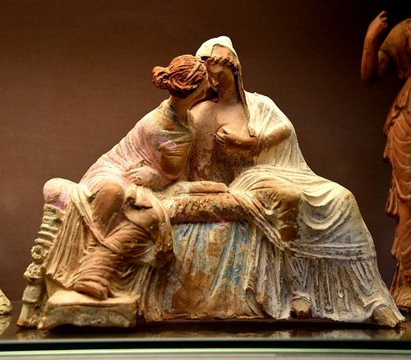
Demeter & Persephone
Osama Shukir Muhammed Amin (CC BY-NC-SA)

Once the temple was completed, Demeter withdrew from the world and lived inside it; at the same time, she created a great drought to convince the other gods to release Persephone from Hades. As the drought claimed ever more victims, crops withered (illustrating Persephone's mastery over agriculture), and there was so little food that mortals could not even offer their sacrifices to the gods, Zeus finally persuaded Hades to release his ill-gotten bride. Before giving her up though, the wily Hades put a pomegranate kernel in the girl's mouth, knowing its divine taste would compel her to return to him. In other versions of the myth, Persephone could have been released if she had not eaten anything in the underworld during her captivity, but at the last moment, Hades gave her a pomegranate seed. Finally, as a compromise, it was decided that Persephone would be released but that she would have to return to Hades for one-third of the year (or in other accounts one half). In gratitude for the return of her daughter, Demeter was said to have sent the prince Demophon to teach humanity the cultivation of grain and other tricks useful for agriculture.

Eleusis & the Eleusinian Mysteries
The story of Demeter and Persephone was perhaps symbolic of the changing seasons and the perennial change from life to death, to life once more, or, in other words, the changes from summer to winter and the return of life in spring. An alternative view of more modern historians is that the disappearance of Peresphone is symbolic of the practice of burying seeds in the summer so that they did not dry out before they could be sown in the autumn. The cycle became one of the rituals of the sacred Eleusinian Mysteries; indeed the symbols of the cult were ears of grain and a torch - symbolic of Demeter's search for Persephone and a reminder that the rituals at Eleusis were carried out at night.
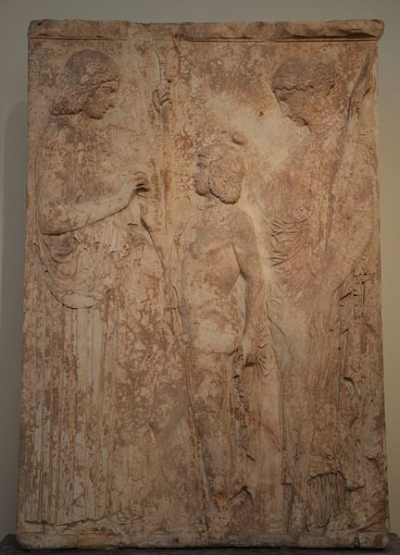
Eleusinian votive relief
Carole Raddato (CC BY-SA)

Eleusis became the most important sanctuary to Demeter, and the site has a religious connection and related monuments dating back to the Mycenaean civilization of the 15th century BCE. From c. 600 BCE the Eleusinian Mysteries became an official ceremony in the Athenian calendar, and Eleusis became a truly pan-Hellenic site under the Athenian dictator Peisistratus (r. 550-510 BCE). In the 5th century BCE Pericles, the Athenian statesman (l. 495-429 BCE), oversaw the construction of a new Telesterion (Initiation Hall and temple), then the largest building in Greece. The site continued to attract pilgrims and worshippers well into Roman times with emperors Hadrian (r. 117-138 CE) and Marcus Aurelius (r. 161-180 CE) aggrandising Eleusis. The sanctuary's fortunes declined significantly following the decree of Theodosius I (r. 379-395 CE) to close down all pagan sites in 379 CE, and Eleusis was destroyed around 395 CE following the invasion of the Visigoths.
THE PRECISE DETAILS OF THE ELEUSINIAN MYSTERIES HAVE TO THIS DAY REMAINED JUST THAT, A MYSTERY.
Unfortunately for us today, because all initiates were bound by a sacred oath not to reveal details of the Eleusinian Mysteries, they have to this day remained just that, a mystery. We do know that, from the 6th century BCE, the ceremonies were held twice a year. The first step in the initiation process was known as the "Lesser Mysteries" and held every spring. The more important "Great Mysteries" were held in the autumn over nine days. Only Greeks could be initiated, although this was later expanded to include Roman citizens. We also know details of some of the outdoor activities, and there was a procession led by the priestess of Demeter along the Sacred Way from Eleusis to the agora of Athens and another return procession led by a symbolic chariot of Iacchus. There were ritual and communal cleansing and purification ceremonies carried out in the sea at Phaleron, the representation or re-enactment of the myths involving the two goddesses, animal sacrifices (pigs), and the interpretation of sacred texts by priests, the mystagōgoi. There was also probably drinking, music, dancing, and general revelry involved, as attested by Greek pottery scenes of the rites which show initiates holding the "bacchus" or sacred rod. Closely associated with fertility and agriculture, the mysteries probably brought worshippers good fortune and, perhaps most important for most participants, the promise of a better afterlife.

Other Places of Worship
Demeter had sanctuaries across the Greek world in most city-states. Homer mentions that the goddess had a precinct named after her at Pyrasos. From the 8th century BCE there was a particularly noted sanctuary and temple to Demeter on Naxos. In the 4th century BCE, a temple was constructed in her honour at Dion. Other notable sites of worship included Andania in Messenia, Lykosoura in Arcadia, and, perhaps most curiously, at Phigaleia, also in Arcadia, where a cult statue of the goddess was placed in a cave which had a horse's head, probably in reference to Demeter's amorous encounter with Poseidon. Many southern Italian city-states, especially in Sicily, had important cults to Demeter where she was often associated with civic duties, a link also seen in her worship at Thebes.
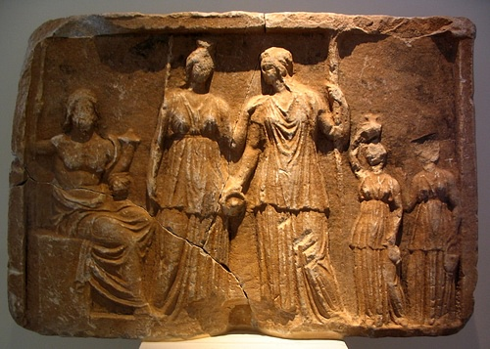
Persephone, Demeter, & Pluto Marble Plaque, Tegea.
Dan Diffendale (CC BY-NC-SA)

Besides the mystery cult, at Eleusis during the Archaic and Classical periods there was the Eleusinia, an important biannual games where the prizes were sacred grain. The Thesmophoria, meanwhile, was an all-female autumn festival in Attica to honour Demeter. Designed to generally promote fertility, the festival saw pigs thrown into pits or caves and left to putrefy; their remains were then mixed with seeds before sowing. Although not particularly informative about the festival itself, Aristophanes (c. 460 - c. 380 BCE), the master of Greek comedy, wrote the play Thesmophoriazusae (411 BCE) where, during the festival, women take advantage of the traditional exclusion of men and debate the elimination of Euripides (c. 484-407 BCE), one of the great writers of Greek tragedy. There was, too, the Haloa, another largely all-female winter festival in honour of Demeter and Dionysos, the Kalamaia, and the Proerosia festivals.

Demeter in Art
In ancient literature, Homer in The Iliad describes the goddess as 'golden-haired', and Hesiod in his Theogony and Works & Days, describes her as 'bounteous Demeter', 'well-garlanded', 'hallowed', and 'reverend'. Demeter rarely appears in the visual arts before the 6th century BCE and then she is usually shown with Persephone. In Archaic and Classical art she is often seated, wears a crown of grain and holds a torch (signifying her search for her lost daughter) or a sceptre, a poppy (the flower that grows so abundantly in untended wheat fields) or simply stalks of grain. In her role as a goddess of fertility, Demeter is also sometimes present in scenes depicting the birth of Athena. From Eleusis, there are surviving relief panels showing both Demeter and Persephone which once adorned the sacred buildings at this her most important sacred site.

8.Dionysos
Dionysos (Roman name: Bacchus, also known as Dionysus) was the ancient Greek god of wine, merriment, and theatre. Being the bad boy of Mt. Olympus, he was perhaps the most colourful of the Olympian Gods.
In Greek mythology, despite being the son of Zeus and Semele (the daughter of Kadmos and Harmonia), Dionysos did not receive the best start in life when his mother died while still pregnant. Hera, wife of Zeus, was jealous of her husband's illicit affair and craftily persuaded Semele to ask Zeus to reveal himself to her in all his godly splendour. This was too much for the mortal and she immediately expired; however, Zeus took the unborn child and reared him in his thigh. Most accounts then attribute the satyrs and nymphs as the carers of Dionysos in his childhood and the wise Silenus as his chief educator on Mt. Nysa, far from Hera's wrath.
HOMER DESCRIBES THE GOD AS THE 'JOY OF MEN', AND HESIOD LIKEWISE DESCRIBES HIM AS 'MUCH-CHEERING'.
Homer describes the god as the 'joy of men', and Hesiod likewise describes him as 'much-cheering'. This is no doubt because Dionysos is credited with giving man the gift of wine. The god gave Ikarios, a noble citizen of Ikaria in Attica, the vine tree. From this, Ikarios made wine which he shared with a group of passing shepherds. However, unaware of the stupefying effects of wine, the shepherds thought they had been poisoned and so swiftly took revenge and killed the unfortunate Ikarios. Notwithstanding this inauspicious start to the wine industry, wine became an extremely popular drink in antiquity. The Greeks usually drank wine diluted with water (one part wine to three parts water), mixed in a large krater vessel. Wine was drunk at banquets, festivals, and private parties, in particular, at a symposium, a kind of informal, male-only drinking session where guests reclined on a couch (kline) and engaged in conversation on topics ranging from gossip to philosophy.
In Greek mythology, Dionysos travelled widely, even as far as India, and spread his cult throughout Greece, indeed he was known as being of an eastern origin himself. Orgiastic rituals were held in his honour, where the participants were taken over by a Dionysian frenzy of dancing and merriment to such a degree that they transcended themselves. It is believed that theatre sprang from this activity as, like Dionysos' worshippers, actors strive to leave behind their own persona and become one with the character they are playing. Indeed, priests of Dionysos were given seats of honour in Greek theatres.
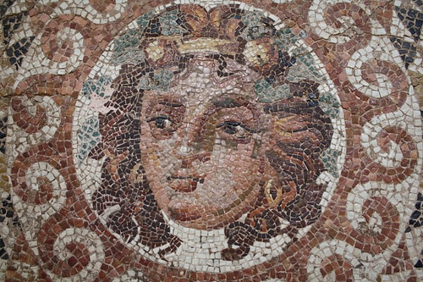
Dionysos Mosaic [Detail]
Mark Cartwright (CC BY-NC-SA)

Dionysos was a protagonist in several other Greek myths. When King Midas of Phrygia found the god's chief follower and drinking partner Silenus rather worse for wear in his garden following a drinking bout, the king gave him nourishment and returned him to Dionysos. In gratitude, the god granted Midas a wish. The king requested that everything he touched would turn to gold but alas this included food and water, so the king almost died of starvation and thirst until Dionysos reversed the gift by telling Midas to wash in the Pactolus river.
Another myth tells of Dionysos' abduction by pirates who were unaware of his identity. The god transformed the ship's mast into a huge vine, the sails dripped with wine, and a heavenly choir filled the air with music. Dionysos transformed himself into a lion and, assisted by a bear, he dispatched the pirate captain. In terror, the remaining crew members leapt overboard and were changed into dolphins. Only the helmsman survived the encounter as he had counselled his crewmates against abducting the stranger in the first place, and the boat sailed on to Naxos where the god remained for a while, falling in love with and marrying Ariadne when Theseus stopped off on his return from killing the Minotaur. When Ariadne died, in her memory Dionysos made her wedding diadem into the Corona constellation.
Other myths include Dionysos persuading Hephaistos (probably with wine) to return to Mt. Olympus and release Hera who had been trapped by the god of metallurgy in an ingenious throne. Hera in her gratitude ensured that Dionysos, actually only a demigod, became a full Olympian god with permission to reside on Mt. Olympus for all time. Lycurgus, King of Thrace, and Pentheus, King of Thebes, both suffered Dionysos' wrath when they prudishly tried to stop the excesses of the god's festivals. The former was driven mad and the latter was ripped to pieces by a maddened group of female worshippers after he had disguised himself as a woman to spy on their debauchery.
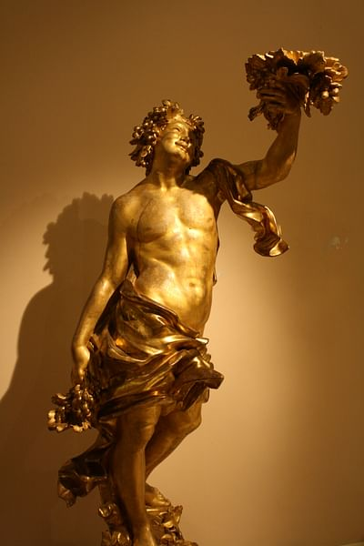
Gold Bacchus Statue
Mark Cartwright (CC BY-NC-SA)

The cult of Dionysos became a significant part of the Greek religion in Athens from the 6th century BCE and the Dionysia festival of Athens and other cities would later evolve into the Bacchanalia of Rome. The island of Naxos was a particularly important sanctuary to the god. There is evidence of a cult to Dionysos dating from the Mycenaean period (14th century BCE) and the site continued to be important right into the Roman period. There was also a sanctuary and theatre of Dionysos at Athens and a temple to the god at Dion (2nd century CE) which also had Mycenaean origins.
In Archaic and Classical Greek art, Dionysos is a popular subject and is often depicted with his thiasos or troupe of satyrs (half-men, half-goat) and nymphs, who from the late 6th century BCE were replaced by maenads, daemonic creatures, who when overtaken by Dionysian frenzy, hunted the forests for victims and ate their raw flesh. The god is usually bearded in 4th- and 5th-century BCE depictions and later on more often beardless. He is often identified through his association with the vine, thyrsos - a sacred rod topped with ivy and vine leaves and sometimes a pinecone, a kantharos - drinking vessel for wine - or a drinking-horn, and on occasion, he wears a wreath of ivy or the pelt of a panther. He often cuts a rather effeminate figure and is sometimes shown riding an ithyphallic mule or in a languid, reclining pose such as the celebrated sculpture on the east pediment of the Parthenon (447-432 BCE). Another famous representation is as an infant in the arms of the Hermes of Praxiteles (ca 330 BCE). Coins from Naxos and Mende depicted the god from the 6th to 4th century BCE, and in the 5th century BCE, he appeared on the coins of Crete, Thebes, and Thasos. Dionysos also plays a central role in Euripides' Greek tragedy, The Bacchae, which is set in Thebes.

9.Hephaistos
Ancient Greek god of fire, metallurgy, and crafts, Hephaistos (Hephaestus) was the brilliant blacksmith of the Olympian gods, for whom he fashioned magnificent houses, armour, and ingenious devices. Hephaistos had his workshop beneath volcanos - Mount Etna on Sicily being a favourite haunt - and was, with his lame foot, unique as the only less-than-perfect god. To the Romans, he was known as Vulcan or Volcanus.

Origins & Family
The origins of Hephaistos are obscure but he probably derives from the common idea that early kings should also be masters at certain crafts, especially metalwork, and perhaps, too, magic (which would have included the manipulation of fire). In Classical Greek mythology, the god was born from Hera and, without a father, Hephaistos was, unlike the other gods, a less than beautiful figure. So much so, that in Greek mythology he is said to have been thrown from the heavens by his mother (or in other accounts by Zeus) because of his ugliness and on landing on the island of Lemnos, the god was crippled. Cared for by Thetis (and possibly also by Eurynome, the daughter of Ocean), he would construct his workshop on the island's volcano where he lived in an imperishable bright bronze house, where he created his masterpieces of metallurgy.
AS AN INGENIOUS CRAFTSMAN, HEPHAISTOS IS CREDITED WITH MAKING THE SCEPTRE & AEGIS OF ZEUS, THE HELMET OF HERMES & EVEN THE LOVELY FIRST WOMAN, PANDORA.
The god's physical problems may have been a reflection in myth of the reality of a blacksmith's harsh working conditions where repeated hammering and toxic fumes can take their toll on both mind and body. The famed expert on Greek myths, Robert Graves, has another theory and points out that in many ancient tribes of both West Africa and Scandinavia, the village blacksmith, a particularly important and revered member of the community, was often deliberately made lame so that he could not easily offer his services to a rival village.
Returning to mythology, Hephaistos married the goddess Aphrodite. The unlikely union occurred as a result of Hephaistos capturing his mother Hera in the invisible chains of a throne he had built, and the wedding was the price of release. The scene is a popular one in Greek art and usually depicts Dionysos leading Hephaistos, under the influence of wine, back to Olympus to free the entrapped Hera. However, the marriage was not to last as Aphrodite had numerous affairs, most notably with the god Ares, although the two were caught red-handed. The whole story is told in some detail by the bard Demodocus in Book 8 of Homer's Odyssey. Hephaistos, one day informed by Helios, spied the lovers for himself and so decided to capture them next time they made misuse of his bed by designing an ingenious and invisible net of chains around it. The amorous couple, sure enough, became entwined in the golden trap, and Hephaistos then called all the Olympian gods to witness the spectacle. Roars of laughter rang around the heights of Olympus and, when finally released, Ares fled to Thrace and Aphrodite to Paphos, Cyprus.
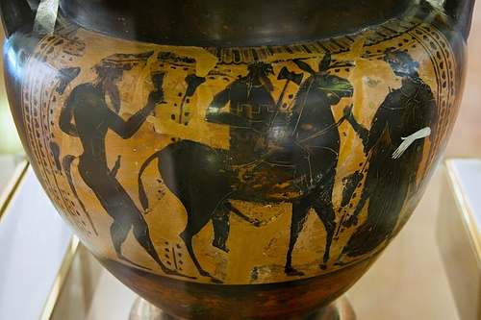
Hephaistos Riding a Mule
Zde (CC BY-SA)

Hephaistos' most notable offspring in Greek mythology were Erechtheus, the first king of Athens, and Periphetes, who lived near Epidaurus and famously killed passing strangers with an iron club. In Attic mythology, Hephaistos once tried to rape Athena but the goddess repelled him. The semen which splashed on her leg was wiped off, landed on earth and gave birth to the Athenians. Hephaistos also lent his name to one of the traditional tribes of Attica. Finally, to assist the god in his workshop, Hephaistos had a team of giant cyclops.

Skills & Associations
As an ingenious craftsman, Hephaistos is credited with making the sceptre and aegis of Zeus, the helmet of Hermes, secret locking doors for Hera's chambers, and even the lovely first woman, Pandora, who he sculpted out of clay. He also manufactured automatons - gold maids who could speak and were intelligent - for himself, bronze Talos as a gift for King Minos of Crete, and watchdogs for Alcinous, king of Phaeacia. The god even acted as midwife at the birth of Athena, splitting Zeus' head with his axe so that the goddess might be born from there.
Both Homer and Hesiod describe Hephaistos as 'the cripple-foot god' and 'the lame one'. Supporting the Achaeans in the Trojan War, he memorably fights and defeats the river god Xanthos with fire and produces magnificent armour and a shield of bronze, gold, silver, and tin for Achilles, the latter being decorated with a multitude of scenes and described at great length by Homer.
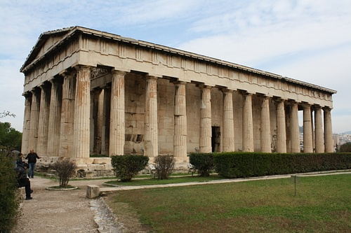
Temple of Hephaistos & Athena, Athens
Mark Cartwright (CC BY-NC-SA)

Worship & Sacred Sites
Hephaistos was particularly worshipped at Athens and Lemnos in the northeast Aegean. Athens had a celebrated temple jointly dedicated to god and Athena (also a patron god of crafts and their exponents); still standing on a rise in the now excavated ancient Agora, it is one of the best-preserved temples in the Greek world. The Doric temple built c. 449 BCE and sometimes known as the Hephaisteion or Thesium has 13 columns on the long sides and six at the facades. The temple originally contained large bronze statues of Athena and Hephaistos. According to Sophocles, blacksmiths would march through the city carrying their tools during the annual Chalkeia festival which honoured the pair of gods. The even more spectacular Hephaestia festival was held in Athens only once every five years and involved torchlight parades and extravagant sacrifices to honour Athena and Hephaistos.
IN GREEK ART, THE GOD OFTEN HOLDS TONGS, AN AXE, HAMMER, SAW, OR CHISEL & IS FREQUENTLY SEEN RIDING A MULE SIDE-SADDLE.
At Lemnos, meanwhile, where, as we have seen, the god was thrown to earth in some accounts, Hephaistos gave his name to the city of Hephaistia, which had a sanctuary dedicated to him. Certain landmarks on the island were linked to the god and his craft such as the bay at Mudros (meaning 'mass of molten metal'). Even the earth of the island was exported in antiquity as people believed it had qualities as both a cure and poison. Other sites where Hephaistos was revered and often associated with naturally-occurring fires included Caria and Lycia. Agrigento on Sicily once had an important temple dedicated to the god (c. 430 BCE), although there are today few remains of it. Finally, as the god was thought to have his workshop beneath volcanos he was linked to many, but especially Mount Aetna (Etna) on Sicily.

Representation in Art
In ancient Greek art, Hephaistos is often depicted wearing a pilos or workman's hat and an exomis or workman's tunic. He also often holds tongs, an axe, hammer, saw, or chisel, and is frequently seen riding a mule side-saddle. The latter depiction is in reference to his lameness which, curiously, is rarely explicitly portrayed in Greek art. In a few Attic vases the god's feet are shown pointing backwards. He is a prominent figure on the east pediment of the Parthenon (447-432 BCE) where the scene of Athena's birth is shown. This mythological subject was also popular on Attic pottery where Hephaistos, with his axe, splits the head of Zeus from where Athena is born. The east frieze of the Parthenon shows all the gods of Olympus in a row watching the city's Panathenaic procession with Athena and Hephaistos, the two patrons of the crafts, sat next to each other chatting.

10.Hera

Hera (Roman name: Juno) is the wife of Zeus and queen of the ancient Greek gods. She represented the ideal woman, was the goddess of marriage and the family, and protectress of women in childbirth. Although always faithful herself, Hera was most famous for her jealous and vengeful nature, principally aimed against the lovers of her husband and their illegitimate chldren.

Family Relations
In Greek mythology, Hera was the daughter of Cronus and Rhea, and mother of Ares (god of war), Hebe (goddess of youth), and Eileithyia (goddess of childbirth), all with Zeus. Hera also gave birth alone to Hephaistos (god of metallurgy) in retaliation for Zeus' similarly single-handed birth of Athena. However, Hera threw Hephaistos from Mount Olympus because of his ugliness, and crashing to earth, the god became lame. In other accounts, Hephaistos was thrown from the heavens by Zeus precisely because of his lameness. In any case, Hephaistos held a grudge against his mother and even imprisoned her in a special throne. Hera was only released from the device by promising her son the hand of Aphrodite in marriage.

The Infidelities of Zeus
HERA CONSTANTLY BATTLED WITH HER HUSBAND ZEUS' INFIDELITY AND SHE OFTEN TOOK SWIFT REVENGE.
Hera constantly battled with her husband's infidelity and she often took swift revenge. Leto was so punished through Hera promising to curse any land that gave the pregnant goddess refuge. Only after months of wanderings could Leto find a place (Delos) to give birth to her son, the god Apollo. Even then, Hera had her daughter Eileithyia prolong the labour to nine months.
In various versions, a very popular myth involved Hera, Zeus, and Io. In some accounts, the queen of the gods turned Io, who was one her own priestesses and a former princess of Argos, into a cow to deter Zeus' advances, but in other versions, it was Zeus who turned the girl into a white cow, either to secretly rendezvous with her or to persuade Hera that he was not really interested in Io. However, Hera discovered their courting, took custody of the cow. and set the one- hundred-eyed Argos to guard her. Zeus then employed Hermes to lull Argos to sleep and kill him. In memory, Hera then set his 100 eyes on the wings of a bird - the peacock. Finally, not to be outdone, the Greek goddess sent a gadfly to continually pester the unfortunate Io.
Other victims of Hera's jealousy were Semele, who was tricked by Hera into asking Zeus to reveal himself in all his godly splendour and the sight immediately destroyed her. Callisto was another of Zeus' lovers who caught the wrath of Hera as she was turned into a bear and hunted by Artemis. Zeus, in pity, later made her into a constellation, the Bear.
Hera went to great lengths to revenge herself for Zeus' infidelity with Alkmene, principally focussing her wrath on their son Hercules. Hera delayed his birth so that his cousin Eurystheus could claim the throne of Tiryns, sent two snakes to kill the infant while he slept, caused the hero to become mad and kill his own wife and children, and had Eurystheus set the hero his twelve labours, which being so dangerous, she hoped they would be fatal. She also set the Hydra of Lerna against the inhabitants of Hercules' home town and set the Amazons against the hero when he went in search of the girdle of Hippolyta. Hera was also responsible for some of the fierce monsters Hercules had to fight - the lion which terrorized Nemea and the Ladon dragon which protected the goddess' sacred apple trees, a wedding gift from Gaia. Another pan-Hellenic hero though, who did receive Hera's favour, was Jason, of the Golden Fleece fame. The hero had helped the goddess unknowingly when she was disguised as an old woman and wanted to cross a dangerous river, and she promised to be always at hand in any hour of need.
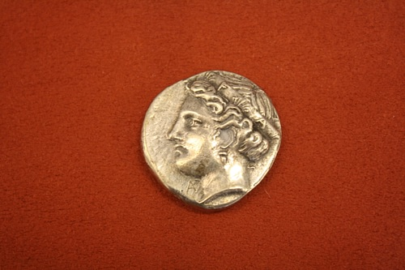
Elis Silver Stater
Mark Cartwright (CC BY-NC-SA)

Finally, two more victims of the queen of gods were Ixion, who was tied to an ever-spinning wheel down in Hades as punishment for his attempted seduction of Hera, and Tityos, who was punished for the same indiscretion by being chained to a rock and having his liver eaten daily by a vulture.

The Trojan War
Hera was a major protagonist in the story of the Trojan War as told in Homer's Iliad. The goddess supports the Achaeans and frequently schemes with other deities to bring the downfall of Troy, as she never forgave the Trojan prince Paris for choosing Aphrodite above her as the most beautiful goddess. In the Iliad, Hera mentions three cities particularly dear to her - Argos, Sparta, and Mycenae (or Mykene). We are also told that as a child she was raised by Ocean and Tethys whilst Zeus battled with Cronos. Homer most often describes Hera as 'white-armed', 'ox-eyed', and 'Hera of Argos'. Hesiod, in his Theogony, similarly describes Hera as: 'of Argos' and more frequently as 'golden-sandaled'.

Sacred Sites
Hera was a major figure in the Greek religion. She was the patron of Argos, which possessed a sanctuary to the goddess from the mid-8th century BCE. She also had a temple dedicated to her at Olympia (650-600 BCE), and Tiryns was an important cult centre to the goddess in the 7th century BCE. The island of Samos, in some accounts the birthplace of the goddess, had been a centre for cult worship of the Greek goddess as far back as the Mycenaean period in the mid-2nd millennium BCE, and a major centre was created from the 8th century BCE which prospered right into the Roman period. Hera was greatly esteemed at Elis, where coins depicted the goddess in the 5th and 4th century BCE. Across Greece, sporting competitions for women, the Heraia, were held in Hera's honour, as were annual marriage festivals (hierogamy) when couples re-enacted the marriage of Zeus and Hera.
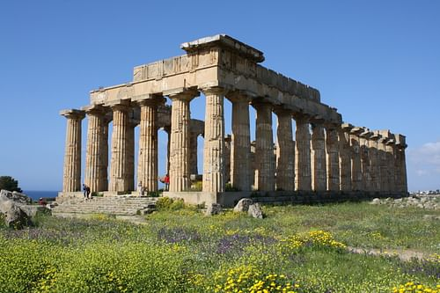
Temple of Hera, Selinus
Mark Cartwright (CC BY-NC-SA)

Representation in Art
As one of the most important deities, Hera was, naturally, a prominent figure in ancient Greek art, particularly on Attic red- and black-figure pottery. However, without any specific attributes she is often hard to distinguish from other goddesses. She is most often seated on a throne and sometimes wears a crown (polos), holds a royal sceptre, and wears a bridal veil. On occasion she is also depicted holding a pomegranate, a traditional symbol of fertility. Other associations include the peacock - symbol of pride - and the cuckoo, the form Zeus first took when he courted Hera - both of which the goddess reportedly kept as pets on Mount Olympus - and finally, with the lily flower.

Hera as Roman Juno
In Roman culture the goddess lived on as Juno, although she principally represented the good family and faithful marriage attributes of Hera rather than the jealous avenger of infidelity. Juno was one of the most important Roman gods along with Jupiter and Minerva; indeed she was also the patron of Rome itself. The annual Matronalia was a festival held in her honour in June, the month which carried her name and the period regarded as the most auspicious time to get married in Roman culture.
RELATED CONTENT BOOKS CITE THIS WORK LICENSE

11.Hermes

Hermes was the ancient Greek god of trade, wealth, luck, fertility, animal husbandry, sleep, language, thieves, and travel. One of the cleverest and most mischievous of the Olympian gods, he was the patron of shepherds, invented the lyre, and was, above all, the herald and messenger of Mt. Olympus so that he came to symbolise the crossing of boundaries in his role as a guide between the two realms of gods and humanity. To the Romans, the god was known as Mercury.

Origins & Family
Hermes has a very long history, being mentioned in the Linear B tablets of the Mycenaean civilization, at its height from the 15th to 13th century BCE. Such tablets have been discovered at Pylos, Thebes, and Knossos. With origins, then, as an Arcadian fertility god who had a special love for the Peloponnese, the ancient Greeks believed Hermes was the son of Zeus and the nymph Maia (daughter of the Titan Atlas) and that he was born on Mt. Cyllene in Arcadia. In mythology, Hermes was also the father of the pastoral god Pan and Eudoros (with Polymele), one of the leaders of the Myrmidons, although the god was not given a wife in any Greek myth. The idea that Hermes represented movement is reflected in his role as the leader of both the Nymphs and Graces (Charites).
HERMES WAS KNOWN AS SOMETHING OF A TRICKSTER, STEALING AT ONE TIME OR ANOTHER POSEIDON'S TRIDENT, ARTEMIS' ARROWS & APHRODITE'S GIRDLE.

Hermes & the Gods
Noted for his impish character and constant search for amusement, Hermes was one of the more colourful gods in Greek mythology. While still a baby, he stole his half-brother Apollo's herd of 50 sacred cattle from Pieria, cleverly reversing their hoofmarks by adding bark shoes to make it difficult to follow their tracks. Hermes, therefore, became associated with thieves and he managed to keep the stolen herd of cattle until the satyrs finally discovered it in a cave in Arcadia. After a hearing before Zeus and the Olympian gods, Hermes was permitted to hold on to the herd (now down to 48 as he had already sacrificed two of them) if he gave Apollo his lyre. The episode illustrates the god's link with both physical and moral boundaries and crossing them, and may have a basis in historical events, as here described by the famed expert on Greek mythology Robert Graves:
A tradition of cattle raids made by the crafty Messenians on their neighbours, and of a treaty by which these were discontinued, seems to have been mythologically combined with an account of how the barbarous Hellenes took over and exploited, in the name of their adopted god Apollo, the Creto-Helladic civilizations which they found in Central and Southern Greece. (66)
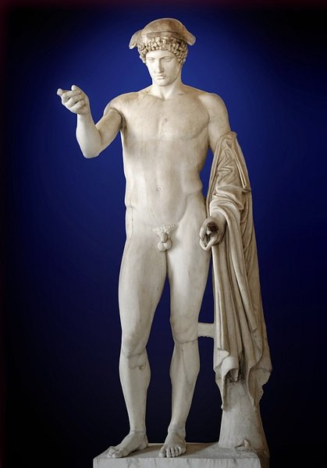
Hermes Ludovisi
Marie-Lan Nguyen (CC BY-SA)

As messenger and herald, particularly for Zeus, Hermes is involved in many mythological episodes. Perhaps most celebrated was his killing of the many-eyed (some accounts say 100-eyed) monster Argos on the orders of Zeus in order to free Io. Hermes also freed Ares from his year-long imprisonment in a cauldron by the twin Giants Otus and Ephialtes. One of his most famous regular roles was as a leader of souls to the river Styx in the underworld, where the boatman Charon would take them to Hades. Hermes was also known as something of a trickster, stealing at one time or another Poseidon's trident, Artemis' arrows, and Aphrodite's girdle.
FAMOUS FOR HIS DIPLOMATIC SKILLS, HERMES WAS REGARDED AS THE PATRON OF LANGUAGES & RHETORIC.

Hermes & the Heroes
Hermes figures in the Trojan War of the Mycenaean period, as told by Homer in the Iliad. Although in one lengthy passage he acts as counsellor and guide to the Trojan King Priam in his attempt to reclaim the body of his fallen son Hector, Hermes actually supports the Achaeans in the Trojan War. The god is most often described by Homer as 'Hermes the guide, slayer of Argos' and 'Hermes the kindly'. Hermes gives particular help to Odysseus, especially on his long return voyage to Ithaca (as told in Homer's Odyssey), for example, giving him an antidote to the spells of Circe. Another hero helped by the god was Perseus, Hermes giving him an unbreakable sword or sickle (harpe) of adamantine and guiding him to the three Graeae who would reveal the location of Medusa.

Inventions & Associations
Hermes was credited with inventing fire, the alphabet, dice (actually knucklebones) - and so he was worshipped by gamblers in his capacity as god of luck and wealth, and musical instruments, in particular, the lyre - made from a tortoiseshell by the god. Hermes was regarded as the patron of thieves and shepherds thanks to his invention of the pan pipes (syrinx). He was the patron of travellers, and stone pillars (hermae) with a phallus symbol were often to be seen set up along roadsides to act as guides and offer good fortune to those who passed. Hermae were particularly set up at boundaries, reminding of the god's role as a messenger between the gods and humanity, as well as his function as a guide for the dead into the next life. In addition, Hermes was regarded as the patron of the home, and people often built small marble stelai in front of their doors in his honour.
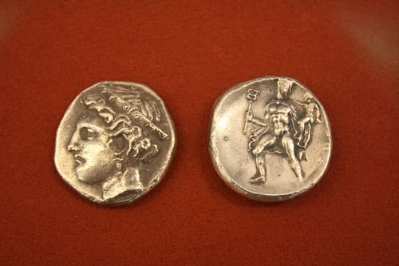
Pheneos Silver Stater
Mark Cartwright (Copyright)

Famous for his diplomatic skills, he was also regarded as the patron of languages and rhetoric. Orators regarded the god who transferred words from sender to receiver as their patron, as did interpreters (another group of boundary-crossers) and, even today, the study and interpretation of texts carries his name: hermeneutics. In the Hellenistic period, the god was often associated with gymnasia and seen as the protector of youths. Finally, the god's Latin name, Mercury, is, of course, the name of a planet, naturally, the fastest one to orbit the sun.

Cults to the God
Hermes was honoured just about everywhere in ancietn Greece but especially in the Peloponnese at Mt. Cyllene and such city-states as Megalopolis, Corinth and Argos. Athens had one of the oldest cults to the god where the Hermaia festival for young boys was held annually. Delos, Tanagra, and the Cyclades were other places where Hermes was especially popular. Finally, the god had a noted sanctuary on Crete at Kato Symi where young men about to become full citizens engaged in a two-month-long rite where they spent time cultivating homosexual relations with older men in the mountains thereabouts. Another Hermaia festival on Crete permitted slaves to temporarily take the part of their masters. Once again, Hermes' association with crossing boundaries of all kinds is evident here.
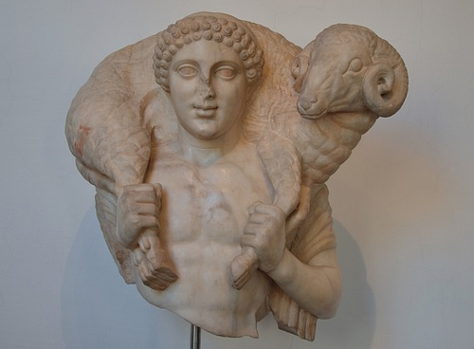
Hermes Kriophoros
Carole Raddato (CC BY-NC-SA)

Representation in Art
In ancient Greek Archaic and Classical art, Hermes is depicted holding the kerykeion or caduceus staff (signifying his role as a herald, the stick is either cleft or with an open figure of 8 at the top), wearing winged sandals (symbolic of his role as a messenger), a long tunic or leopard skin, sometimes also a winged cap (petasos), and occasionally with a lyre. He may also carry a ram in a nod to his role as patron of shepherds, especially in Boeotian and Arcadian art. In his association with youths, the god was often portrayed as abeardless youth holding the infant Hercules or Achilles. At the same time, his association with trade is evidenced in the seals of Delos where he carries a purse. Perhaps the most celebrated depiction of Hermes in Greek art is the magnificent statue by Praxiteles (c. 330 BCE) which once stood in the temple of Hera at Olympia and now resides in the archaeological museum of the site.

11.Poseidon
Poseidon was the Greek god of the sea and rivers, creator of storms and floods, and the bringer of earthquakes and destruction. He was perhaps the most disruptive of all the ancient gods but he was not always a negative force. He was a protector to mariners and, as a tamer of horses, the patron of that animal and horse breeding. To the Romans, he was known as Neptune.

Origins & Family
Cults to Poseidon date as far back as the late Bronze Age and the Mycenaean civilization (at its peak from the 15th to 12th century BCE), as attested by Linear B inscriptions found at Pylos in the Peloponnese and Knossos on Crete. Indeed, the god seems to have been one of the most important Mycenaean deities, perhaps no surprise given the culture's obvious seafaring skills. It may be that Poseidon was a mix of an indigenous but pre-Greek god with Potis, an Indo-European deity. Pylos, we know, had Poseidon as its main god with a priestess as the head of his cult.
POSEIDON WAS THE FATHER OF THE HERO THESEUS, THE HUNTER ORION & THE WINGED-HORSE PEGASUS.
In later Greek mythology, Poseidon was the son of Kronos and Rhea, and brother of Zeus and Hades. He was a key figure in the battles for control of the universe between the Titans, the Giants, and the Olympians. On their victory, the three brothers drew lots to decide which domain they would reign over, and Poseidon gained the seas. The god dwelled in magnificent golden mansions beneath the sea, beautifully adorned with coral and sea flowers. Traditionally, this undersea palace, which included the god's stables of fine white horses, was located near Aegae in Euboea. Seemingly not content with the seas alone, Poseidon often interfered in the plans of Zeus, and once even attempted to overthrow his brother with the aid of Hera and Athena. It was as punishment for this treachery that Poseidon was made to build the magnificent walls of Troy.
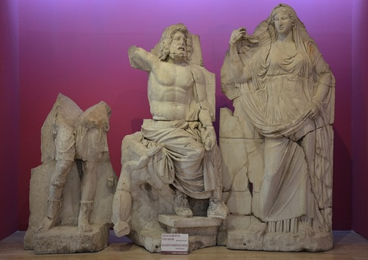
Artemis, Poseidon and Demeter
Carole Raddato (CC BY-NC-SA)

Poseidon's wife was the Nereid Amphitrite although she had proved a little difficult during the courting process and once fled to the Atlas mountains. Fortunately, the sea god was helped by the dolphin Delphinus who persuaded Amphitrite to return and marry Poseidon. In gratitude, Poseidon ensured that Delphinus was remembered for all time by making a constellation in her likeness which still carries her name.
THE GOD WAS PARTICULARLY REVERED AT CORINTH & WAS THE FOCUS OF THE PANHELLENIC ISTHMIAN GAMES.
The god's most famous son with Amphitrite was Triton, who was half-man, half-fish. Two other children were Rhode and Benthesicyme. However, as with the other divinities, Poseidon fathered many other offspring with various partners. Most notable are Theseus (with Aithra), Polyphemus the Cyclops (whom Odysseus famously encountered on his lengthy return from the Trojan War), Orion the hunter (with the daughter of Minos), the flying horse Pegasus (after the rape of Medusa), the wild horse Arion, and Charybdis (with Gaia), the ship-eating sea monster which created terrible whirlpools. Perhaps justifiably jealous of all these affairs, Poseidon's infatuation with Scylla, the daughter of the sea god Phorcys, led Amphitrite to cast some magic herbs in the girl's bath which turned her into a raging monster with twelve feet and six heads. Both Scylla and Charybdis would menace mariners who passed the Straits of Messina between Sicily and mainland Italy.
Poseidon was himself responsible for another terrible creature - the Minotaur. Minos' failure to sacrifice the bull given as a gift by the god resulted in Poseidon bewitching Minos' wife Pasiphae into falling in love with the bull; and the fruit of their amorous relationship was the half-man, half-bull creature which inhabited the labyrinth of Knossos.
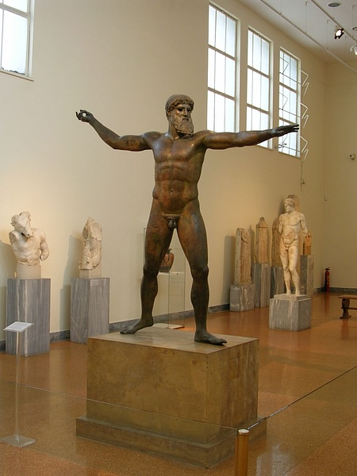
Zeus or Poseidon from Cape Artemisium
Mark Cartwright (CC BY-NC-SA)

In Hesiod & Homer
The god is a major protagonist in the Trojan War of Homer's Iliad, where he supports the Greeks and gives them either encouragement with rousing speeches, often in disguise as various Achaean personalities, or actually leads them in battle with flashing sword. However, he does also give aid to the Trojan hero Aeneas in order to escape from the fearsome Achilles. Poseidon also features in Homer's Odyssey as the nemesis of Odysseus. In revenge for the blinding of his son Polyphemus, he cursed Odysseus to wander the sea for ten years. Poseidon is most often described by both Homer and Hesiod as 'deep sounding Earth-shaker', the 'dark-haired one' and 'encircler of the earth.' The latter title reminds that many ancients believed that all waterways were connected and that the land floated on water. For this reason, it made sense that one god looked after all these waterways which encircled the earth (even if many rivers and springs had their own specific personifications in mythology).

Worship & Sacred Sites
In the Greek religion, Poseidon was said to hold the Isthmus of Corinth in special regard; probably as it was an important sea route. The god was particularly revered here and was the focus of horse races and other events at the Panhellenic Isthmian games which were held in his honour near Corinth. The games were held every two years in the spring and, like the Olympic Games, athletes, charioteers, and horse racers competed for prizes, in this case, a prestigious crown of first pine and then, in the Classical period, of dry celery. Corinth was also one of the earliest cities to connect Poseidon to maritime trade and navigation as indicated by votive clay plaques dating to the Archaic period. Sounion was another strategic site close to the god, and his 5th-century BCE temple still stands on the promontory which overlooks ships entering the Saronic gulf. The god was honoured by boat races held at the cape once every four years.
In the legendary competition with Athena to win the patronage of Athens, Poseidon offered to the city the gifts of a saltwater spring and a horse. However, Athena's gift of an olive tree gained greater favour, and it was she who would become the patron of the great city. Still, the god was honoured by the annual Posideai festival - which perhaps had more to do with agriculture than the sea - and the mid-winter month of Posideon carried his name.
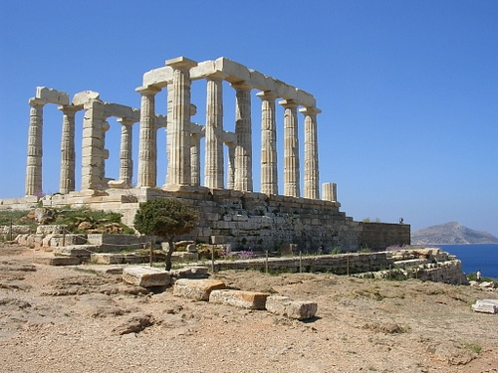
Temple of Poseidon, Sounion, Greece
Mark Cartwright (CC BY-NC-SA)

As a protector during earthquakes (despite the fact he was also seen as their cause), the god was often appealed to as Poseidon Asphaleios, and a temple to the god was built on Rhodes for just that purpose. Poseidon had an oracle at Taenarum in Laconia and important sanctuaries at the small island of Calauria off Troezen and Onchestus in Boeatia. Onchestus had a curious ceremony whereby horses pulled a riderless chariot through the site, and if it crashed, then the chariot was dedicated to the god. Many coastal settlements across the Mediterranean bore his name (for example, Posidonia/Paestum), and mariners and fishermen everywhere made votive offerings to Poseidon for protection. His cult worshippers most frequently sacrificed bulls, stallions, and male sheep. Finally, the god was also credited as being the father of at least 30 different semi-historical city-founders and several major tribes across Greece, likely reflecting the importance the god had in the Mycenaean period.

Representation in Art
Poseidon is most commonly depicted in ancient Greek art as mature and bearded. He often brandishes his trident, fashioned by the Cyclopes, with which he would create earthquakes by striking it to the ground. He is also frequently portrayed riding his golden chariot pulled by hippocamps - half-horse and half-serpent creatures with fishtails - or gold-shod horses, of which he was patron. Dolphins, seahorses, and tuna fish are additional marine animals frequently seen in the god's company in art.
The god appears with Athena in their competition to become the patron of Athens on the west pediment of the Parthenon (447-432 BCE). Poseidon appeared on coinage, perhaps most strikingly the silver tetradrachms of ancient Macedon (306-283 BCE) where he seems about to hurl his trident. Perhaps the most celebrated representation of Poseidon is the 2 metre-high bronze statue (c. 460 BCE) from Cape Artemisium (although such is the similarity in the depiction of Poseidon and Zeus in ancient Greek art, it may well represent the latter). The statue was recovered from a shipwreck in the 1920s CE, and the magnificent striding figure now dominates one of the rooms of the National Archaeological Museum of Athens.

12. Zeus was the king of the Olympian gods and the supreme deity in Greek religion. Often referred to as the Father, as the god of thunder and the 'cloud-gatherer', he controlled the weather, offered signs and omens and generally dispensed justice, guaranteeing order amongst both the gods and humanity from his seat high on Mt. Olympus.

Zeus' Struggle for Power
Zeus' father was Cronus and his mother Rhea. Cronus had usurped control of the heavens from his father Ouranos and he was constantly wary of not having the same thing happen to him from his own children. To pre-empt any takeover he, therefore, swallowed all of his children: Hestia, Demeter, Hera, Hades, and Poseidon. However, Rhea saved her youngest child Zeus by wrapping a stone in swaddling clothes and giving this to Cronus to swallow. Zeus was spirited away to Mt. Dikte on the island of Crete where he was raised by the primeval goddess Gaia (Earth), or in some versions by the Nymphs. Amongst these was the Nymph Amaltheia (in some versions of the myth she was a goat) who suckled the young god.
On reaching adulthood Zeus made Cronus cough back up the children he had swallowed and Zeus then married his sister Hera. However, the lawless Titans, encouraged by Gaia, immediately tried to wrestle control of the world from the Olympian gods in a ten-year battle known as the Titanomachy. The Titans were the brothers and sisters of Cronus and it was only through the help of the Cyclopes - who made Zeus his lightning bolts - and the hundred-handed giants or Hecatoncheires (Briareos, Cottus and Gyges) that Zeus was finally able to imprison the Titans in Tartarus, the deepest part of the Underworld. Making himself ruler of the skies, Zeus then gave dominion over the seas to Poseidon and of the Underworld to Hades.
The Olympians still could not reign peacefully, though, for Gaia then enlisted the help of the terrible and savage Giants to battle with Zeus in the Gigantomachy. The Olympians were this time helped by the great hero Hercules and, after Zeus outwitted Gaia in her attempt to give the giants a magic herb, they once again won the battle for control of the world, not, however, before the Giants had created great destruction by moving mountains, islands and rivers.
Zeus's reign was only once more challenged when some of the gods, notably Hera, Athena and Poseidon, tried to takeover Zeus' role as head of the Olympian gods and bound him to his bed. The Father was, however, freed by one of the Hecatoncheires and the status quo restored.

Zeus' Offspring
Although first married (briefly it seems) to the Titan Metis and then married to Hera, Zeus was infamous in Greek mythology for his adulterous affairs, during which he often used his magical power to transform himself into various incarnations to bed his prey. He, therefore, had many offspring:
- Hephaistos, Ares, Hebe, Eileithyia - with Hera.
- Athena - with Metis but as Zeus swallowed his wife in fear a son would usurp his position, Athena was born from Zeus' head and she became the god's favourite child.
- Apollo & Artemis - with Leto.
- Hermes - with the Nymph Maia. Zeus, impressed by his trickery and silver tongue, gave him the role of messenger of the gods.
- Dionysos - with Semele who, being tricked by a jealous Hera, asked to see Zeus in all his godly splendour and immediately expired as a consequence. Dionysos was born from Zeus' thigh as a result of his mother's premature death.
- Hercules - with Alkmene and he was, therefore, forever the subject of a jealous Hera's scheming but on his death Zeus brought him to Mt. Olympus and made him into a god.
- Perseus - with Danae, who was won over to the charms of Zeus when he appeared to her as golden rain in order to enter her chamber where she was imprisoned by her father Acrisius.
- Persephone & Iacchus- with Demeter.
- The Fates, the Hours, Horae (Seasons), Eunomia (Lawfulness), Dike (Justice), Eirene (Peace) - with Themis.
- Helen, the Dioskouroi & Polydeuces - with Leda, for whom he transformed himself into a swan.
- Aglaea (Splendour), Euphrosyne (Joy) & Thalia (Good Cheer) - (the three Graces) with Eurynome.
- Minos, Rhadamanthys & Sarpedon - with Europa after Zeus disguised himself as a magnificent white bull and whisked her off to Crete.
- Epaphos - with Io.
- Iasion - with Electra.
- Arcas - with the Nymph Callisto - both son and mother were transformed into bears by a jealous Artemis but Zeus made them into constellations - Ursa Minor and Major.
- The nine Muses - with Mnemosyne after the couple slept together for nine consecutive nights.
Zeus was also regarded as the founder of certain races, notably the Magnesians and the Macedonians. He also turned ants into the magnificent fighting Myrmidons for his son Aiakos, later to be led by Achilles in the Trojan War.
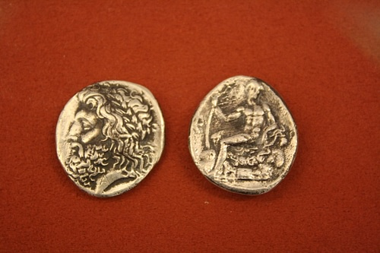
Arcadian Silver Stater
Mark Cartwright (CC BY-NC-SA)

Zeus the Punisher
The god was also the great punisher. Those who did wrong or committed acts of impiety were severely punished, often for all time. The Titans were imprisoned in Tartarus and after acts of impiety against Zeus, Apollo and Poseidon were made to build the magnificent walls of Troy which proved so useful in the Trojan War. An explanation for the war in mythology was that Zeus sought to curb the rising population of humanity. Zeus also selected Paris as the judge in the famous beauty contest between Aphrodite, Hera and Athena, and when the young prince won Helen as his reward for choosing Aphrodite it was cited as another, more human cause for the Trojan War.
...IT IS NOT POSSIBLE IN ANY WAY TO EVADE THE MIND OF ZEUS. HESIOD, WORKS & DAYS
Other victims of Zeus' vengeance included The Titan Prometheus who was condemned to have his liver eaten by an eagle every day after he stole fire from the gods and gave it to humankind. Atlas had to support the heavens for eternity because of his role in the Titanomachy. Sisyphus, punished for his trickery, was condemned to forever roll a huge stone up a hill in the Underworld. Asclepius was killed by one of Zeus' thunderbolts because the former's medicine and his ability to raise the dead threatened the balance of power between men and gods. Pandora, the first woman was sent into the world by Zeus as punishment for receiving the gift of fire and she was to be the source of all mankind's misfortunes, carried with her in a box. Phineus, who was tricked by Hera into blinding his two sons, was himself blinded by Zeus who also sent the Harpies to continuously harass him. Ixion rashly declared his love for Hera and so Zeus banished him to Hades to be forever bound to a rotating wheel. Lycaon gave human flesh to Zeus to test his divinity and the god punished his impudence by turning him into a wolf. Salmoneus thought he was a god and pretended to be Zeus by throwing flaming torches for lightning bolts and riding his chariot to make a noise like thunder but Zeus swiftly put a stop to his antics by killing him instantly with a real bolt of lightning. The list goes on but the message is clear, wrong-doing and lack of respect would be severely punished.

Zeus the Peacemaker
Despite the terrible punishments Zeus could inflict he was also a peacemaker, famously reconciling Apollo and Hermes when they fought over the first lyre. Similarly, Zeus resolved the conflict between Apollo and Hercules over the tripod from Delphi. He also persuaded Hades to part with Persephone for part of each year and so end the terrible drought her mother Demeter had caused for the human race in protest at being held captive in the Underworld. For mere mortals, Zeus was at least fair-minded. At his feet Zeus had the jars of Fate - one full of bad things, another full of good things and he dispensed both with justice. Similarly, the time of a mortal's death was carefully weighed in Zeus' golden scales.
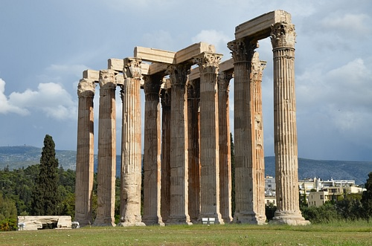
Columns, Temple of Olympian Zeus, Athens
Carole Raddato (CC BY-NC-SA)

Sites Sacred to Zeus
As a major figure in the Greek religion, Zeus had an oracle, the oldest in fact, at Dodona in northern Greece where ascetic priests served an oracle which interpreted the sounds from the wind in the branches of the sacred oak trees and the babbling of water from the holy spring. Another great sanctuary dedicated to Zeus was at Olympia where every four years from 776 BCE the Olympic Games drew crowds from all parts of the Greek world to honour the father of the gods and where 100 oxen were sacrificed to Zeus at the end of each Games. Also at Olympia, the massive 5th century BCE temple of Zeus housed the gigantic gold and ivory statue of the god by Pheidias which was one of the Seven Wonders of the ancient world. Other important sacred sites for the god were on Mt. Lycaios, in Athens, Nemea, Pergamon, Stratos, and in Libya.
There were surprisingly few festivals in honour of Zeus, one was the Diasia of Athens. Generally, though, Zeus, as head of the Greek pantheon, was omnipresent and so made no particular attachments to specific cities. Zeus was, however, worshipped in most family homes where an altar was often dedicated to him in each courtyard, for as Zeus Herkeios, he protected the family hearth and property in general. He was also Zeus Xenios, the god of hospitality, Zeus Polieus, protector of cities, Zeus Horkios guardian of oaths and Zeus Soter, the protector and general benefactor to all.
Zeus or Poseidon from Cape Artemisium
Mark Cartwright (CC BY-NC-SA)

Representations in Art
In Greek art Zeus is almost always bearded and carries either a lightning bolt or sceptre. He was also strongly associated with bulls, oak trees and eagles, one of the latter sometimes appears at his side when he does not have his lightning bolt or sceptre. Zeus is a central figure in the east pediment of the Parthenon but without doubt the most majestic representation of the god is the bronze statue from Artemesium (460 BCE) where he confidently stands, feet wide apart, about to launch a thunderbolt.
Some scholars believe the figure is Poseidon but the art historian J.Boardman presents the convincing argument that the stance is much more familiar to representations of Zeus in Greek art (see the Dodona statue) and if the figure held a trident (much longer than a thunderbolt) it would obscure the face, an undesirable aesthetic consequence for Greek sculpture. Greek pottery is another rich source of the myths involving Zeus, in particular scenes representing his many metamorphoses and Zeus also appeared on many coins, notably those of Elis.

