Salem witch trials
American history
Print Cite Share More
BY Jeff Wallenfeldt Last Updated: Jun 11, 2021 | View Edit History

FAST FACTS
- 2-Min Summary
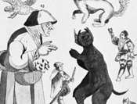
Witch
See all media
Date:

May 1692 - October 1692
Location:

Massachusetts Salem United States
Key People:

Samuel Sewall
TOP QUESTIONS

What caused the Salem witch trials?

How many people were killed during the Salem witch trials?

How did the Salem witch trials end?
Show more
FULL ARTICLE
Salem witch trials, (June 1692–May 1693), in American history, a series of investigations and persecutions that caused 19 convicted “witches” to be hanged and many other suspects to be imprisoned in Salem Village in the Massachusetts Bay Colony (now Danvers, Massachusetts).

Witch hunts
The events in Salem in 1692 were but one chapter in a long story of witch hunts that began in Europe between 1300 and 1330 and ended in the late 18th century (with the last known execution for witchcraft taking place in Switzerland in 1782). The Salem trials occurred late in the sequence, after the abatement of the European witch-hunt fervour, which peaked from the 1580s and ’90s to the 1630s and ’40s. Some three-fourths of those European witch hunts took place in western Germany, the Low Countries, France, northern Italy, and Switzerland. The number of trials and executions varied according to time and place, but it is generally believed that some 110,000 persons in total were tried for witchcraft and between 40,000 to 60,000 were executed.
The “hunts” were efforts to identify witches rather than pursuits of individuals who were already thought to be witches. Witches were considered to be followers of Satan who had traded their souls for his assistance. It was believed that they employed demons to accomplish magical deeds, that they changed from human to animal form or from one human form to another, that animals acted as their “familiar spirits,” and that they rode through the air at night to secret meetings and orgies. There is little doubt that some individuals did worship the devil and attempt to practice sorcery with harmful intent. However, no one ever embodied the concept of a “witch” as previously described.
The process of identifying witches began with suspicions or rumours. Accusations followed, often escalating to convictions and executions. The Salem witch trials and executions came about as the result of a combination of church politics, family feuds, and hysterical children, all of which unfolded in a vacuum of political authority.
Get a Britannica Premium subscription and gain access to exclusive content.Subscribe Now

Setting the scene
There were two Salems in the late 17th century: a bustling commerce-oriented port community on Massachusetts Bay known as Salem Town, which would evolve into modern Salem, and, roughly 10 miles (16 km) inland from it, a smaller, poorer farming community of some 500 persons known as Salem Village. The village itself had a noticeable social divide that was exacerbated by a rivalry between its two leading families—the well-heeled Porters, who had strong connections with Salem Town’s wealthy merchants, and the Putnams, who sought greater autonomy for the village and were the standard-bearers for the less-prosperous farm families. Squabbles over property were commonplace, and litigiousness was rampant.
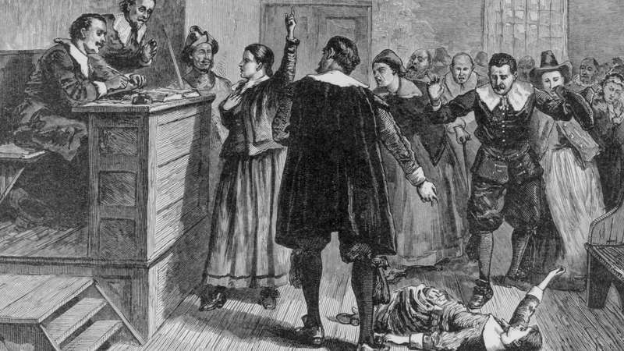

Learn about the Salem witch trials and their legacy
Questions and answers about the Salem witch trials.
Encyclopædia Britannica, Inc.See all videos for this article
In 1689, through the influence of the Putnams, Samuel Parris, a merchant from Boston by way of Barbados, became the pastor of the village’s Congregational church. Parris, whose largely theological studies at Harvard College (now Harvard University) had been interrupted before he could graduate, was in the process of changing careers from business to the ministry. He brought to Salem Village his wife, their three children, a niece, and two slaves who were originally from Barbados—John Indian, a man, and Tituba, a woman. (There is uncertainty regarding the relationship between the slaves and their ethnic origins. Some scholars believe that they were of African heritage, while others think that they may have been of Caribbean Native American heritage.)
Parris had shrewdly negotiated his contract with the congregation, but relatively early in his tenure he sought greater compensation, including ownership of the parsonage, which did not sit well with many members of the congregation. Parris’s orthodox Puritan theology and preaching also divided the congregation, a split that became demonstrably visible when he routinely insisted that nonmembers of the congregation leave before communion was celebrated. In the process Salem divided into pro- and anti-Parris factions.

Fits and contortions
Probably stimulated by voodoo tales told to them by Tituba, Parris’s daughter Betty (age 9), his niece Abigail Williams (age 11), and their friend Ann Putnam, Jr. (about age 12), began indulging in fortune-telling. In January 1692 Betty’s and Abigail’s increasingly strange behaviour (described by at least one historian as juvenile deliquency) came to include fits. They screamed, made odd sounds, threw things, contorted their bodies, and complained of biting and pinching sensations.
Looking back with the perspective provided by modern science, some scholars have speculated that the strange behaviour may have resulted from some combination of asthma, encephalitis, Lyme disease, epilepsy, child abuse, delusional psychosis, or convulsive ergotism—the last a disease caused by eating bread or cereal made of rye that has been infected with the fungus ergot, which can elicit vomiting, choking, fits, hallucinations, and the sense of something crawling on one’s skin. (The hallucinogen LSD is a derivative of ergot.) Given the subsequent spread of the strange behaviour to other girls and young women in the community and the timing of its display, however, those physiological and psychological explanations are not very convincing. The litany of odd behaviour also mirrored that of the children of a Boston family who in 1688 were believed to have been bewitched, a description of which had been provided by Congregational minister Cotton Mather in his book Memorable Providences, Relating to Witchcraft and Possessions (1689) and which may have been known by the girls in Salem Village. In February, unable to account for their behaviour medically, the local doctor, William Griggs, put the blame on the supernatural. At the suggestion of a neighbour, a “witch cake” (made with the urine of the victims) was baked by Tituba to try to ferret out the supernatural perpetrator of the girls’ illness. Although it provided no answers, its baking outraged Parris, who saw it as a blasphemous act.

Three witches
Pressured by Parris to identify their tormentor, Betty and Abigail claimed to have been bewitched by Tituba and two other marginalized members of the community, neither of whom attended church regularly: Sarah Good, an irascible beggar, and Sarah Osborn (also spelled Osborne), an elderly bed-ridden woman who was scorned for her romantic involvement with an indentured servant. On March 1 two magistrates from Salem Town, John Hathorne and Jonathan Corwin, went to the village to conduct a public inquiry. Both Good and Osborn protested their own innocence, though Good accused Osborn. Initially, Tituba also claimed to be blameless, but after being repeatedly badgered (and undoubtedly fearful owing to her vulnerable status as a slave), she told the magistrates what they apparently wanted to hear—that she had been visited by the devil and made a deal with him. In three days of vivid testimony, she described encounters with Satan’s animal familiars and with a tall, dark man from Boston who had called upon her to sign the devil’s book, in which she saw the names of Good and Osborn along with those of seven others that she could not read.
The magistrates then had not only a confession but also what they accepted as evidence of the presence of more witches in the community, and hysteria mounted. Other girls and young women began experiencing fits, among them Ann Putnam, Jr.; her mother; her cousin, Mary Walcott; and the Putnams’s servant, Mercy Lewis. Significantly, those that they began identifying as other witches were no longer just outsiders and outcasts but rather upstanding members of the community, beginning with Rebecca Nurse, a mature woman of some prominence. As the weeks passed, many of the accused proved to be enemies of the Putnams, and Putnam family members and in-laws would end up being the accusers in dozens of cases.
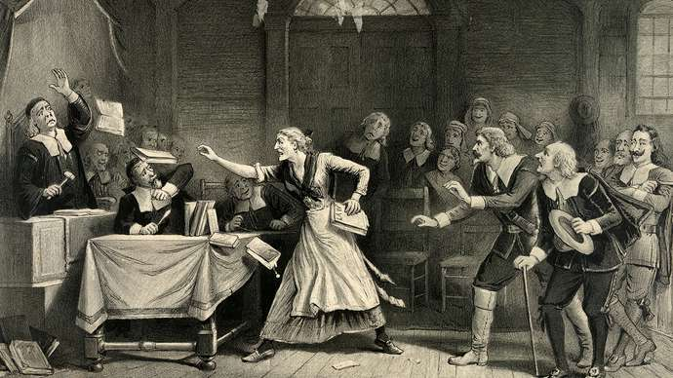
Salem witch trial
Witch trial in Salem, Massachusetts, lithograph by George H. Walker, 1892.
Library of Congress, Washington, D.C. (LC-DIG-pga-02986)

The trials
On May 27, 1692, after weeks of informal hearings accompanied by imprisonments, Sir William Phips (also spelled Phipps), the governor of Massachusetts Bay Colony, interceded and ordered the convening of an official Court of Oyer (“to hear”) and Terminer (“to decide”) in Salem Town. Presided over by William Stoughton, the colony’s lieutenant governor, the court consisted of seven judges. The accused were forced to defend themselves without aid of counsel. Most damning for them was the admission of “spectral evidence”—that is, claims by the victims that they had seen and been attacked (pinched, bitten, contorted) by spectres of the accused, whose forms Satan allegedly had assumed to work his evil. Even as the accused testified on the witness stand, the girls and young women who had accused them writhed, whimpered, and babbled in the gallery, seemingly providing evidence of the spectre’s demonic presence. Those who confessed—or who confessed and named other witches—were spared the court’s vengeance, owing to the Puritan belief that they would receive their punishment from God. Those who insisted upon their innocence met harsher fates, becoming martyrs to their own sense of justice. Many in the community who viewed the unfolding events as travesties remained mute, afraid that they would be punished for raising objections to the proceedings by being accused of witchcraft themselves.
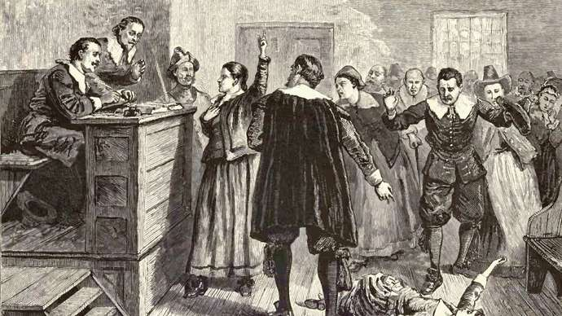
Salem witch trials
Salem witch trials, illustration from Pioneers in the Settlement of America by William A. Crafts, 1876.
On June 2 Bridget Bishop—who had been accused and found innocent of witchery some 12 years earlier—was the first of the defendants to be convicted. On June 10 she was hanged on what became known as Gallows Hill in Salem Village. On July 19 five more convicted persons were hanged, including Nurse and Good (the latter of whom responded to her conviction by saying that she was no more a witch than the judge was a wizard). George Burroughs, who had served as a minister in Salem Village from 1680 to 1683, was summoned from his new home in Maine and accused of being the witches’ ringleader. He too was convicted and, along with four others, was hanged on August 19. As he stood on the gallows, he recited the Lord’s Prayer perfectly—something no witch was thought to be capable of doing—raising doubts about his guilt for some in attendance, though their protests were refuted, most notably by Mather, who was present. (Mather’s role in the trials in general was complex, as he at various times seemingly both condoned and questioned aspects of the proceedings.) On September 22 eight more convicted persons were hanged, including Martha Corey, whose octogenarian husband, Giles, upon being accused of witchcraft and refusing to enter a plea, had been subjected to peine forte et dure (“strong and hard punishment”) and pressed beneath heavy stones for two days until he died.
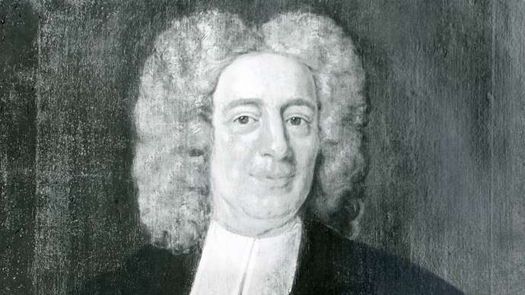
Cotton Mather
Cotton Mather, portrait by Peter Pelham; in the collection of the American Antiquarian Society, Worcester, Massachusetts.
Courtesy of the American Antiquarian Society, Worcester, Mass.
As the trials progressed, accusations spread to individuals from other communities, among them, Beverly, Malden, Gloucester, Andover, Lynn, Marblehead, Charlestown, and Boston. On October 3 Cotton Mather’s father, Increase Mather, an influential minister and the president of Harvard, condemned the use of spectral evidence and instead favoured direct accusations:

The devil never assists men to do supernatural things undesired. When, therefore, such like things shall be testified against the accused party, not by specters, which are devils in the shape of persons either living or dead, but by real men or women who may be credited, it is proof enough that such a one has that conversation and correspondence with the devil as that he or she, whoever they be, ought to be exterminated from among men. This notwithstanding I will add: It were better that ten suspected witches should escape than that one innocent person should be condemned.
On October 29, as the accusations of witchcraft extended to include his own wife, Governor Phips once again stepped in, ordering a halt to the proceedings of the Court of Oyer and Terminer. In their place he established a Superior Court of Judicature, which was instructed not to admit spectral evidence. Trials resumed in January and February, but of the 56 persons indicted, only 3 were convicted, and they, along with everyone held in custody, had been pardoned by Phips by May 1693 as the trials came to an end. Nineteen persons had been hanged, and another five (not counting Giles Corey) had died in custody.

Aftermath and legacy
In the years to come, there would be individual and institutional acts of repentance by many of those involved in the trials. In January 1697 the General Court of Massachusetts declared a day of fasting and contemplation for the tragedy that had resulted from the trials. That month, Samuel Sewall, one of the judges, publicly acknowledged his own error and guilt in the proceedings. In 1702 the General Court declared that the trials had been unlawful. In 1706 Ann Putnam, Jr., apologized for her role as an accuser. Twenty-two of the 33 individuals who had been convicted were exonerated in 1711 by the Commonwealth of Massachusetts, which also paid some £600 to the families of the victims. In 1957 the state of Massachusetts formally apologized for the trials. It was not until 2001, however, that the last 11 of the convicted were fully exonerated.
The abuses of the Salem witch trials would contribute to changes in U.S. court procedures, playing a role in the advent of the guarantee of the right to legal representation, the right to cross-examine one’s accuser, and the presumption of innocence rather than of guilt. The Salem trials and the witch hunt as metaphors for the persecution of minority groups remained powerful symbols into the 20th and 21st centuries, owing in no small measure to playwright Arthur Miller’s use in The Crucible (1953) of the events and individuals from 1692 as allegorical stand-ins for the anticommunist hearing led by Sen. Joseph McCarthy during the Red Scare of the 1950s.

