Biomolecules
[Basic molecules of living systems and their structures-Carbohydrates, proteins, nucleic acids]
General Introduction:
The reactions
Nucleic Acids:
Nucleic acids are the polymers of nucleotides and are macromolecules. There are two types of nucleic acids namely — deoxyribonucleic acid ($DNA$) and ribonucleic acid ($RNA$). Nucleotide serves as the building block of nucleic acid. A nucleotide is composed of —
($i$) A phosphate group —
($ii$) A five-carbon sugar or pentose sugar (monosaccharide): In $RNA$ the sugar is ribose (thus the name ribonucleic acid) and in $DNA$ the sugar present is deoxyribose (thus the name deoxyribonucleic acid). The structures of these sugars are —
($ii$) A Heterocyclic Nitrogen-containing Base: There are four different bases commonly found in DNA: Adenine ($A$), Guanine ($G$), thymine ($T$) and Cytosine ($C$). RNA also contains adenine, guanine and cytosine, but instead of thymine it has Uracil ($U$). Adenine and guanine are double-ring bases called purines. Cytosine, thymine and uracil are single-ring bases called pyrimidines.
The nitrogenous basic molecule is joined to the sugar molecule by a glycosidic bond and forms a structure called nucleoside. The nucleoside combines with a phosphate group by an ester bond to form nucleotide.
In a nucleic acid a phosphate moiety links the $3'$- $C$ of one sugar molecule to the $5'$- $C$ of the sugar of the succeeding nucleotide. The bond formed between the phosphate and hydroxyl group of sugar is an ester bond. As there is one such ester bond on either side, it is called phosphodiester bond.
DNA is the genetic material and forms molecular basis of heredity (the transmission of genetic characters from parents to offspring) in all organisms. In certain viruses, such as tobacco mosaic virus ($TMV$) $RNA$ is the genetic material.
Nucleic acid exhibit a wide variety of secondary structures, for example, one of the secondary structures exhibited by $DNA$ is the famous Watson - Crick Model.
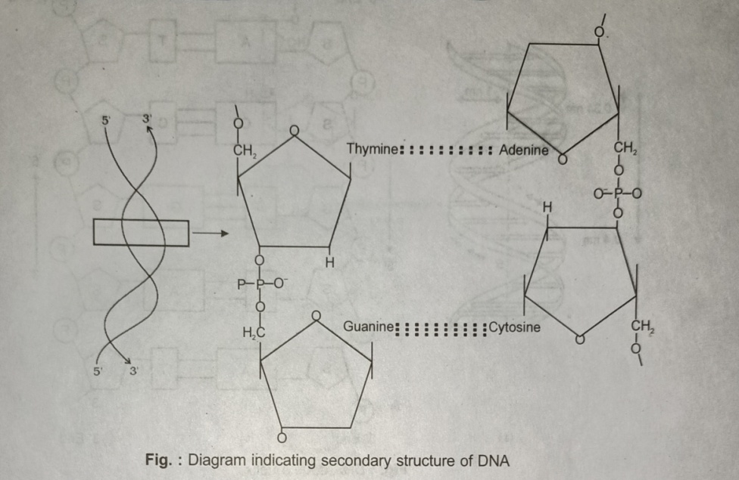
Watson - Crick Model: The silent features of Watson - Crick Model are —
- This model says that $DNA$ exists as a double helix. A $DNA$ molecule has two unbranched polynucleotide strands. Each polynucleotide strand or chain consists of a sequence of nucleotides linked together by phosphodiester bonds. The polynucleotide strands are anti-parallel, i.e. run in the opposite direction.
- The two strands are not coiled upon each other but the double strand is coiled upon itself around a common axis like spiral staircases with base pairs forming steps while the backbones of the two strands from railings. The backbone is formed of sugar and phosphate.
- The $N$- bases are projected more or less perpendicular to the sugar phosphate backbone but face inside.
- The base-pairing is specific. Adenine is always paired with thymine and guanine is always paired with cytosine ($ATGC$). Thus, all base-pairs consist of one purine and one pyrimidine nucleus. Once the sequence of bases in one strand of $DNA$ double helix is known the sequence of bases in the other strand is also known because of the specific base pairing. The two strands of a $DNA$ double helix are thus said to be complementary (not identical). This is known as complementary base pairing.
- The two polynucleotide strands are held together in their helical structure by $H$- bonding between bases in opposite strands. Adenine and thymine from two $H$- bonds. Guanine and cytosine form three $H$- bonds.
- One end of the strand is called $5^{'}end$ where the 5th $C$- of pentose sugar is free and the other end is called $3^{'}end$ where the 3rd $C$- of pentose sugar is free.
- At each base pair the strand turns $36°$. One full turn of the helical strand ($360°$) would involve ten base pairs, i.e. one turn of $360°$ of helical strand has about $10$ nucleotide on each strand of $DNA$. The base-pairs in $DNA$ are stacked $3.4 Å$ as ten base-pairs occupy a distance of $34 Å$.
- This form of $DNA$ with the above mentioned salient features is known as $B$-$DNA$.
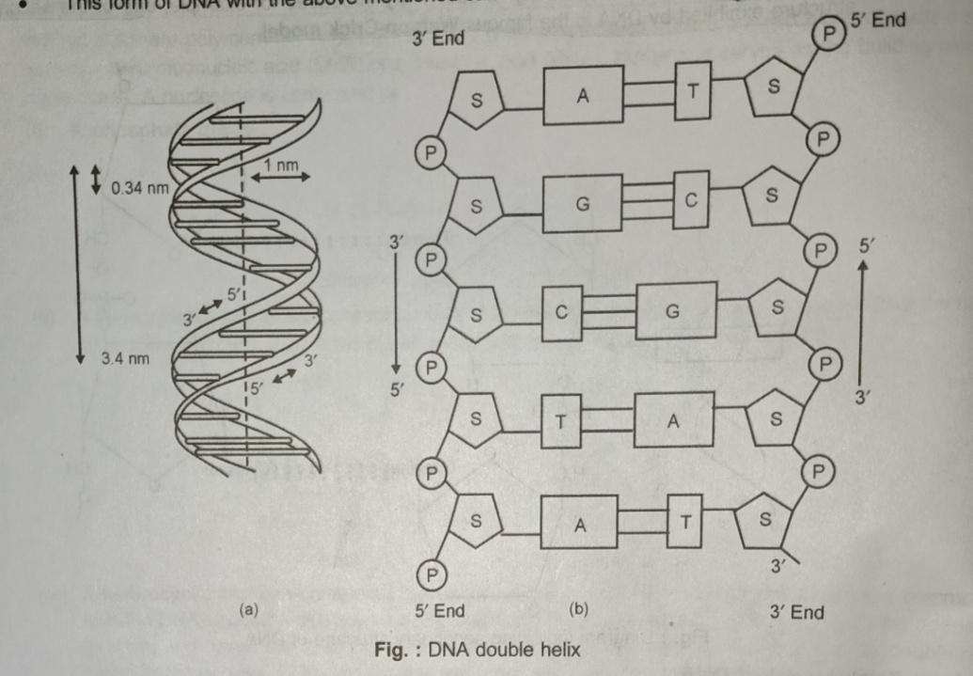
Chargaff’ Rule:
In $1950$, Erwin Chargaff found that in any $DNA$ molecule —
- The amounts of purines and pyrimidines are equal i.e. $A+G=T+C$
- The amount of adenine is always equal to that of thymine and the amount of guanine is always equal to that of cytosine ($i.e.A=T \& G=C$)
- The base ratio ${(A+T)}/{(G+C)}$ may vary from one species to another, but is constant for a given species.
- The deoxyribose sugar and phosphate components occur in equal proportions.
RNA is usually single-stranded, but sometimes (as in Reovirus and Rice dwarf virus), it is double-stranded. RNA does not follow Chargaff’s rule i.e. $1:1$ ratio does not exist between purines and pyrimidines bases due to single-stranded nature and lack of complementary.
RNA (Ribonucleic Acid):
There are three types of $RNA$ —
- Messenger RNA ($m$-$RNA$): It is produced in the nucleus and carries the information for the synthesis of proteins; it was discovered by Jacob & Monod (1961).
- Ribosomal RNA ($r$-$RNA$): It is the largest $RNA$ and constitutes about $80\%$ of the total cellular $RNA$. It is found in the ribosome where protein synthesis takes place.
- Transfer RNA ($t$-$RNA$): It is also named as Soluble $RNA$ ($s$-$RNA$) or Adaptive $RNA$ ($a$-$RNA$). It is the smallest type of $RNA$ and constitutes about $10-15\%$ of the total cellular $RNA$. These are found in the cytoplasm and are different types (usually 20, as 20 amino acids). Their function is to collect amino acids from the cytoplasm for protein synthesis.
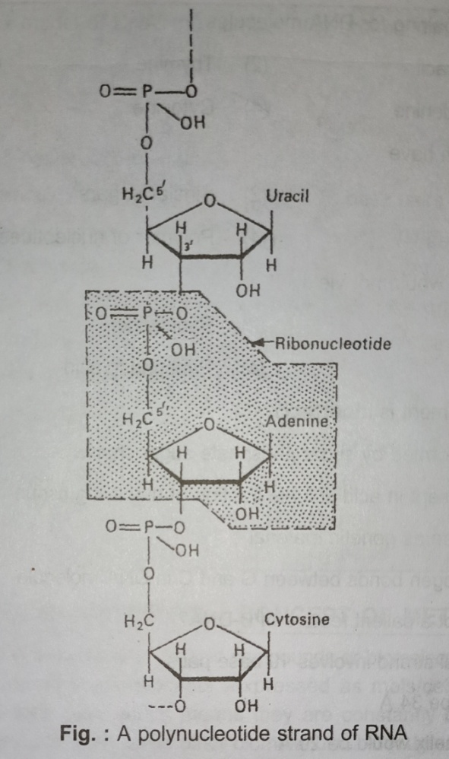
The silent features of Watson - Crick Model are —

The End

