A simple c program

Program to Display "Hello, World!"
#include<stdio.h>
int main()
{
printf("Hello, World!");
return 0;
}
Output
Hello, World!
- The #include is a preprocessor command that tells the compiler to include the contents of stdio.h (standard input and output) file in the program.
- The stdio.h file contains functions such as scanf() and printf() to take input and display output respectively.
- If you use the printf() function without writing #include <stdio.h>, the program will not compile.
- The execution of a C program starts from the main() function.
- printf() is a library function to send formatted output to the screen. In this program, printf() displays Hello, World! text on the screen.
- The return 0; statement is the "Exit status" of the program. In simple terms, the program ends with this statement.

Note:
First line is pre-processor Directive.We know that natural languages like Assamese,English etc have their own dictionary/library.Thus C has its library and it consists of some pre-written,known as header files.Here in this program,the header file namely ‘stdio.h’ is included as it the basic header file that needs to be included fora simple C program.The extension of a header file in C is’.h’.The header file,stdio.h contains the basic input/output functions and other items those are important for a simple C program.The main() function is necessary for each and every C program as when we execute a C program,the execution starts from main().

Program to Add Two Integers
#include <stdio.h>
int main()
{

int number1, number2, sum;

printf("Enter two integers: ");
scanf("%d %d", &number1, &number2);

// calculating sum
sum = number1 + number2;

printf("%d + %d = %d", number1, number2, sum);
return 0;
}
Output
Enter two integers: 12
11
12 + 11 = 23
In this program, the user is asked to enter two integers. These two integers are stored in variables number1 and number2 respectively.
printf("Enter two integers: ");
scanf("%d %d", &number1, &number2);
Then, these two numbers are added using the + operator, and the result is stored in the sum variable.

sum = number1 + number2;
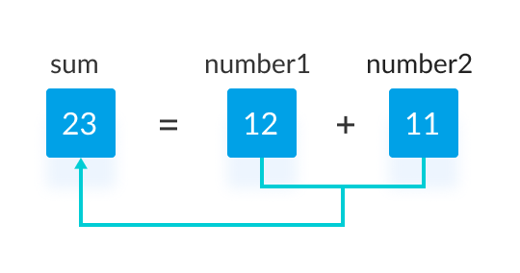
Finally, the printf() function is used to display the sum of numbers.

Note:
printf() is used to display text onto the screen
& is used to assign the input value to the variable and store it at that particular location.
scanf() is used to take input from the user using format specifier.

