**Organic photochemistry**

**General Introduction:**

The reactions caused or initiated by the absorption of **visible** & **ultraviolet** light are termed as the **photochemical reactions**. For example, formation of ***glucose*** in green plants by the **reduction** of $CO_{2}$ in presence of ***chlorophyll*** (a plant pigment) and **sunlight** is a well studied photochemical reaction known as the ***photosynthesis*** — which is the basic reaction that **sustains** life on the plant kingdom.

$$6CO_{2}+6H_{2}O\underset{→}{{Sunlight}/{Chlorophyll }} C_{6}H_{12}O_{6}+ 6O_{2}↑$$

It has been observed that many organic syntheses which are not easily accessible by the conventional chemical methods can be easily performed by photochemical paths, thus, organic photochemical reactions are very import not only for academic interest but also in synthetic organic chemistry.

**Photochemical *Versus* Thermal Reactions:**

In photochemical reactions a molecule is raised to an electronic excited state by the absorption of a photon of appropriate wavelength and undergoes photochemical transformations.

The ***difference*** between a photochemical reaction and an ordinary thermal reaction is that in a ***photochemical reaction individual molecules are promoted to highly energised or excited state*** ***without affecting the surrounding molecules***, whereas in thermal reactions all molecules are affected by the distribution of heat applied to them. Thus, ***selective excitation of individual molecules by electromagnetic radiation of visible or $UV$- region is a unique characteristic of photochemical reaction***.

**Secondly**, in a photochemical reaction, ***chemical changes take place in energy rich molecules*** accompanied by the loss of energy from the excited species, whereas in ***thermal reactions activation energy is gathered in small fractions*** from the environment.

The chemistry of the excited molecules is quite different from that in the ground state and it is often possible to change the course of a reaction by activating the reactants by light rather than by the application of heat.

**Electronic Excitation:**



A combination of two atomic orbitals (to form a bond) produces two molecular orbitals ($MOs$), a lower energy MO known as the ***bonding molecular orbital*** ($BMO$) which accommodates both the electrons in the ground state ($GS$) of the molecule. The other orbital having higher energy and a nodal plane as well is called ***antibonding molecular orbital*** ($ABMO$) which remains vacant, as shown in the figure given below.

Since the photochemical reactions are induced by the absorption of $UV$- $Vis$ light ( $λ=100$ to $600 nm$) energy by the molecules, and the process involves the promotion of electrons from bonding to the corresponding antibonding orbitals. The antibonding orbitals belong to $σ \& π$ bonds are represented as $σ^{*} \& π^{*}$ respectively.

The non-bonding ($n$) electrons are generally not involved in bond formation. Therefore, there are no antibonding orbitals to them as $n^{*}$. However, excitation can also promote a non-bonding electron to either $σ^{*}$ or $π^{*}$ MO $i.e.n→σ^{*} or n→π^{*}$.

**Classification of Electrons:**

For majority molecules, electrons fall into one of the following 3- classes:

1. $σ$- Electrons,
2. $π$- Electrons, and
3. $n$- Electrons (non-bonding electrons), which plays no role in the bonding of atoms into molecules.

**In chemical Terms:**

A single bond between atoms, such as $C-C, C-H, O-H$, etc. contains only $σ$- electrons. A multiple bond, such as $C=C, C≡C, C=N$, etc. contains $π$- electrons. Atoms right to the $C$- atom in the periodic table, notably $N, O$, and the halogens possess $n$- electrons.

**Energy Content:**

In general the $σ$- electrons are most firmly bound to the nuclei and hence require a great deal of energy to undergo transition, while $π \& n$- electrons require less energy, the $n$- electrons usually (but not invariably) requiring less than the $π$- electrons. Thus, the transitions —

$σ→σ^{*}$ Falls in vacuum $UV$

$π→π^{*} \& n→σ^{*}$ Appear near borderline of the near and far $UV$

$n→π^{*}$ Falls near $UV \& Vis$ regions

These generalizations are schematically shown below —



**Note**:

1. Saturated hydrocarbons *i.e*. alkanes containing $σ$- bonds only can undergo only $σ→σ^{*}$ transitions, do not give rise to spectra with any analytical interest since, they fall outside the generally available range. ***For example*** —

$σ→σ^{*}$ Transition for $CH_{4}$, $i.e$. $λ_{max}\left(CH_{4}\right)=122 nm$

$C_{2}H_{6}$, $i.e$. $λ_{max}\left(C_{2}H_{6}\right)=135 nm, etc.$

1. Groups containing $n$- electrons attached with the saturated system shows both $σ→σ^{*}$ and $n→σ^{*}$ transitions and in addition also tends to increase the wavelength of $σ→σ^{*}$ absorption. ***For example***, for —

$${CH}_{2}{\ddot{N}H}_{2}, λ_{max}\left(σ→σ^{*}\right)=170 nm \& λ_{max}\left(n→σ^{*}\right)=213 nm$$

Similarly, we can consider —

1. The attachment of group containing $n$- electrons with unsaturated system (for example $α,β$- unsaturated ketone)
2. Isolated double bond,
3. Conjugated double bond, etc.

Detailed studies for these are generally studied along with UV – Vis spectra.

**Modes of Dissipation of Energy, Excited States:** —

($a$) **Singlet & Triplet States**: **Jablonski Diagram**

Nearly all stable molecules have ***even*** number of electrons ***with spins*** paired in their ground state. When paired, they have ***no*** net electron ***magnetic moment*** due to opposite spins. These ***non-magnetic states*** are known as the ***singlets*** (abbreviated by the symbol $S, S_{0} or S_{1}$ etc. for different energy states).

Absorption of light of appropriate energy (*i.e*. wavelength), causes ***excitation*** of electrons (from the $GS, S$) **without** any change in ***electron spins***. Therefore, electron spins remained paired in the excited state but in different orbital *e.g*. $π,π^{*}$. This state is commonly called ***excited singlet state*** or $S_{1}$**- *state***. Such singlet state ($S_{1}$) can be converted to another excited state by inverting one of the electron spins, and this results to a ***new excited state*** (with ***two unpaired electrons***, $ue$) in which the electronic magnetic moments do not quench ($i.e., ue>0$). This ***new excited state*** having a net magnetic moment is called a ***triplet state*** or $T_{1}$ for which $2S+1=2×1+1=3$. From the above explanation it is obvious that the ***direct excitation of ground state*** ($S_{0}$) ***to a triplet state is never possible*** and thus, $T_{1}$ **is invariably populated *via $S_{1}$*** , the excited singlet state.

The entire process of electronic excitation can be well explained by taking the example of ***ethylene*** molecule, in which the absorption of correct wavelength ($162 nm$) of light causes promotion of one of the $π$- electrons to $π^{*}$- state as depicted in the figure given below.



The term ***singlet*** and ***triplet*** **originated** from the fact that ***singlet states*** don not split in the applied magnetic field whereas ***triplet states*** have three **possible** ***orientations*** as shown in the ***figure*** given below.



Further, it is obvious that a ***triplet*** state with **unpaired electron** spins is **more stable** than a **singlet** state, because two electrons in the same orbital cause repulsion and ***instability*** in the species.

The **excited** states are **not stable**, and they must **react or decay** to ground state. The various decay processes are shown in the ***figure*** given below.



From the figure, it is obvious that decaying of energy takes place by the following two radiations less processes —

1. **Internal conversions** ($IC$): The decay of one excited state to another state of same spin multiplicity such as $S_{2}→S_{1} or T_{2}→T_{1}$ is known as internal conversion, whereas
2. **Intersystem crossing** ($ISC$): The decay with change in spin multiplicity such as $S_{1}→T_{1} or S_{2}→T_{2}, etc.$ is known as intersystem crossing (ISC).

Usually, excited singlets and triplets ($S_{1} \& T_{1}$) have the same electronic configurations to a first approximation. The ***triplets*** lie at somewhat lower ***energy level than the singlets*** due to less electron-electron repulsion in triplets.

It is found that decay of $S_{1} and T_{1}$ to ground state ($S_{0}$) also occurs but at much slower rate than decay from higher states to the next lower excited states. Therefore, $S_{1} and T_{1}$ have the ***longest lives*** than other excited states and therefore, these states are responsible for photochemical changes. When we compare $S_{1} and T_{1}$ excited states, it is found that $T_{1}$ states have especially long lives because their decay back to the ground state ($S_{0}$) requires not only energy loss but also reorientation of an electron spin (which can only occur through an agency called the matrix or a de- quencher). The various decay processes were schematically represented by Jablonski, and hence the above diagram is known as the ***Jablonski diagram***.

($b$) **Fluorescence & Phosphorescence**: It has been observed that the $S_{1} and T_{1}$ excited states of many molecules live long enough before deactivation by emission of light (which is reverse to light absorption) can occur. This type of emission resulting from $S_{1}$- state is called ***fluorescence***. It has been observed that most of the fluorescent emission lies at longer wavelengths and the band looks like mirror image of as shown in the figure given below.



The fluorescence is usually very weak or undetectable except in small molecules, for example, diatomic molecules or rigid molecules such as aromatic compounds. The fluorescence rates are quantitatively related to the intensities of $S_{0}→S_{1}$ transitions in absorption. The intense fluorescence exhibited by a yellow dye ***fluorescein***, has a brilliant greenish fluorescence due to its intense first absorption band.

Since, $T_{1}$ has lower energy than $S_{1}$, it is not converted back to $S_{1}$. Therefore, it may either undergo a chemical reaction or return back to a ground state $S_{0}$ by emission of a ***photon***. This slow emission from $T_{1}$ excited state is called ***phosphorescence***. The lifetimes of ***fluorescence*** is usually of the order of ${10}^{-7}-{10}^{-9} sec$, against $10-{10}^{-3} sec$ for the ***phosphorescence***.

***Photochemical properties of $S_{1} \& T_{1}$ States***:

Since, $S_{1} \& T_{1}$ states differ in energy contents and also in electronic configurations; therefore, they are expected to show different photochemical properties. ***For example***, $S_{1}$- state of $1,3$- butadiene undergoes valence isomerisation to (I) and (II), whereas $T_{1}$- state prefer its dimerization to (III), (IV) and (V) by energy transfer as shown below.



The conversion of $S_{1} to T_{1}$ is energetically gainful and a slow process in accordance to spectroscopic rule that ***change in multiplicity is a forbidden*** process. If the singlet state is sufficiently long-lived as in aromatic and carbonyl compounds, the $S_{1} to T_{1}$ change ($ISC$) occurs with a high degree of efficiency. Intersystem crossing is more efficient in molecules where the energy gap between $S_{1} \& T_{1}$ is small, as in benzophenone with $5 k cal {mol}^{-1}$.

($c$) **Franck-Condon Transition/ Principle**:

Although quantum mechanics imposed no restrictions on the change in vibrational quantum number during an electronic transition, hence the vibrational lines in a band are not equally intense. The shapes of absorption band associated with the intensities of vibrational transitions and the functions of the equilibrium bond length about the approximately harmonic oscillation occur.

Since, at normal temperature most of the molecules resides in the zero vibrational level of the ground state and only a small fraction ($1 \%$) occupies the higher vibrational levels. Again, since the wave function for the zero vibrational level has a maximum at the centre, the region of maximum population, therefore, the most probable transition is that which originates from the centre of vibrational level, *i.e*. $ν"=0$. The time taken for an electronic transition is of the order of ${10}^{-15}s$, whereas the time period of vibration is about ${10}^{-13}s$, which is nearly $100$ times as slow. As a consequence, the internuclear distance does not change during electronic transition. Hence the transition process can be represented by a vertical line which is parallel to the potential energy axis. This forms the basis of ***Franck-Condon Principle***, which states that — “***electronic transitions are so fast in comparison to the nuclear motion that immediately after the transition, the nuclei have the same relative position and momentum as they did have just before the transition***.” The principle implies that it is difficult to convert electronic energy rapidly into vibrational kinetic energy and the most probable transitions are those for which the momentum and position of the nuclei do not change very much. The most probable transition appears at the most intense absorption time.

Two types of electronic band structures are observed in the diatomic molecules. The difference between these two cases is in the position of the energy minima of the excited electronic states as compared to the excited ground state. In the first case, the potential energy is minimum for excited state at nearly the same internuclear distance (**figure** ($1$)) as that the ground state. When the molecules is in the ground state, absorbs radiation, it is likely to be at its equilibrium internuclear distance ($r_{e}$). Therefore, the vertical line representing the electronic transition originates at $r_{e}$ for $ν"=0$ level. As the two potential energy curves have the similar shape and $r_{e}$, the $ν"=0→ν'=0$ transition will be most probable and the intensities of the spectral line will be maximum for this transition. The intensities of the spectral lines corresponding to $0→1, 0→2$, etc. transitions decrease substantially.

The most common type of electronic spectrum for a diatomic molecule is one in which the minimum of potential energy curve for the excited state is at a larger internuclear distance, than for the ground electronic state. In this case, the most probable transition is $ν"=0→ν'=3$, because the probability density in $ν'=3$ level is the maximum at $r_{e}$. The intensity of the other transition will be less. So, we get a plot as shown in the figure $2a$ and $2b$.

If the molecule is raised to an energy above its dissociation energy ($D_{0}$), the absorption will be continuous and the molecule dissociates within its vibrational period. The transition from discrete line to the continuum is called the convergent limit. If the potential energy curve for excited state is shifted even more to the right a considerable part of the absorption band will be continuous.

Few transitions are also possible from other positions of $ν"=0$ level, adding to the width absorption band. Moreover, those molecules which are able to reside in higher vibrational levels in the ground state $ν"=1,2,3,…, etc.$ undergo vibrational transitions of lower probabilities and form a part of the absorption band.



The dissociation energy of a molecule can be determined with more accuracy from its electronic spectra. It is calculated from the convergent series of the spectra. Since, the dissociation energy of a diatomic molecule may take place in excited state, it is necessary to know the energy states of the atom, in order to calculate the dissociation energy from the limit of continuous absorption. The energy approach by various potential energy curves at infinite internuclear separation corresponds to different energies of excitation of two separate atoms. The excitation energy of the atom is subtracted to obtain the dissociation energy in the ground state.

***For example***, the dissociation energy of $O_{2}$ molecule has been determined from its $UV$- spectrum. The continuous absorption begins at $56877 {cm}^{-1}$. One of the $O$- atoms produced in the excited state with an energy of $15868 {cm}^{-1}$, above the ground state and the other atom in the excited state. Therefore, the dissociation energy of the two atoms in the ground state is $56877 {cm}^{-1}-15868 {cm}^{-1}=41009 {cm}^{-1}$. //

($d$) **Energy Transfer/ Photosensitization**:

Majority of the photochemical reactions involves a photo-sensitizer, and the well studied example is the photosynthesis. In photosensitized reaction, one type of molecule is known as the ***donor*** ($D$) that absorbs the light of characteristic wavelength and excited to transfer its energy to another type of a molecule known as ***acceptor*** ($A$). In this energy transfer process, the donor (***sensitizer***) molecule returns to the ground state and the ***acceptor*** molecule ($A$) raised to the excited state, that can either undergo emission or a photochemical reaction. This process is known as the **Photosensitization**.

The following conditions must be fulfilled for the ***donor-acceptor*** relationships in such type of photosensitization reactions —

1. The ***donor- excited state*** must have sufficient life time to be able to transfer its energy to the acceptor molecule. For instance, triplet state having longer lifetime than singlet is favoured over the latter.
2. The transfer of energy from D to A ($D→A$) will occur only if the energy of the latter is smaller than that of the former. The most common sensitizer benzophenone, for example, has $S_{1} \& T_{1}$ states with energies $346 kJ$ and $291 kJ$ respectively. This is more than $S_{0}$- state.
3. Generally, the multiplicities of $D^{*} \& A^{*}$ (excited states) are the same.

The actual transfers of energy from D to A takes place through collisions, provided above conditions are fulfilled. A general energy transfer reaction is as given below —



($d$) **Intramolecular Energy Transfer**:

Substituted aromatic ketones and aldehydes are able to transfer excited energy from one part to the other part of the same molecule. Such reactions are known as intramolecular energy transfer reactions. For example, —

The energy transfer from the carbonyl group to carbon-carbon double bond is observed in the $cis$- $trans$- isomerisation of $4$- hexen- $2$- ene, as shown below —



***Quantum Efficiency or the Quantum Yield ($ϕ$)***:

According to ***Einstein’s law of photochemical equivalence***, one molecule would react with each quantum absorbed, but it is hardly seen in practice. The reason for this is that it follows two processes —

1. **The primary process**: Here, the light is **absorbed** by the molecule to produce the **excited molecule**. If the absorbed energy is higher than the bond energy of the molecule, dissociation occurs to generate ***free radicals***. This generally involves the fission of $C=C$ single bond (bond energy $=348 kJ{mol}^{-1}$), a quantum of $λ=300 nm (∆E≈398 kJ{mol}^{-1})$ with higher energy than bond energy will bring about ***homolytic fission***. The primary process the law of ***photochemical equivalence*** and is followed by —
2. **The Secondary process**: Here, the products of primary process ***undergo further reaction*** to complete the process. In some cases the 1st process decays fast and in some others it can also react with molecules in the $GS$, thereby giving $ϕ≈2$ or more.

The total of these two processes is called ***quantum efficiency*** or ***quantum yield***, represented by the symbol $ϕ$. This is defined mathematically as —

$$Quantum yield, ϕ=\frac{Number of moles reacting or produced}{Number of Einstein absorbed}$$

The value of ‘ $ϕ$’ is rarely a unity in actual practice. Its value varies from ${10}^{-2} to {10}^{4}$ or more. If $ϕ>1$, it indicates that the reaction is a ***chain reaction*** whereas $ϕ<1$ shows either a ***non-chain*** process or a ***reversible*** reaction. The quantum yield is measured by a process called ***actinometry***. A ***ferrioxalate actinometer*** permits calculation of the amount of light falling on the compound undergoing a photochemical reaction. //

***Photochemical Reactions***:

[***Important***: The additional terms frequently used in the study of photochemical reactions are —

($a$) ***Photolysis***: It denotes the breaking of a covalent bond by the application of light energy ($hν$) to produce free radicals and sometimes small molecules are eliminated. In few cases photolysis produces ions also.

($a$) ***Flash Photolysis***: Flash photolysis is a process in which reaction mixture is irradiated by light of high intensity lasting for a fraction of a microsecond (${10}^{-6}s$)]

Photochemical reactions involving secondary processes are of various types namely —

1. Elimination,
2. Substitution,
3. Addition,
4. Dimerization,
5. Rearrangement, etc.

**Elimination Reactions**: Photochemical elimination reaction processes are of two types —

1. Norrish type I elimination, and
2. Norrish type II elimination

**Norrish Type I Photochemical Elimination Process**:

Photochemical reactions of ***Ketones*** and ***Aldehydes*** involving the cleavage (fission) of $α$- $C$ and carbonylic carbon ($C^{α}-CO$), followed by the elimination are classified as the ***Norrish type I process***. For example, —

[$1$] **Photolysis of symmetrical Ketones** (like ***acetone***): Symmetrical ketones undergo photolysis in ***vapour phase*** in two ways —

($a$) **At room temperature**: At room temperature, symmetrical ketones such as acetone, absorbs light to form $n→π^{*}$ excited state with $αC-C$ cleavage of acetone to form acetaldehyde, methane, biacetyl and hexane- $2,6$- dione by the union of two acetonyl radicals. This reaction involves the following $5$- steps —



($b$) **At elevated temperature or in Vapour phase**: At high (elevated) temperature or in vapour phase, acetone on irradiation by $UV$- $Vis$- radiation undergoes decarbonylation to form ethane as illustrated below —



[**Important**: The $C-C$ single bond is the weakest bond in acetone. The excited states are $S_{1} \& T_{1}$ but the decomposition *via $T_{1}$* is the most efficient. The quantum yield is close to unity.]

[$2$] **Photolysis of unsymmetrical Ketones** (for example, ethyl methyl ketone *i.e*. ***butanone***): Photolysis of unsymmetrical ketone i.e. irradiation of unsymmetrical proceeds through the formation of more stable radical (here ethyl radical). Thus, —



**Norrish Type II Photochemical Elimination Process**:

**Long chain** containing ***aliphatic ketones having $γ$- $H$- atoms*** upon irradiation (*i.e*. on photolysis) forms a $6$- membered cyclic ***transition state*** ($I$) followed by the abstraction of $γ$- $H$- atom and cleavage of the molecule to generate an alkene via enol intermediate. Spectroscopic studies have shown that the disappearance of starting ketone and appearance of an alkene and a ketone (smaller) in the product occur simultaneously (*i.e*. concerted reaction).



The photolysis reactions of ketones and aldehydes involving $γ$- hydrogen followed by $α,β$- cleavage are known as the ***Norrish type II photolytic reactions***.

***Photolysis of Cyclic Ketones***:

Photolysis of cyclic ketones involves the $n→π^{*}$ excitation of the carbonyl group followed by $α$- fission. The resulting ***biradical*** may either abstract $β$- $H$- atom to form an unsaturated aldehyde or eliminates $CO$ to generate a new biradical which gives different products.

For example, ***photolysis of cyclopentanone*** — Irradiation of cyclopentanone results in the formation of carbon monoxide, cyclobutane, pent-4-enal and ethylene



Intramolecular $H$- abstraction with $α$- cleavage is known as ***Norrish type III reaction***.

Similarly, ***photolysis of cyclohexanone derivative*** — Irradiation of cyclohexanone results in the formation of carbon monoxide, unsaturated aldehyde and cyclopentane derivt.



***Photochemistry of Aldehydes***:

Photolysis of aldehydes involves the formation of formyl and alkyl radicals in the primary process followed by the formation of alkane and $CO$ in the secondary process. Thus —

$$RCH=O \underset{→}{{hν }/{Vap Phase}} {\left[RCHO\right]}^{*}⟶ \dot{R} + \dot{C}H=O$$

Aldehyde Alkyl radical Formyl radical

Now,



**Important Note**: The above mentioned products are actually formed in photochemical elimination reactions, provided the reactions are carried out in vapour phase and in ***inert aprotic*** solvents.

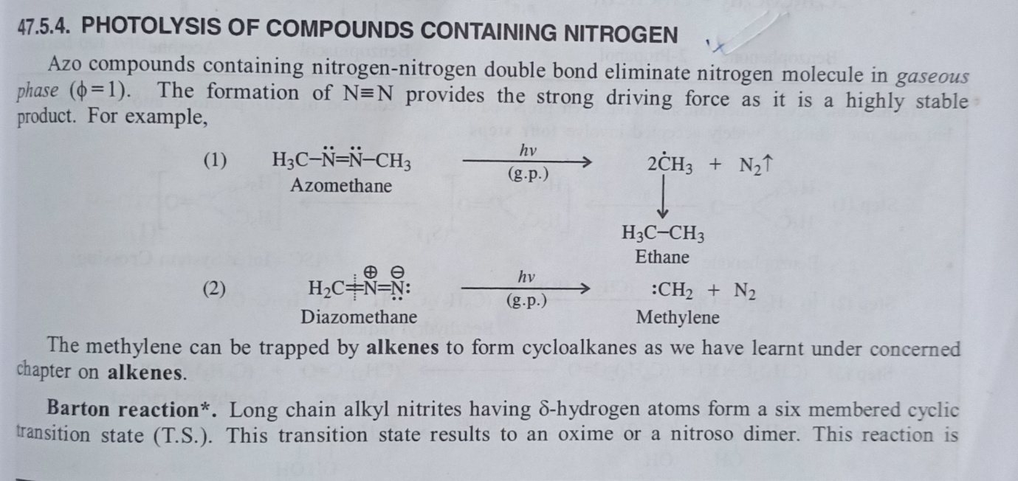

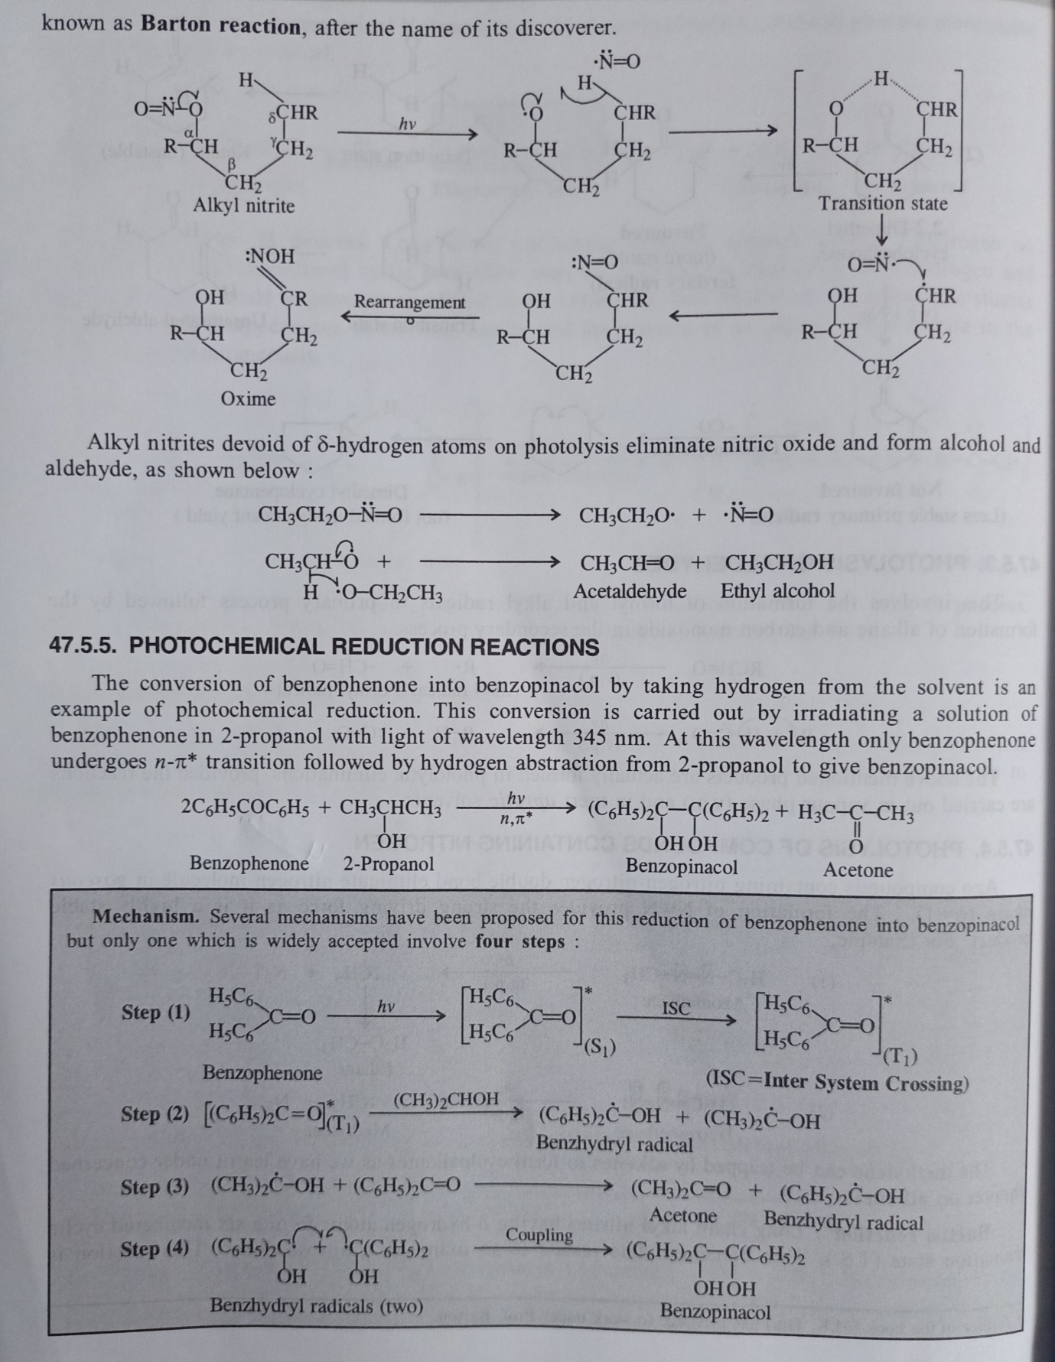

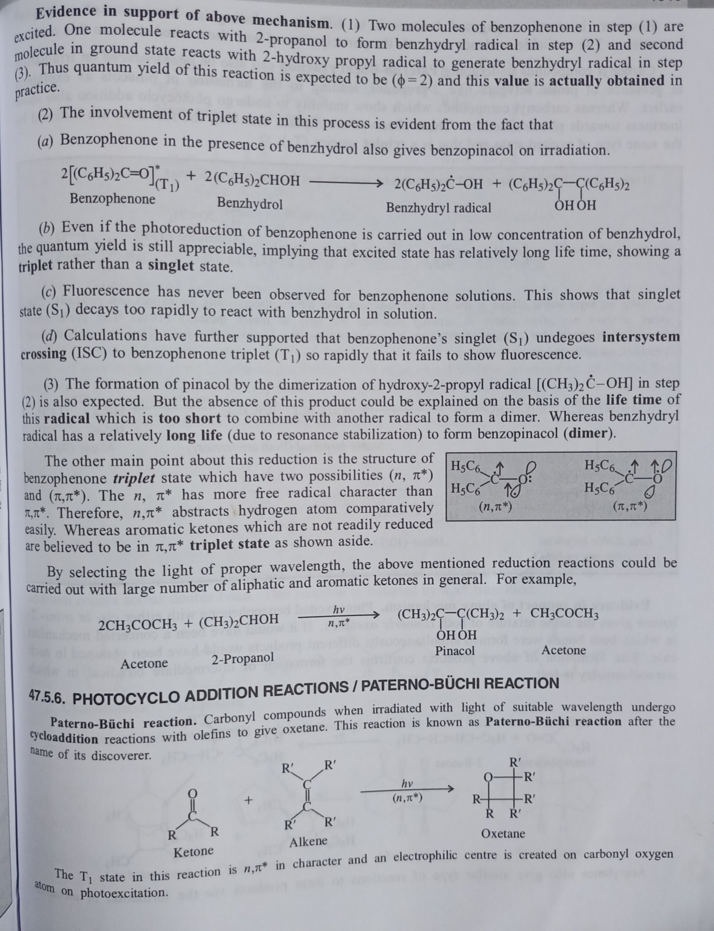

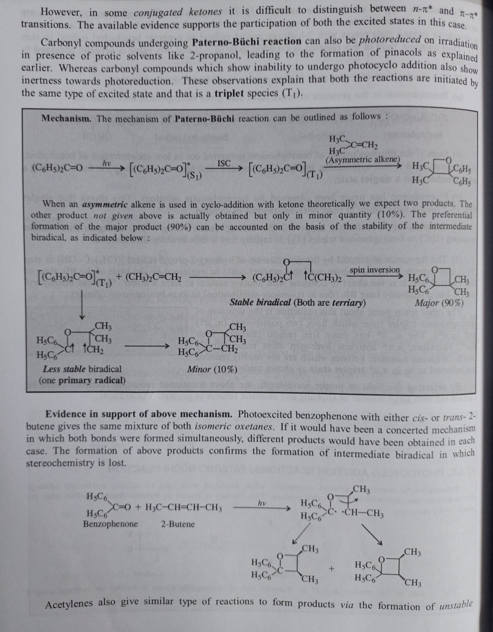

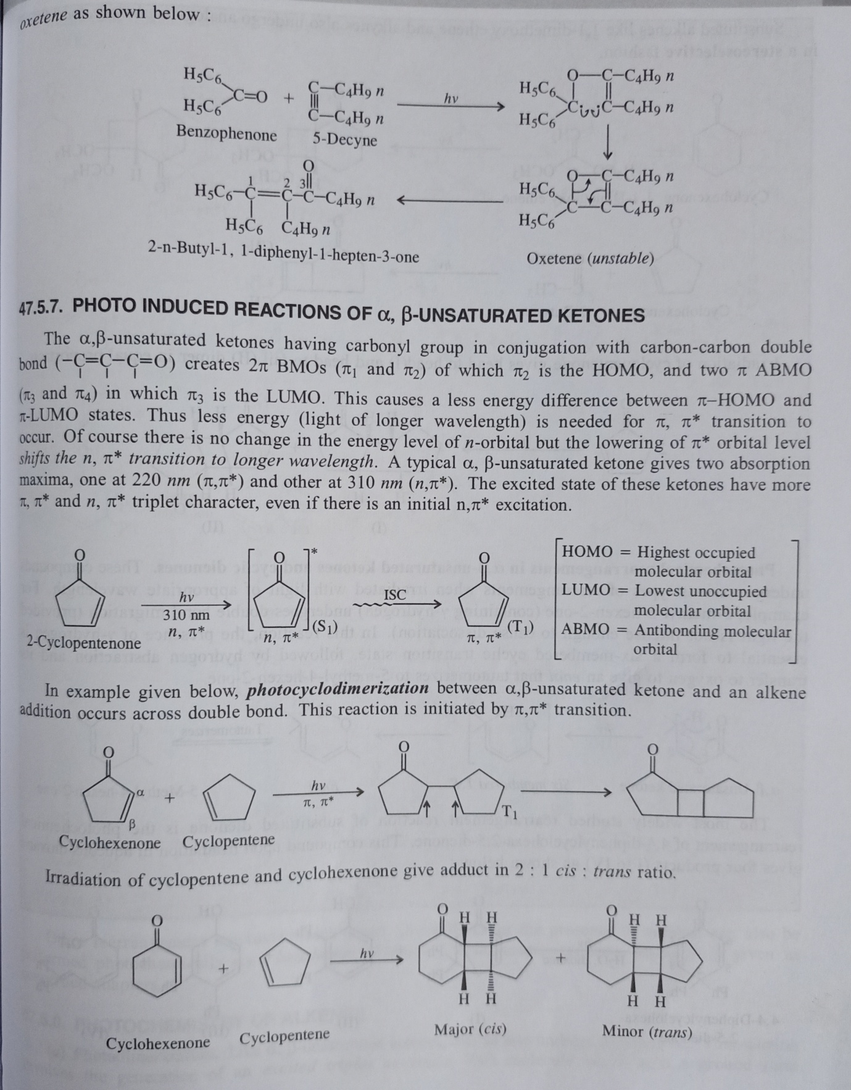

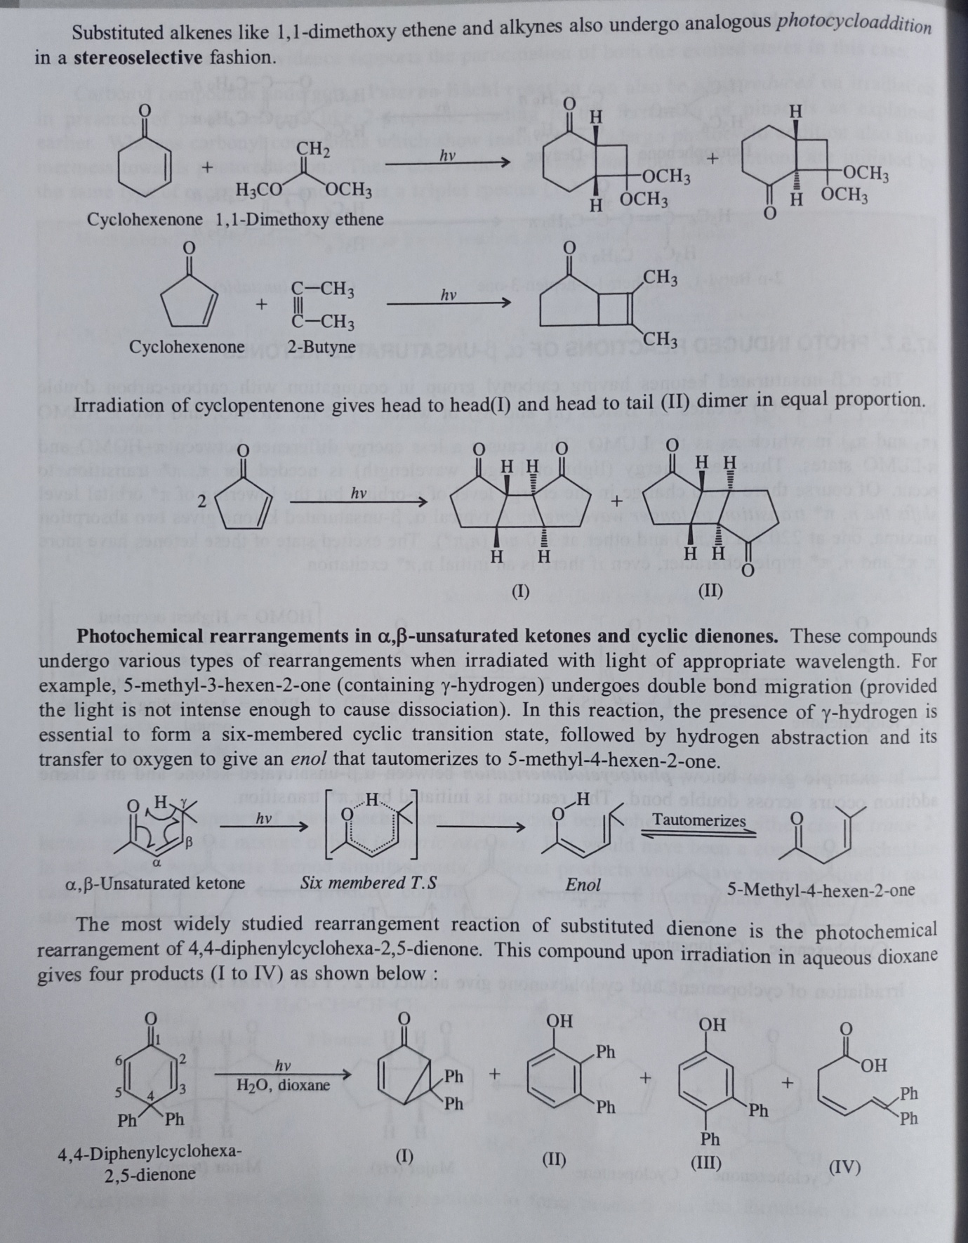

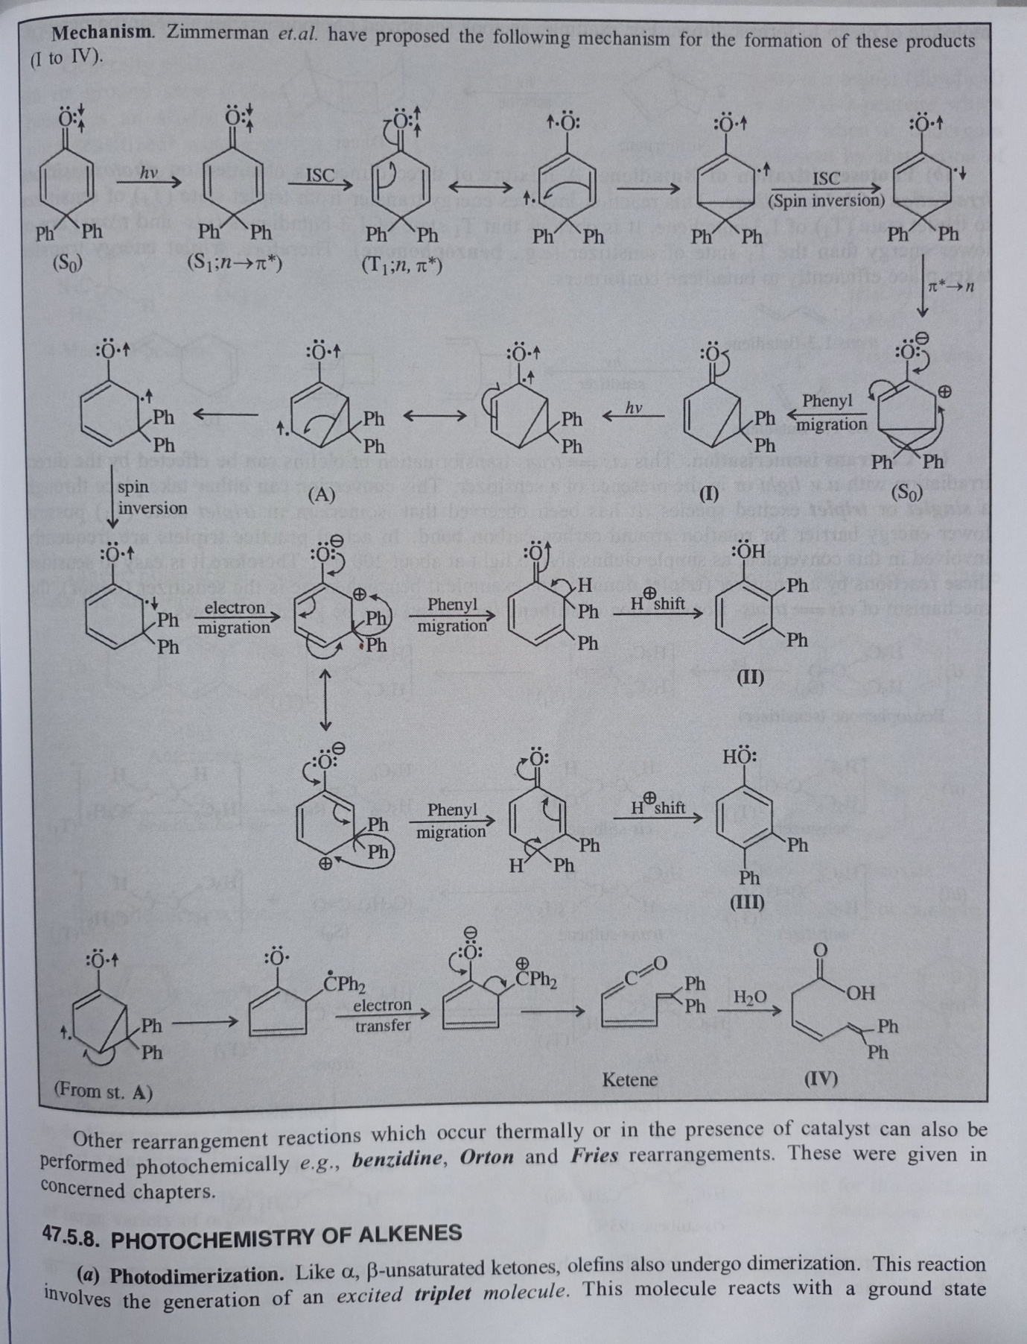

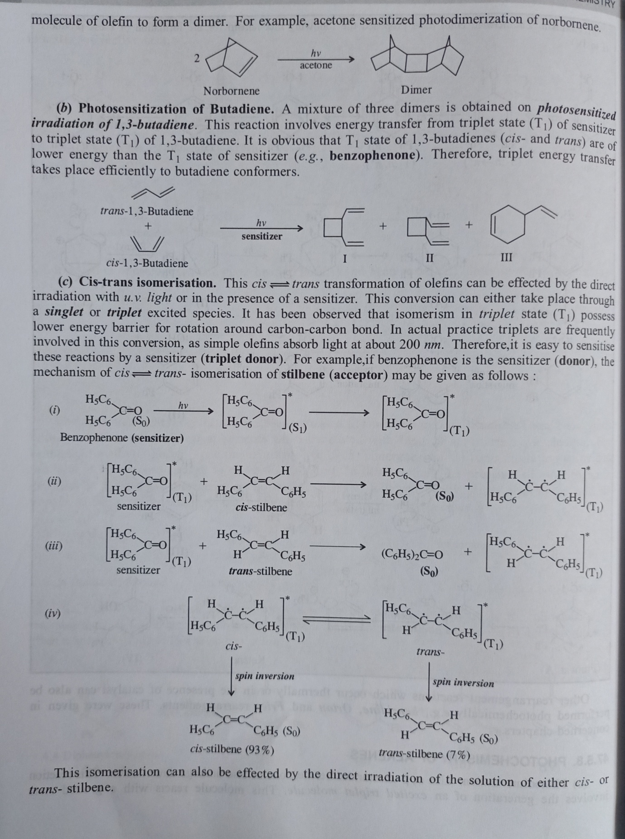

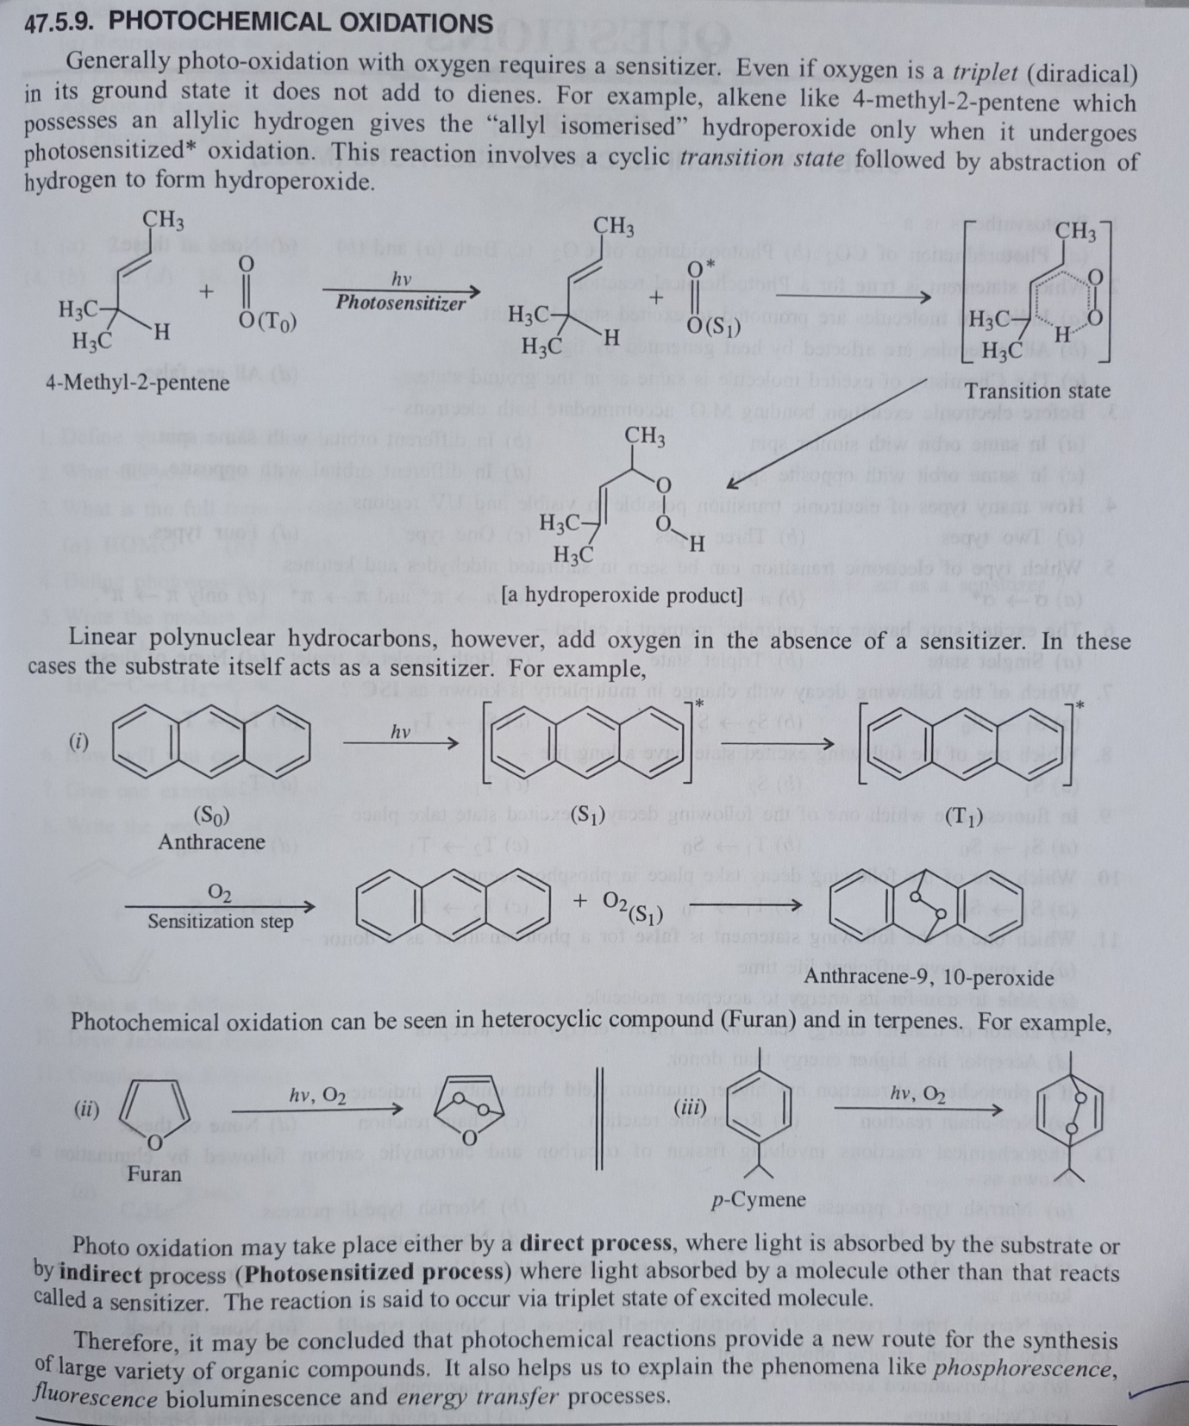

**The End**