ROLE OF MACRO & MICRO NUTRIENTS
Essential elements perform several functions. Various forms and functions of mineral elements are given in table below:
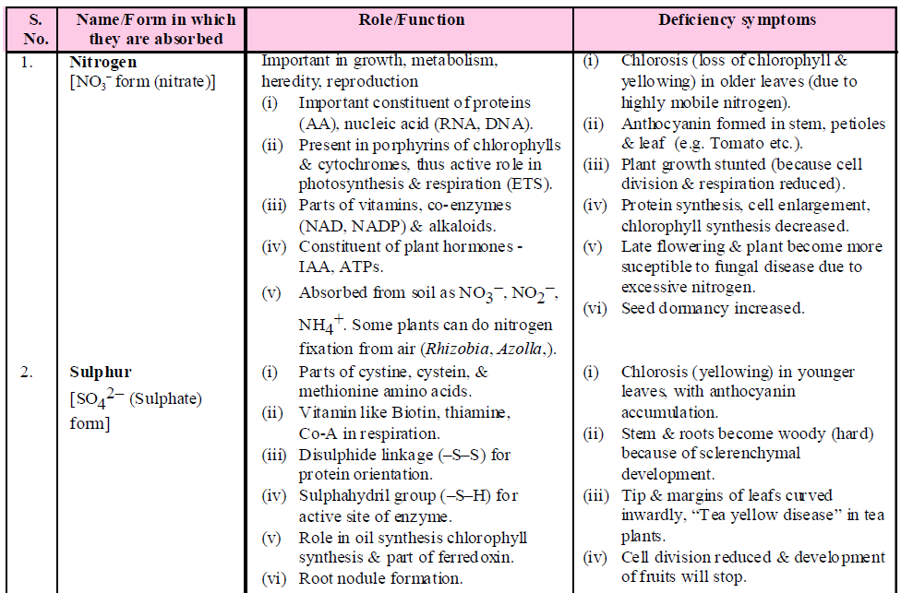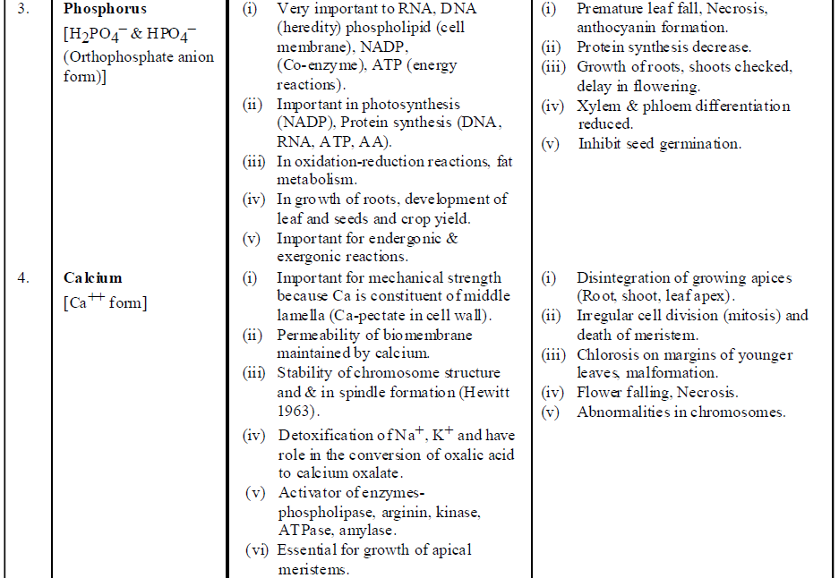
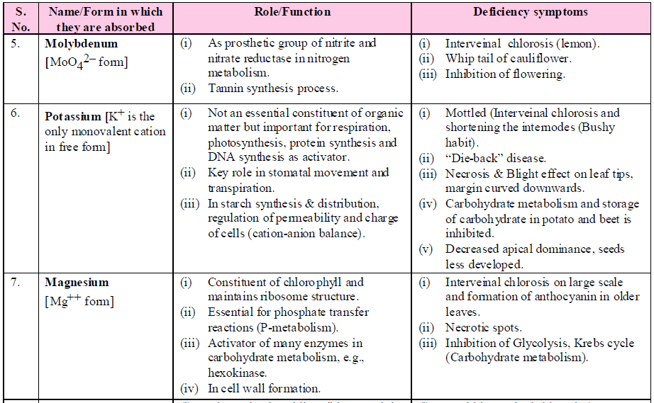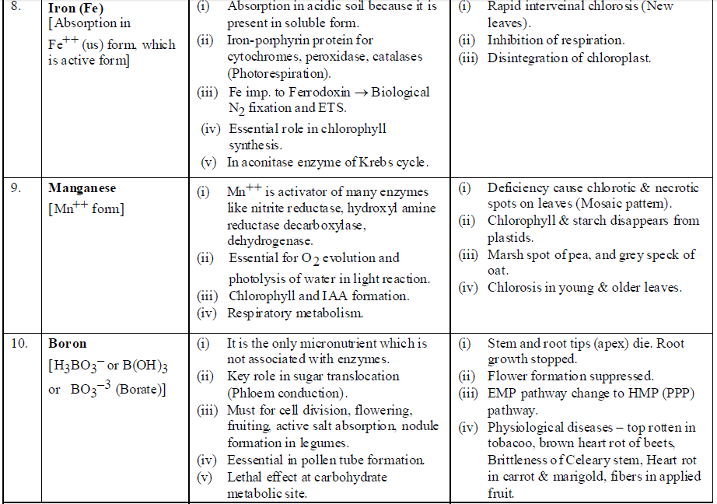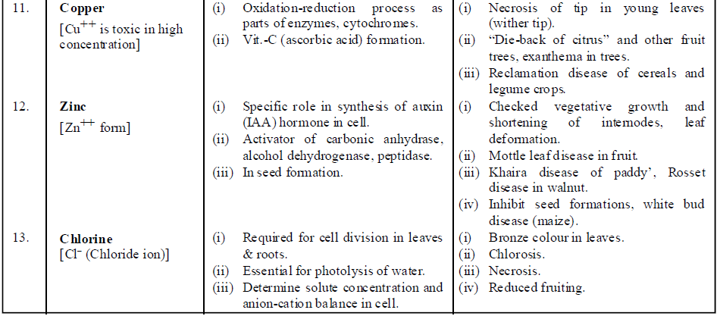

DEFICIENCY SYMPTOMS
- The element is said to be deficient when it is present below the critical concentration.
- Critical concentration is the concentration of essential elements below which plant growth is retarded.
- Deficiency Symptoms are extremely visible pathological conditions which are produced due to absence or deficiency of some essential nutritive substance.
- The deficiency symptoms of highly mobile elements in plants like N,P,K,Mg first appear in older plant parts. These minerals are present as structural constituents of biomolecules of mature plant parts and when plant parts become older, these biomolecules are broken down making these elements available for younger plant parts.
- The deficiency symptoms of immobile elements like Ca, S are first to appear in young plant parts, as they are not transported from older plant parts.

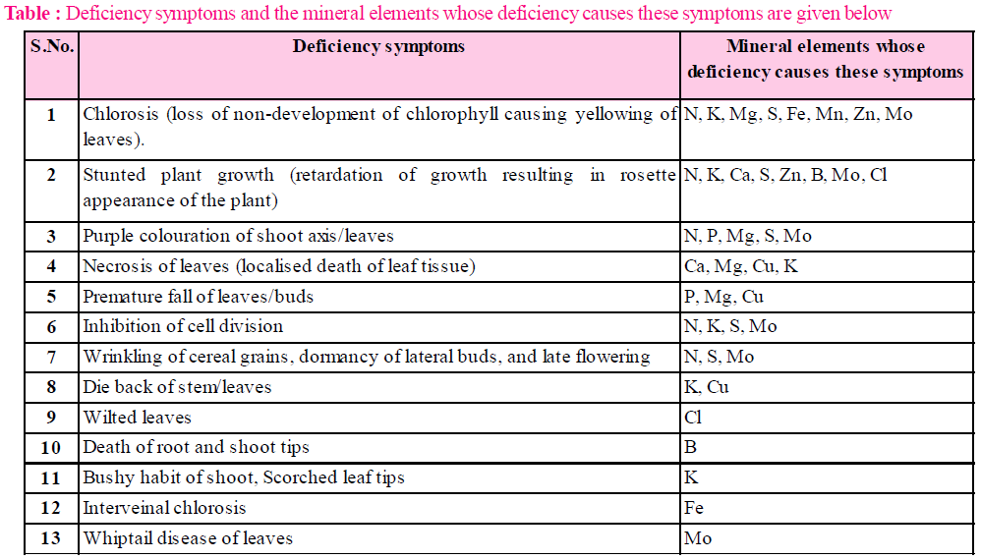MINERAL TOXICITY
- Any mineral ion concentration in plant tissue that reduces the dry weight of tissue by about 10 percent is considered as toxic or toxic element and this effect is called as toxicity.
- Most of micronutrients become toxic as their required amount for plants is very low. This excess concentration inhibits activity of other essential elements.
E.g., Excess Mn (Manganese) may induce deficiency of iron, magnesium and calcium and causes appearance of brown spots surrounded by chlorotic veins. Mn competes with iron (Fe) and magnesium (Mg) for uptake and with Mg for binding to enzymes. Mn also inhibits calcium translocation into the shoot apex and cause disease called crickle leaf.
So the dominant symptoms of Mn toxicity may actually be the symptoms of Fe, Mg and Ca deficiency.

MECHANISM OF ABSORPTION OF ELEMENTS
- Soil is the main source of mineral salts. These mineral salts are mainly absorbed by the (sub-terminal) meristematic region of the roots.
- There are two methods of absorption of mineral salts : Passive and active.

PASSIVE ABSORPTION OF MINERALS (WITHOUT EXPENDITURE OF ATP)
- By simple diffusion : According to this method, mineral ions may diffuse in root cells from the soil solution.
- By mass flow : According to this method, mineral ion absorption occurs with the flow of water under the influence of transpiration.
- By ion exchange : This involves exchange of mineral ions with the ions of the same charge.
  - By contact exchange : When the mineral ions exchange with the H⁺ and OH– ions.
  - Carbonic acid exchange : When the mineral ions exchange with the ions of carbonic acid.
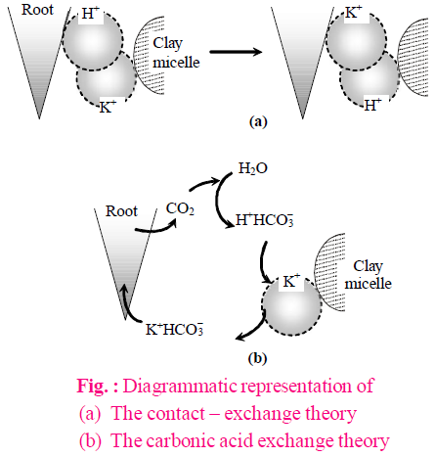
- By Donnan equilibrium : This theory explains the passive accumulation of ions against the concentration gradient or electrochemical potential (ECP) without ATP. At the inner side of the cell membrane which separates from outside (external medium), there are some anions which are fixed or non-diffusible and membrane is impermeable to these anions, while cations are diffusible.

ACTIVE ION ABSORPTION (BY EXPENDITURE OF ATP)
Evidences in favour of active mineral absorption are :
- Rate of respiration of plant is increased when the plant transferred into mineral solution (salt respiration).
- Factors like deficiency of oxygen, CO, CN, which inhibit rate of respiration, also inhibit the absorption of mineral ions in plants.
- Absorption of K⁺ ions in Nitella algae is observed against the concentration gradient.
Cytochrome pump theory : (By Lundegardh Burstorm, (1933)) According to this theory, only anions are absorbed by active mechanism through cytochrome pumping and absorption of cation is a passive process.

Carrier concept : (By Vanden honert) According to this theory, some specific carrier molecules made up of proteins are present in cell membrane of root cell which absorb both the ions and form ion-carrier complex. This complex breaks inside the cell membrane with expenditure of energy.
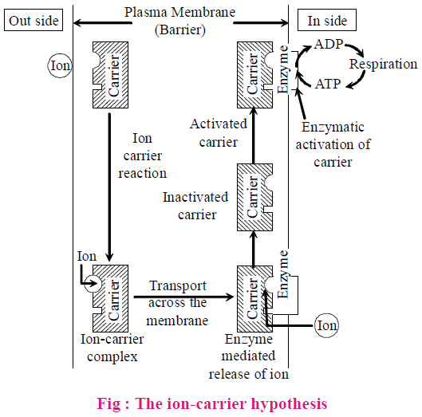

FACTORS AFFECTING MINERAL ABSORPTION
- The process of mineral absorption is influenced by the following factors like temperature, light etc.
- Temperature : The rate of absorption of salts and minerals is directly proportional to temperature.
The absorption of mineral ions is inhibited when the temperature has reached its maximum limit, perhaps due to denaturation of enzymes.
- Light : When there is sufficient light, the more photosynthesis occurs. As a result, more food energy becomes available and salt uptake increases.
- Oxygen : A deficiency of O₂ always causes a corresponding decrease in the rate of mineral absorption. It is probably due to unavailability of ATP. The increased oxygen tension helps in increased uptake of salts.
- pH : It affects the rate of mineral absorption by regulating the availability of ions in the medium. At normal physiological pH, monovalent ions are absorbed more rapidly whereas alkaline pH favours the absorption of bivalent and trivalent ions.
- Interaction with other minerals : The absorption of one type of ions is affected by other type. The absorption of K⁺ is affected by Ca⁺⁺, Mg⁺⁺ and other polyvalent ions. It is probably due to competition for binding sites on the carrier. However, the uptake of K⁺ and Br– becomes possible in presence of Ca⁺⁺ ions. There is a mutual competition in the absorption of K, Rb and Cs ions.
- Growth : A proper growth causes an increase in surface area, the number of cells and in the number of binding sites for the mineral ions. As a result, mineral absorption is enhanced.

TRANSLOCATION OF SOLUTES (MINERAL SALTS)
- By use of radio-isotopes, it has been proved that inorganic substances move up the plant through xylem. These substances move along with water by transpiration pull.
- The rate at which inorganic solutes are translocated through xylem corresponds to the rate of translocation of water. After absorption of minerals by roots, ions are able to reach xylem by two pathways: apoplast and symplast pathway.

SOIL AS RESERVOIR OF ESSENTIAL ELEMENTS
- Soil provides anchorage, air, water and minerals to the plants growing in it.
- Majority of the nutrients that are essential for the growth and development of plants become available to the roots due to weathering and breakdown of rocks. These processes enrich the soil with dissolved ions and inorganic salts. Since they are derived from the rock minerals, their role in plant nutrition is referred to as mineral nutrition.
- Soil consists of a wide variety of substances. Soil not only supplies minerals but also harbours nitrogen-fixing bacteria and other microbes.
- Since deficiency of essential minerals affect the crop-yield, there is often a need for supplying them through fertilizers.
- Both macro-nutrients (N, P, K, S, etc.) and micro-nutrients (Cu, Zn, Fe, Mn, etc.) form components of fertilizers and are applied as per need.

METABOLISM OF NITROGEN
- Nitrogen occurs in environment as oxides, organic amines etc. Nitrogen content in the environment is 78.8 % by volume.
- Plants can not absorb nitrogen in molecular form. It is absorbed by plants in nitrate (NO₃– ) and ammonium (NH₄⁺) form.

NITROGEN CYCLE
- Nitrogen is the most critical element. Apart from carbon, hydrogen and oxygen, nitrogen is the most prevalent element in living organisms.
- Nitrogen is found in essential compounds like proteins, nucleic acids, growth regulators and many vitamins.
- Plants compete with microbes for the limited nitrogen that is available in soil. Thus, nitrogen is a limiting nutrient for both natural and agricultural ecosystems.
- Nitrogen exists as two nitrogen atoms joined by a very strong triple covalent bond (N ≡ N).
- N₂ gas of the atmosphere is converted into ammonia by the process of nitrogen-fixation.
- In nature, lightning and ultraviolet radiation provide enough energy to convert nitrogen to nitrogen oxides (NO, NO₂, N₂O). Industrial combustions, forest fires, automobile exhausts and power-generating stations are also the sources of atmospheric nitrogen oxides.
- A regular supply of nitrogen to the plants is maintained through nitrogen cycle. Nitrogen cycle is a regular circulation of nitrogen amongst living organism.
- Nitrogen cycle consists of four processes called nitrogen fixation, ammonification, nitrification and denitrification.

NITROGEN FIXATION
- Nitrogen fixation is the conversion of inert atmospheric nitrogen or dinitrogen (N₂) into utilizable compounds of nitrogen like nitrate, ammonia and amino acids, etc. There are two methods of nitrogen fixation – abiological and biological.
- Physical or abiological nitrogen fixation occurs in atmosphere in four steps.
  - Conversion of nitrogen into nitric oxide due to lightning.
  - Oxidation of nitrogen oxide into nitrogen dioxide
(Nitrogen dioxide)
  - Nitrogen dioxide reaches the soil in the form of nitrous and nitric acid when dissolved in rainwater.
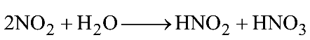
  - These react with alkali of soil and form nitrates (absorbable form).
nitrates
- On industrial scale, abiological fixation occurs by Habers–Bosch nitrates process at high pressure and temperature.
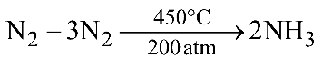(Ammonia)
- Conversion of gaseous nitrogen into nitrogenous compounds by living organisms like bacteria, cyanobacteria is called biological nitrogen fixation.

AMMONIFICATION
- The nitrogenous organic compounds in the dead bodies of plants and animals are converted into ammonia or ammonium ions in the soil. This is carried out by ammonifying bacteria. Ammonia is toxic to the plants but ammonium ions can be safely absorbed by the higher plants.
- Ammonification occurs due to ammonifying bacteria, e.g., Bacillus mycoides, B. yugaris and B. ramosus, etc.
- Ammonification is a mineralisation process.
- Protein (from dead cells)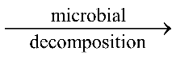 Amino acids Ammonia (NH₃) + Organic acid (ROH).
- Organic acid released in this process are used by microorganisms for their own metabolism.
- Some of this ammonia volatilises and re-enters the atmosphere but most of it is converted into nitrate.
- If ammonia is not absorbed directly by plants then it is converted to nitrate through the process of nitrification.

NITRIFICATION
- The conversion of NH₃ in soil into nitrates (–NO₃) and nitrites (–NO₂) is called nitrification. It is done by nitrifying bacteria, e.g., Nitrosomonas, Nitrosococcus (converts NH₃ into nitrites) and Nitrobacter (converts nitrites into nitrates).
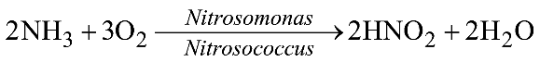
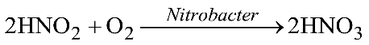
- Nitrifying bacteria are chemoautotrophs and are benefitted by utilizing energy released in oxidation, which is used in chemosynthesis. At soil temperature 30°C – 35°C in alkaline soils and with sufficient moisture and aeration, the activity of ammonifying and nitrifying bacteria is found to be maximum.
- The nitrate thus formed is absorbed by plants and is transported to the leaves. In leaves, it is reduced to form ammonia that finally forms the amine group of amino acids.

DENITRIFICATION
- The conversion of nitrates and nitrites in soil into atmospheric N₂ is called denitrification, which is done by denitrifying bacteria, e.g., Micrococcus denitrificans and Bacillus denitrificans, Pseudomonas & Thiobacillus.
- Denitrification is also called dissimilatory nitrate reduction.
- Denitrification occurs in four steps –
- Nitrates are reduced to nitrites by the enzyme nitrate reductase. The nitrites are reduced to ammonia by nitrite reductase. The ammonia is so formed is enzymatically incorporated in amino acids.
- Denitrification does not occur to any significant degree in well aerated soils with moderate amount of nitrates and organic matter. It occurs in water logged anaerobic soils with a high organic matter content.
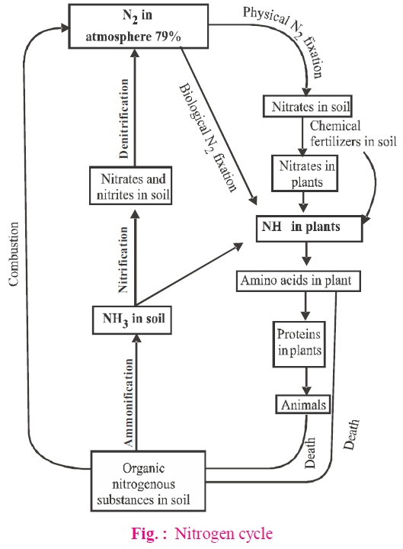

BIOLOGICAL NITROGEN FIXATION
- The process of fixing atmospheric nitrogen into the usable (inorganic nitrogenous compound) form by living organism is called biological nitrogen fixation.
- The enzyme, nitrogenase, which is capable of nitrogen reduction is present in prokaryotes. Such microbes are called N₂-fixers.
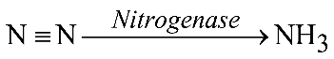
- The bacteria may be free living (asymbiotic) or symbiotic.
  - Free living nitrogen fixing bacteria. Azotobacter, Beijernickia (both aerobic) and Bacillus, Klebsiella, Clostridium (anaerobic).
  - Free living nitrogen fixing cyanobacteria. Many free living blue-green algae (BGA) or cyanobacteria perform nitrogen fixation, e.g., Anabaena, Nostoc, Calothrix, Lyngbia, Aulosira, Cylindrospermum, Trichodesmium. Cyanobacteria are mainly responsible for maintaining the fertility and productivity of rice fields. E.g., Nostoc, Anabaena, Cylindrospermum are active in sugarcane and maize fields.
  - Symbiotic nitrogen fixing cyanobacteria. Anabaena and Nostoc species are common symbionts in lichens, Anthoceros, Azolla and Cycas roots are other symbionts.
  - Symbiotic nitrogen fixing bacteria. Rhizobium is a nitrogen fixing bacterial symbiont of papilionaceous roots. Sesbania rostrata has Rhizobium in root nodules and Aerorhizobium in stem nodules. Frankia is a symbiont in root nodules of several non-legume plants like Casuarina (Australian Pine).
- The most prominent among them is the legume-bacteria relationship. Species of rod-shaped Rhizobium has such a relationship with the roots of several legumes such as alfalfa, sweet clover, sweet pea, lentils, garden pea, broad bean, clover beans, etc.
- The most common association on roots is as nodules. These nodules are small outgrowths on the roots.
- The microbe, Frankia, also produces nitrogen-fixing nodules on the roots of non-leguminous plants (e.g., Alnus).
- Nodules act as the site for N₂ fixation. It contains leghaemoglobin (a pink pigment) and enzyme nitrogenase (Mo-Fe protein).
- Both Rhizobium and Frankia are free-living in soil, but as symbionts, can fix atmospheric nitrogen.

NODULE FORMATION
Nodule formation involves a sequence of multiple interactions between Rhizobium and roots of the host plant.

Principal stages in the nodule formation are summarised as follows:
- Rhizobia multiply and colonise the surroundings of roots and get attached to epidermal and root hair cells.
- When root hair of leguminous plants come in contact with Rhizobium, its curves get deformed by the chemical substance secreted by the bacteria and result in nodule formation.
- The Rhizobia enter the root hair by invading root tissue and reproduce in cortex cell.
- Simultaneously, the division of cortex cell takes place due to which nodules are formed in the root.
- The bacteria living in such nodules gets carbohydrate from host cell and also convert the absorbed atmospheric nitrogen into ammonia.
- It is believed that a combination of cytokinin produced by infected bacteria and auxin produced by plant cell stimulates cell division and extension leading to nodule formation.
- The formation of root nodules and nitrogen fixation occurs under the control of plant nod genes and bacterial nod, nif and fix gene cluster.
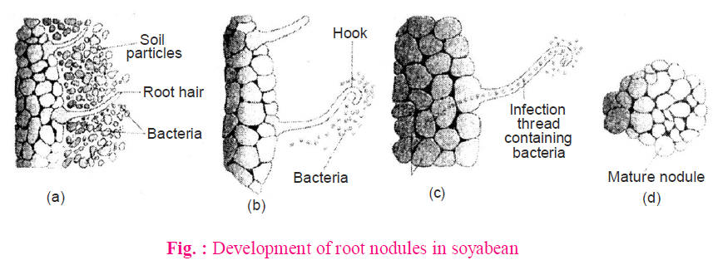
(a) Rhizobium bacteria contacts a susceptible root hair and divides near it.
(b) Upon successful infection of the root hair, it gets curled.

