lipids & Structure of cell
[Lipids and structure of cell membrane; membrane transport]
Lipids:
Lipids (fats) are the non-polymeric, water insoluble organic compounds of $C,H \&O$ and are the main component of cell membrane. These are the compounds of biological origin that dissolve in non-polar solvents, such as chloroform and diethyl ether, dehydration of which results in the formation of molecular assembly to form macromolecules. The name lipid comes from the Greek word $lipos$, for fat. Unlike carbohydrates and proteins, which are defined in terms of their structures, lipids are defined by the physical operation that we use to isolate them.
Lipids could be simple fatty acids or triester glycerol i.e. glycerides. Many lipids have both glycerol and fatty acid units. Some lipids also have phosphorous (phosphotriglyceride, also called lecithin) and phosphorylated organic compound in them. Some lipids have more complex structure containing cholesterol (a steroid) unit, or even terpenoid (such as menthol & vitamin $A$ skeleton).
Thus, the lipids include the following structural units —
Classification of Lipids:
The lipids are classified into sub-groups as follows —
Simple Lipids: These are the esters of fatty acids with various alcohols. Simple lipids are mainly of two types — Natural or true fats and Waxes
Neutral or true Fats: Neutral or true fats are the simple lipids are the esters of fatty acids with glycerol only. These are also called glycerides. A fat molecule consists of one molecule of glycerol and one to three molecules of the same or different long-chain unbranched fatty acids. The fatty acids used in glycerides formation may be saturated (such as Palmitic or Stearic acid, etc.) or unsaturated (such as Oleic or Linoleic, Linolenic, Arachidonic acid, etc.)
Neutral or true fats may be monoglyceride, if there is only one molecule of fatty acid attached to a glycerol molecule. If the number of fatty acids attached to a glycerol happens to be two, it is called diglyceride or triglyceride if the number of fatty acids is three.
Based on the melting point of triglycerides can be called as fats or oils. Fats gave high melting point and remain as solids at room temperature, e.g. butter, ghee, etc., while oils have low melting point and remain as liquids/ oil at room temperature, e.g. gingelly oil (edible or cooking oil obtained from Sesame seeds ), sunflower oil, etc.
Waxes: These are the esters of fatty acids with high molecular weight alcohols instead of glycerol, e.g. bee wax, lanolin, etc. They have an important role to play protection. They form water insoluble coatings on hair and skin in animals and stems, leaves and fruits of plants.
[Bees wax is formed from Palmitic acid ($C_{16}H_{32}O_{2}$) and myricyl alcohol ($C_{30}H_{61}OH$). Bees wax is also called $Hexacosyl Palmitate$, secreted by worker bees. Lanolin (wool fat) forms a water proof coating around the animal fur.]
Bacteria that cause tuberculosis and leprosy produce a wax ($wax$-$D$) that contributes to their pathogenicity.
Compound or Conjugated Lipids: These are the esters of fatty acids with alcohols, but contain some other substances also. These are basically of $4$- types —
Phospholipids, Glycolipids, Lipoproteins and Chromolipids
Phospholipids: The phospholipids are composed of a molecule of glycerol or other alcohol having — ($a$) a phosphate group joined to one of its outer $–OH$ groups, ($b$) two fatty acid molecules linked to the other two $–OH$ groups, and ($c$) a $N$- containing choline molecule, bound to the phosphate group. Phospholipids are found in cell membranes. Lecithin is one example of phospholipid.
Glycolipids: Glycolipids contain fatty acids, alcohol (sphingosine) and sugar can be Galactose or other. The sugar replaces one fatty acid molecule. The Glycolipids are present in myelin sheath of nerve fibres and in the outer surface of cell membrane of chloroplast.
Lipoproteins: Lipoproteins contain lipids (mainly phospholipids) and proteins in their molecules. Membranes are composed of lipoproteins.
Chromolipids: These contain pigments such as carotenoids e.g. carotene, vitamin A.
Derived Lipids: Derived lipids do not contain any fatty acid units. Common example is the steroids. The steroids do not contain fatty acid, but they are composed of $4$- fused ring systems. The various steroids in the number and position of double bonds between the $C$- atoms and in the side chain linked to the nucleus. The most common steroids are sterols, and cholesterol is a sterol.
Cholesterol is the most abundant steroid in the animal tissues, whose precursor is acetic acid. Food rich animal fats contain cholesterol, and it is also synthesised in liver. Cholesterol is an essential component of animal plasma membrane.
Phospholipids and Cell membranes:
(Phospholipids Bilayer & Membrane Transport)
The fats are found in storage fat cells of plants and animals. Their function rests on their chemical properties; through oxidation, they are consumed to help provide energy for the life processes.
The phospholipids, on the other hand, are found in the membrane of cells — all cells — and are the basic structural element of living organisms. This vital function depends in a fascinating way, on their physical properties.
Phosphoglyceride molecules are amphipathic, and in this respect differ from fats — but resemble soaps and detergents. The lipophilic part is, again, the long fatty acid chains. The hydrophilic part is the dipolar ionic end; the substituted phosphate group with its $+ve \&-ve$ charges.
In aqueous solution, as we would expect, phosphoglycerides form micelles. In certain situations, however — at an aperture between two aqueous solutions, for example — they tend to form bilayers: two rows of molecules are lined up, back to back, with their polar ends projecting into water on the two surfaces of the bilayer (as shown in the figure given below). Although the polar groups are needed to hold molecules in position, the bulk of the bilayer is made up of the fatty acid chains. Non-polar molecules can therefore dissolve in this mostly hydrocarbon wall and pass through it, but it is an effective bilayer to polar molecules and ions.
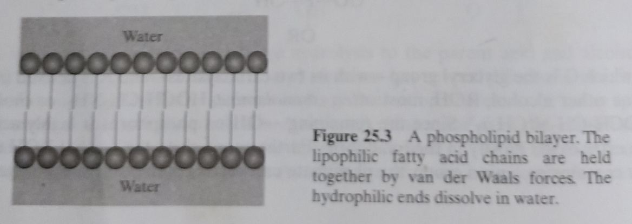
It is believed that the bilayers of phosphoglycerides exist in cell membrane. These bilayers not only constitute the wall but also very selectively control the passage, in and out, the various substances — nutrients, waste products, hormones, etc. — even from solution of low concentration to a solution of high concentration. Now, many of these substances that enter and leave the cells are highly polar molecules like carbohydrates and amino acids, or ions like sodium and potassium. The selective permeability of these molecules or ions can be explained as —
The cell membrane (phospholipid bilayer) involves some proteins also: embedded in the bilayer. Again, proteins are very long-chain amides, polymers of twenty-odd different amino acids. Protein chains can be looped and coiled in a variety of ways; the conformation that is favoured for a particular protein molecule depends on the exact sequence of amino acids along its chain.
It has been suggested that transport through membranes happens in the following way —
A protein molecule, coiled up to turn its lipophilic parts outwards, is dissolved in the bilayer, forming a part of the cell wall. A molecule approaches: a potassium ion, say. If the particular protein is the one designed to handle potassium ion, it receives the ion into its polar interior. Hidden in this lipophilic wrapping, the ion is smuggled through the bilayer and released on the other side.
Now, if the transport protein is to do its job, it must be free to move within the membrane. The molecules of the bilayer, while necessary aligned, must not be locked into a rigid crystalline lattice — as they would be if all the fatty acid chains were saturated. Actually, some of the chains in the membrane phospholipids are unsaturated and these, with their $cis$- stereochemistry and the accompanying bend (as shown in the micelle figure given below), disrupt the alignment enough to make the membrane semi-liquid at physiological temperature.
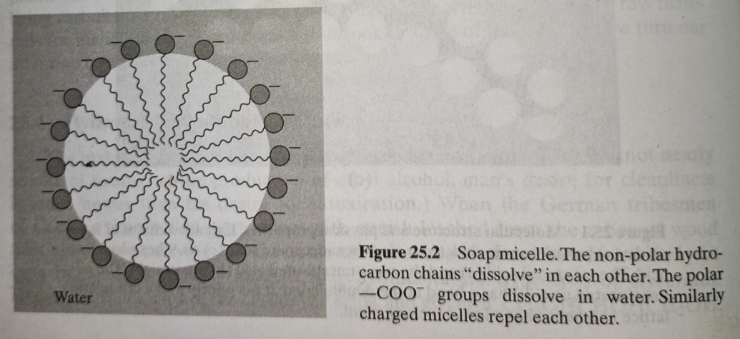

The End

